EDUCATION AND SOCIAL CARE

STAFF DEVELOPMENT OPPORTUNITY

ACTING QUALITY IMPROVEMENT OFFICER

(0.5 FTE JOB-SHARE)

Until March 2018

Salary £51,687 - £57,672 – pro-rata
As an innovative and improving local authority, we are looking for an experienced and capable individual for this exciting and challenging post in our QIO team. The post arises as a result of the retirement of the current postholder. Each QIO has responsibility for a number of clusters of schools in addition to a range of other remits. This post has responsibility for the Forres Associated Schools group including Early Learning and Childcare partners as well as Parental Engagement/Family Learning. The working pattern can be negotiated once a candidate has been appointed although the preferred working days would be Monday-Wednesday in the main.
This is a challenging post which will require qualities of vision, leadership, teamwork and good communication skills. The successful candidate should be able to demonstrate their impact on improving the quality of services and outcomes for service users and in raising, or maintaining, high standards of service delivery. They should also be committed to collegiate working and working in partnership with colleagues from Education and Social Care.
If you have substantial experience of, and success in, managing at a senior level in schools and are able to demonstrate a commitment to the delivery of top quality public services then we would like to hear from you. You should be educated to degree level or equivalent and have direct recent experience of managing self-evaluation and quality improvement.
If you would like to discuss any aspects of this post prior to submitting an application, please contact Vivienne Cross, Head of Schools & Curriculum Development on (01343) 563411 or vivienne.cross@moray.gov.uk.
The application form, reference form and job description are attached. Completed application forms should be returned to:

Vivienne Cross
Head of Schools and Curriculum Development
Education and Social Care
The Moray Council
High Street, ELGIN
IV30 1BX

The closing date for the post is 12.00pm on Wednesday 22nd March 2017
Proposed interview date – Thursday 20th April 2017
Proposed start date – as soon as possible after appointment

EDUCATION AND SOCIAL CARE

ACTING QUALITY IMPROVEMENT OFFICER
(0.5 FTE JOB-SHARE)

Surname: ……………………………… Forenames: …….…………………….…………….…

Preferred Title:………… Payroll No: MC TCH ……..…………… GTC No:..........................

Home Address ……………………………………………………………………..………………

………………………………………………………………………………………………………...

Postcode…………..….… Tel No ……………...…… E-mail:………………….…..……………

School …………..…………………..…….. Post ………………..…………………..………..…

Signature …………………………..…..…………… Date ………………………………………

Please state why you consider you are a suitable candidate for this post:

(Continuation from page 1)

Completed application forms should be returned to:

Vivienne Cross
Head of Schools and Curriculum Development
Education and Social Care
The Moray Council
High Street
ELGIN
IV30 1BX

Closing date 12.00pm on Wednesday 22nd March 2017

Please ask your line manager to complete the attached report before forwarding to:

Mrs Vivienne Cross, Head of Schools and Curriculum Development, Education and Social Care, The Moray Council, High Street, Elgin IV30 1BX no later than Thursday 20th April 2017.

Brief Comments by Line Manager

Signature of Line Manager ………………………………. Date ……………………

Signature of Applicant …………………………………… Date ……………………..
(having seen this report)

(1) JOB IDENTITY
POST TITLE: Quality Improvement Officer – 0.5 Job-share
DEPARTMENT: Education & Social Care
SECTION: Schools & Curriculum Development LOCATION: HQ, Elgin
REPORT TO: Head of Schools & Curriculum Development
GRADE: QIO POST NO:
(2) JOB PURPOSE AND WAY OF WORKING
To support educational establishments in the identification and meeting of curricular and professional development needs and to support the Council implementation of major national and local authority priorities, including Curriculum for Excellence.

To support establishments an Associated School Group (ASG) in service delivery.

To be thoroughly familiar with The Moray Council policies as they relate to education and to ensure that establishments/services are aware of and operate within these policies.

To assist and support in the implementation, monitoring and evaluation of the Council’s professional review and development programmes.

To assist, as appropriate, in the preparation and presentation of reports and briefing papers including those for Council Committees.

Extend and develop networks, integrated thinking and approaches to maximise opportunities and enable services to be managed in a complex and changing environment.

To support and advise on continuous improvement across Schools and Curriculum Development as well as Integrated Children’s Services.

To provide strategic direction in terms of Family Learning and Parental Engagement.

To be the link officer for an identified no of areas.

(3) MAJOR TASKS
Under the direction of the Director of Education and Social Care:

- To contribute to the continuous improvement agenda.

- To participate in the application of Best Value.

- To monitor and track service performance.

- To contribute towards the implementation of curriculum development.

- To undertake appropriate duties in relation to a number of Associated Schools Groups.

- To undertake any other duties as required by the Director of Education and Social Care where such duties are appropriate to both the grade and the primary functions of the post.

- To undertake lead officer role in specific aspects of service delivery including advice and support to Strategy Group

- To apply procedures associated with Education Scotland inspection of schools, including those associated with follow-through reports
(4) REPORTING RELATIONSHIPS This job is indicated by *
Corporate Director (Education & Social Care)

Head of Schools and Curriculum Development

Quality Improvement Officer*

SIGNATURES AND ADMINISTRATION ONLY
Author’s Signature:  Postholder’s Name:  Supervisor’s Name: | Validator’s Signature:  Signature:  Signature: | Date:  Date:  Date:
(5) DUTIES TYPICALLY INCLUDE:
Specific areas of activity related to the post at the present time are:

- Quality Improvement
- To support and guide Head Teachers in their duties
- To support school and service self-evaluation
- To help schools prior to and during inspection and to support them post inspection
- To support School Improvement Planning and Standards and Quality Reporting
- To support and challenge schools in terms of raising achievement and attainment
- To investigate parental complaints against Head Teachers/service delivery
- Work jointly with the Continuous Improvement Officer to carry out thematic reviews
- Work jointly with the Continuous Improvement Officer to train, develop and manage the peer reviewer team

- Best Value
    - To promote the effective use of appropriate Quality Indicators
    - To develop and share best practice in service delivery
    - To adhere to the principles of Quality Management in Education
    - To assist in Best Value Reviews as appropriate

- Curriculum Development
    - To contribute in the development and implementation of Curriculum for Excellence
    - To support the development of policies in relation to education across Moray
    - To support and guide the work of other officers within the Schools and Curriculum Development section
    - To support progression through the education system from 3 to 18 and promote cross sector working
    - To support and promote professional development activities

- ASG Officer
    - Responsible for a number of Associated Schools Groups
    - Advise and be involved in Head Teacher and Depute Head Teacher appointments from initial advertisement to final interview stages.

- Other Duties – as required
    - Carry out Head Teacher PR&D in line with Council policy.
    - To liaise and work co-operatively with appropriate national and local agencies
    - To maintain an awareness of national priorities and current educational developments.
    - To represent the authority at conferences, meetings, working parties at local, national and international levels as appropriate.
    - To liaise and work co-operatively with other Council departments
    - To participate in the Council’s employee review and development programme.
    - To advise Elected Members as appropriate
The above is intended to provide a clear but concise statement of the present MAJOR TASKS and ACTIVITIES of the job. It is not an exhaustive list of all its detailed duties.
Please note that the finalised remit will be agreed with the postholder, taking account of their strengths and the ongoing review of the remits of all Quality Improvement Officers.

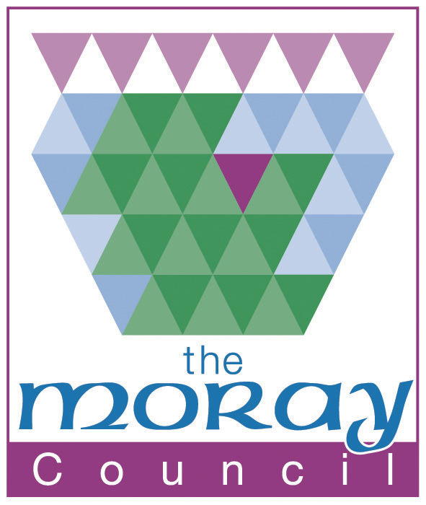
PERSON SPECIFICATION: Quality Improvement Officer
Department: Education & Social Care
Date Specification Completed: 17 November 2016
Note: Any disabled applicant who meets the essential criteria for the post is guaranteed an interview.

ATTRIBUTES | ESSENTIAL  The minimum acceptable levels for safe and effective job performance | DESIRABLE  The attributes of the ideal  candidate
- Experience | Experience of a promoted post in a school at Principal Teacher level or above. | Previous experience in educational development outwith schools settings, for example, secondment on a specific task basis or as a member of local/national working groups.
- Education & qualifications* | Education to Degree or equivalent level. | Post Graduate Diplomas/Degrees in Education and related areas
- Skills/abilities (general) | Ability to work as part of a team and also on own initiative.  Ability to prioritise own workload  High degree of IT skills including experience of spreadsheets and word processing | A knowledge of data analysis, databases and management information systems
- Skills/abilities specific to post* | A deep knowledge and understanding of curriculum development and learning and teaching.  You will be expected to travel efficiently and effectively between various work locations within Moray to meet the operational requirements of the service. Due to the rural nature of Moray this is normally undertaken by the use of a car.
- Inter-personal & social skills | Self-motivating; able to work independently but with equal commitment to team working; High level of networking and interpersonal skills; the ability to work under pressure to timescales; persuasive and effective negotiator; highly articulate communicator, both verbally and in written form | Experience of using coaching and mentoring techniques.
- Working environment & physical demands | Ability and willingness to undertake both office and  non-office based tasks.  Ability and willingness to attend meetings and events outwith office hours, including periods away from home, when required.

* Candidates will be required to show these documents if invited for interview.
Satisfactory Disclosure Scotland check required? NO
Membership of Protecting Vulnerable Groups Scheme (Working with Children) YES
Membership of Protecting Vulnerable Groups Scheme (Working with Vulnerable Adults) NO
Satisfactory pre-employment medical screening required? NO

