Planning Enforcement enquiry form
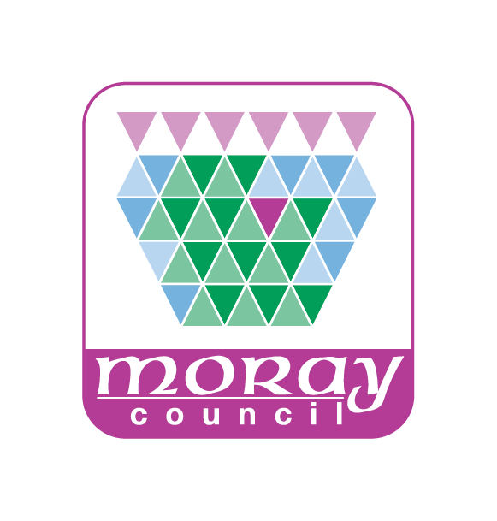

PLANNING SERIVCES – Development Management
Please use this form to submit any complaints or queries you have regarding a development or use of land or buildings which is causing you concern. You should try to provide as much information as possible; any additional information you can give us, such as photograph, or a diary of events, will help us to get a clearer picture of the alleged breach of planning control. Before you send us the form, you may wish to look at our Enforcement Charter at http://www.moray.gov.uk/downloads/file118894.pdf which explains the Enforcement system and powers.
Completing the Planning Enforcement complaint form will help both you and the council in a number of ways:
- It provides a written record of the primary evidence which initiated an investigation and possible formal legal action;
- It ensures that we have enough information to investigate your complaint fully;
- It gives you the opportunity to register your concerns about the development and its effect on your amenity;
- It helps us to establish priorities and to use resources efficiently.

What is the nature of alleged breach?
Mark X in the box for any which are applicable. Further details required on page 2
Unauthorised building or engineering works have been/are being carried out
Use of land or building has changed – from ……………………….to…………………………….
Breach of planning condition(s)
Works are not being carried out in accordance with the approved plans
Development/Works being carried out a Listed Building or within a Conservation Area
Unauthorised demolition works
Works to trees without consent
Unauthorised advertisement
Other – please give full details of a separate sheet if necessary
Planning Enforcement enquiry form

Details of Site and those involved
Address (including postcode)
Name of owner/resident (if known)
Name of any other person/company involved (with details of their involvement if possible)
Please use this box to give us as much detail as you can of the development or activity. (continue on a separate sheet if necessary)
When did the development take place or the activity start?
Is the activity still continuing? (including details of hours of operation if appropriate)
How is the development or activity affecting your amenity or the amenity of the wider locality?

Planning Enforcement enquiry form

Your name, address and contact details
Name
Address
Postcode
Telephone
Email

The support of complaints is important in determining the outcome of an enforcement investigation. We will treat your complaint as confidential during our initial enquiries and as much as possible after that. However, should the matter end in court action the testimony of witnesses could be necessary in securing a successful prosecution.

Development Management, Moray Council PO Box 6760, Elgin, IV30 9BX
Telephone | 0300 1234561
Email | Planning.enforcement@moray.gov.uk
Web - | www.moray.gov.uk

