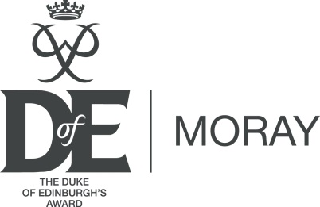

Moray Duke of Edinburgh’s Award Committee Funding Request – Support for Training

The Moray Duke of Edinburgh’s Award Committee’s (MDEAC) offers support to volunteers to gain qualifications in order to support DofE in Moray.
MDEAC require volunteers to make a commitment to the Award prior to approving funding. MDEAC also ask volunteers to explore other options of funding (for example DofE Diamond Fund, Teacher CPD funds, etc) to spread the cost of your training.
MDEAC are prepared to provide up to 100% funding, providing other options have been exhausted.

Please fully complete the application below:

Your information
First name |  | Surname
Address
Town |  | Postcode
Phone (daytime) |  | Mobile
Email

Course information
Course Name
Organisation Delivering the Course
Course Location
Dates
Full Cost
Additional Funding Source
Amount Requested

Your DofE information
Which DofE Group(s) do you volunteer with?
How long have you volunteered with this group?
Please detail how attending this course will benefit your DofE Group

MDEAC or the DofE Office will contact you when your application has been approved

We will ask applicants who receive funding to provide feedback of how the funding and subsequent qualification has helped support your DofE group. This helps us to promote the scheme and enables MDEAC to provide evidence that this fund is making a significant impact in developing the skills of volunteers and improving the experience of DofE participants.

If you have any queries please contact DofE office on 01343 813614 or dofemoray@moray.gov.uk

Please return completed forms to: Volunteer Funding Application
The Duke of Edinburgh Award
Lossiemouth Community Centre
Coulardbank Road
Moray
IV31 6JW

Email: dofemoray@moray.gov.uk

For office use:

Supporting statement from DofE Office
First name |  | Surname
Comments

