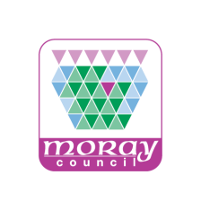
Notice of proposed disposal of land

Consultation Representation Form

Section 104 of the Community Empowerment (Scotland) Act 2015 requires that, before making a decision to dispose of common good land, a local authority must first publish details of the proposed disposal. In making its decision, the local authority must have regard to any representations made in respect of the proposal.

Asset Name / Reference* | land at Borough Briggs Road, Elgin
Representation Name*
Representation Organisation
Representation Email Address
Representation Postal Address*
Inc. Postcode*
Comments on asset transfer request:

Any representations regarding the proposed disposal of land should be submitted in writing to the Asset Management Coordinator at the address below no later than 12 Noon 25 October 2019. Representations should state the name and address of the person making the representation, the matters to which they relate, and the grounds on which they are made.

Following the closure of this consultation a report will be submitted to the council’s Policy and Resources Committee asking the committee to determine whether the council should apply to the Sheriff Court for consent to dispose of the land as required by Section 75(2) of the Local Government (Scotland) Act 1973.

* Mandatory Fields

