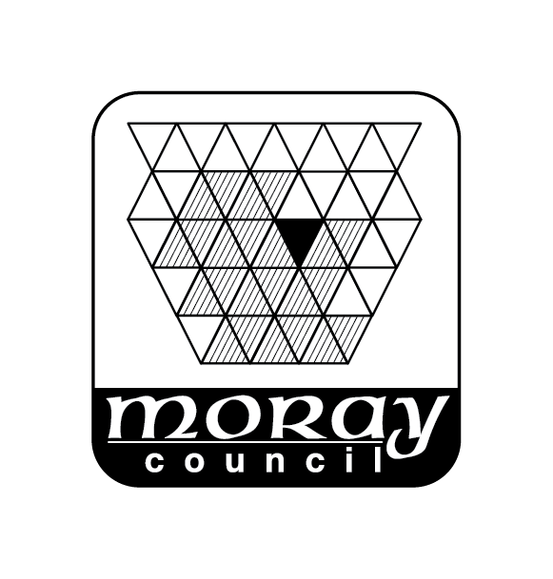
Joint tenancy termination notice form

Tenant name
Address | Postcode
I, the tenant named above, want to end my interest in the tenancy at the above address.
I understand that (in line with the Housing (Scotland) Act 2001 Section 13) to end my interest in the joint tenancy I must:
- give you, Moray Council, four weeks’ notice in writing (by filling in and submitting this form); and
- give each and every other joint tenant four weeks’ notice in writing.

I understand that
- I will remain jointly and severally liable for the payment of rent and any housing related debt until the date that my interest in the tenancy ends.
- Any unpaid housing debt may affect any future applications I make for social housing.
- Once you receive this notice of termination form, you will contact the other joint tenants to confirm that I have given them four weeks’ notice in writing.
- You will contact me and confirm the termination date.

My forwarding address will be:
Name
Address | Postcode
Contact details

I confirm that I have understood the above and that I have given every other joint tenant four weeks’ notice in writing to end my interest in the joint tenancy at the above address.
Signed tenant |  | Date

