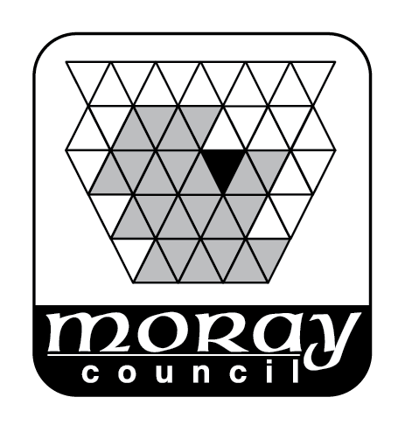
Advice for tenants facing rent or financial challenges during the Coronavirus crisis

If you are worried about paying your rent
We know that many tenants may be struggling financially because of the current Coronavirus (COVID-19) and may be worrying about how to make ends meet. We are here to help. If you need any help or advice with your rent account or you are worried about a change in your circumstances due to loss of earnings, please contact us. We can also help with income maximisation and tenancy sustainment issues.

Please continue to pay rent. If you are having problems, get in touch soon as possible and stay in touch with us. Please phone 0300 123 4566.

Sources of support and help
The government has made several changes to the welfare benefits system to help people to cope with a reduced or a loss of income.

Statutory Sick Pay
If you can’t work due to coronavirus or you are self-isolating, you may be able to claim Statutory Sick Pay (SSP). If you are eligible you will get it from day one rather than the fourth day of your illness. You must inform your employer. If you need to provide evidence to your employer that you need to stay at home due to coronavirus, do not go to your doctor. You can get an isolation note online from NHS 111 at www.111.nhs.uk/isolation-note.

If the amount that you get isn’t enough to meet your living expenses, you can claim Universal Credit to top your income. If you already receive Universal Credit or Housing Benefit you can ask for your award to be revised.

You can get more information on SSP at www.gov.uk/statutory-sick-pay.

New style’ employment and support allowance and jobseeker’s allowance
‘New style’ employment and support allowance (ESA) and jobseeker’s allowance (JSA) are the new names for contributory ESA and JSA (or just simply ESA and JSA). In each case you will only be entitled if you have paid enough national insurance contributions in the previous two or three years. Normally you aren’t entitled to ESA or JSA during the first seven days of your claim, but for ESA you are entitled from your first day of absence if you are infected, in isolation or caring for a child in your household who is.

If you are concerned about paying your rent due to loss of earning because of illness or self-isolation you can get advice on the DWP website at
www.gov.uk/government/news/coronavirus-support-for-employees-benefit-claimants-and-businesses.

Universal Credit
If your income has changed due to the impact of the Coronavirus, you can claim UC top it up to help pay your rent and other living expenses. You can find out more about Universal Credit and eligibility at www.understandinguniversalcredit.gov.uk/coronavirus/

UC can be backdated for up to one month. It is important that you apply as soon as possible. If you need to claim Universal Credit, apply on line at www.gov.uk/universal-credit/how-to-claim or phone 0800 328 5644.

If you already claim Universal Credit and are staying at home on Government advice, you should report this in this via your online journal. The amount of Universal Credit you receive should adjust as your earnings change.

Please be aware that your local Jobcentre may call you if you’ve applied online and haven’t been able to get through to book an appointment. They will use your online journal to tell you they plan to call. This call may come from a number with “no caller ID” or from another area code. Please answer the call. The Jobcentre cannot process your claim unless you answer their call. Jobcentre staff will ask you a few security questions which will confirm the call is genuine.

Discretionary Housing Payments
Discretionary Housing Payments (DHP) are payments that we can make to people who need financial help to pay their rent. There is no legal right to get receive an award. To qualify for a DHP a person must:
- be entitled to some Housing Benefit or the housing cost element of Universal Credit; and
- need financial help to pay their rent or other housing costs.
You can find more information at www.moray.gov.uk/moray_standard/page_41496.html.

The Scottish Welfare Fund
The Scottish Welfare Fund supports vulnerable people in Scotland when they have a crisis. It is normally a one-off grant for living expenses or household goods, but there are items which it will not fund. There are two grants available - Crisis Grants and Community Care Grants. You can find more information at www.moray.gov.uk/moray_standard/page_84329.html.

Other sources of support
If you are worried about the short-term impact of the Coronavirus on your employment, then you can contact Skills Development Scotland’s PACE helpline on
0800 917 8000 or view their website at www.ourskillsforce.co.uk.

More advice can also be found on the Money Advice Service website at www.moneyadviceservice.org.uk/en/articles/coronavirus-what-it-means-for-you.

Court action and eviction
Arrears recovery actions currently at Court will be either Continued or Sisted (stopped temporarily) by the Sheriff for the time being. Our Area Housing Officers and Housing Support staff will continue to work with tenants offering advice and support on financial circumstances and agreeing affordable repayment plans.

The Scottish Government has announced emergency legislation to suspend new evictions from social or private rented accommodation during the Coronavirus crisis.

Energy supply issues
If you are self-isolating or recovering from Coronavirus (COVID-19), this will mean you may not be able to leave your home. This can be a problem if you have a pre-payment meter, which requires you to go to the shop to top-up. Different energy suppliers will have their own ways of dealing with this. If you or anyone in your home has any underlying health conditions, you should also contact your energy supplier to let them know. They will add you to the Priority Service Register, which will give you extra support should you need it. If you are self-isolating, you should contact your energy company as soon as you become aware of an issue to do with your prepay meter, as some of the solutions can take a few days.

Other advice on energy related issues can also be found at
www.ofgem.gov.uk/coronavirus-covid-19/coronavirus-covid-19-and-your-energysupply.

More information
The Government is regularly updating information about coronavirus and claiming benefits. You can find the most up to date information at www.understandinguniversalcredit.gov.uk/coronavirus/.

How to contact us
Phone: 0300 123 4566
Email: housing@moray.gov.uk

