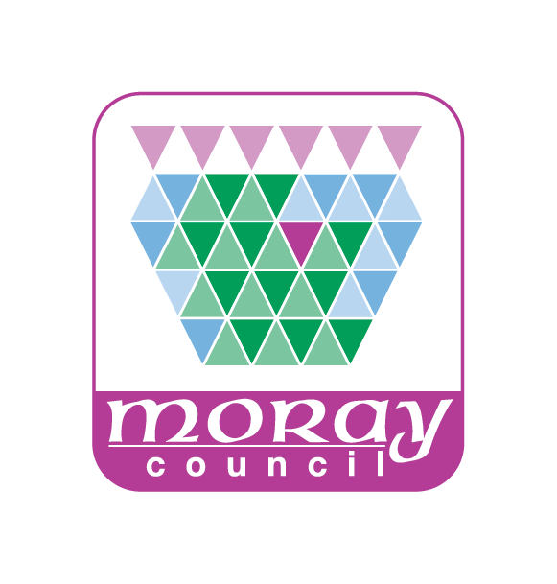
PRIVACY NOTICE
Household Waste Recycling Centres – Booking Visits
How we use your information
As part of booking visits to Council-run recycling centres, your personal information is required as follows:
- Your name, address and vehicle registration number are required to verify your identity upon visiting the site and to ensure that members of the public visit no more than once every two weeks.
- Your phone number and email address are required in order to contact you about matters relating to your appointment (for example, to notify you if the site needs to close at short notice).
Our legal basis
Whenever the Council processes personal data we need to make sure we have a legal basis for doing so. We understand the Council’s basis in data protection law to be Article 6(1)(e) of the General Data Protection Regulation (GDPR) as your personal data is necessary for the performance of a task carried out in the public interest (ensuring the fair use of recycling centres).
Who we share your information with
Your personal data may be shared internally with authorised officers of the Council if having access to personal data is a necessary part of their roles to ensure records are accurate and up to date which improves the standard of the services we deliver. It may also be shared with other relevant Council departments where applicable.
The Council may also share your personal data with other relevant Council departments and third parties, where we are under a legal obligation to do so. For example this may be with Police, UK Border Agency or other Registered Professional Bodies.
The Council is required by law to protect public funds against fraud. It may share personal data with other relevant Council departments and third parties responsible for auditing and administering public funds, or who otherwise have responsibility for preventing and detecting fraud.
How long the information is held for
Your personal data will not be held by Moray Council for any longer than is necessary to carry out the purposes for which it has been collected or to meet any other legal obligations. You can find all the information about how long we retain personal data for on our website:
http://www.moray.gov.uk/moray_standard/page_92820.html (found on the Moray Council website under Section 5 of the Records Management Plan)

Your rights
Moray Council is the Data Controller for this personal data. You have legal rights about the way the Council handles and uses your personal data. These include the right to ask for a copy of it, to ask us to correct it and to ask us to stop doing something with your personal data. For more information about these rights please contact the Council’s Data Protection Officer at info@moray.gov.uk or 01343 562633.
As so far as the legislation permits, you also have the right to request the deletion of your data and to object to the processing.
You also have the right to make a complaint to the Information Commissioner’s Office. They are the body responsible for making sure organisations like the Council handle your personal data lawfully.
Information Commissioner’s Office
Wycliffe House, Water Lane, Wilmslow, Cheshire, SK9 5AF
Telephone: 0303 123 1113
Email: casework@ico.gov.uk
Website: www.ico.org.uk

