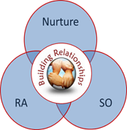

Emotion Coaching
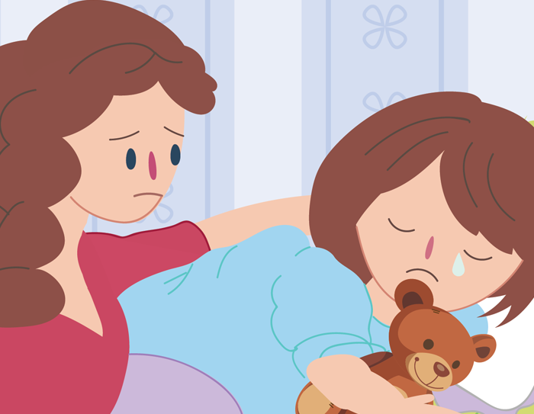
Emotion Coaching is a way we can respond to our children in the moment to support their ability to manage their emotions. This leaflet can be useful on its own and also supplements online training provided by Moray Council Educational Psychology and SEBN Services.

What is it?
- The ability to effectively manage and respond to emotional experiences
- Being aware of our feelings and acting in a suitable way
- In school, children need to be able to self-regulate to help them be ready to learn.
- A vital skill in the human world

Why is it important?
- To help children identify how they are feeling
- To learn (and teach) effective responses known as self-regulation strategies
- To teach children that there are no ‘bad’ emotions, but to recognise whether their emotional response is appropriate to the situation
- Emotion coaching conveys love and support to your child. Research tells us that children who benefit from this become more successful socially, academically and behaviourally
What happens when children cannot self-regulate?
- Tantrums and outbursts
- Abusive behaviours (e.g. punching , kicking biting)
- Emotional distress
- Inattention /distractibility
- Refusal to participate

What can I do?
- All children learn about their emotions from their parents. Comforting, listening to and understanding their thoughts, behaviours and feelings will help them understand themselves. Remember you are your child’s first teacher - model talking about feelings and respond openly to the emotions you see in your child, help them problem solve
- Talk to your child about how they are feeling, help them name the emotion
- Talk about their body cues when they feel that emotion (e.g. you are crying, are you sad?)
- Notice when your child uses a strategy and praise them for it
- Emotion Coaching can provide a structured way to support your child in a difficult moment and to develop the skill of regulating their emotions to help throughout their lives.
- Emotion coaching gets easier the more you do it
So what is Emotion Coaching?
- Teaching your child about the world of emotion ‘in the moment’
- Giving your child strategies to deal with ups and downs
- Accepting negative emotions as normal
- Using moments of negative behaviour as opportunities for teaching
- Building trusting and respectful relationships with your child

What do I need to do?
- Be aware of child’s responses, making sure to be interested in the emotions we see rather than to judge them – be curious, not furious
- Recognise emotional times as opportunities for intimacy and teaching
- Listen empathetically and validate child’s feelings
- Help child to verbally label emotions – helps sooth the nervous system and promote recovery rate
- Set limits while helping child to problem solve

What about my experiences?
Adults can respond to emotions in a range of ways and that’s OK. Let us think about the styles that you experienced when you were a child.
- How did adults respond to your feelings of anger, sadness and fear?
- What did this make you think about these emotions?
- What did you learn about how to deal with these emotions?
- How do you think your own experiences are shown in your parenting?
Styles of Managing Emotions
There are 4 main styles, you may identify having experiences of any of these. Often we will have a default style which we tend to use most often.

Effects of Emotion Disapproving and Dismissing Style
- Child learns ‘what I am feeling is not right, my assessment of the problem is wrong, I must not feel this way’
- Child does not learn to trust own feelings affecting decision making
- Not given opportunities to experience emotions and deal with them effectively so grow up unprepared for life’s challenges
- Not given opportunities to self-regulate or problem-solve
- Can lead to suppression of natural emotions, less or lack of self-regulation, reliance on distraction to get rid of emotion
- Generates more negative feelings – resentment, guilt, shame, anger
Effects of Laissez-Faire Style
- Child does not learn how to calm down when angry or upset
- Not given opportunities to develop coping skills when they are in stressful situations
- Find it difficult to concentrate and learn new skills
- Have difficulty picking up on social cues, so they find it harder to make and keep friends

A little about our brain
- Make a fist with your hand – our brain has an upstairs and downstairs part. The upstairs part is your fingers – it helps have think and make good choices and stay calm. Upstairs takes care of planning, creating, calming, problem solving, flexibility and empathy, reflection and our attention and memory
- Your thumb is the downstairs part – it holds onto all our big feelings. When we feel big emotions our upstairs brain helps to keep our downstairs brain calm.
- If we get really upset we flip our lids (raise your fingers) so the upstairs brain can no longer help to calm the downstairs brain as they are not connected
- When this happens our flight, fight and freeze responses can start and we can not be reasoned with – our behaviours can be big – don’t ask what and why questions now
- As grown ups we want to help our children to keep upstairs connected to downstairs and stop the big feelings taking over the thinking

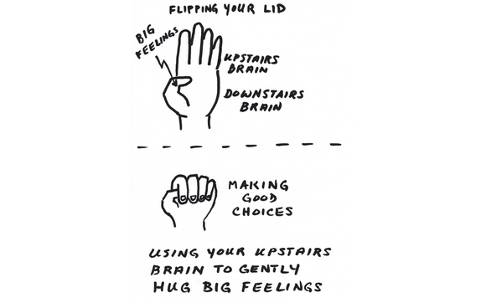

How do I do emotion coaching?
- Step 1 – Get ready to connect
  - “CONNECT BEFORE CORRECT” - proposing solutions before empathising is like trying to build a frame of a house before you lay a firm foundation
  - Make sure you are in the frame of mind to model calm warmth, if not see if you can take a breath and carry on, or decide if this is not the best time for you and if not take a step back this time – you don’t need to emotion coach every time, just over half the time is fine
  - Check your tone of voice, facial expression and body language to be calm clear and open

- Step 2 – Label the feelings
  - Feelings are not the problem
  - Recognise behaviour as communication
  - Look for physical and verbal signs of the emotion being felt
  - Help the child by naming their feelings at the time
Label: ‘I looks like you are feeling annoyed’

- Step 3 – Validate the feelings
  - Recognise all emotions as being natural
  - Take on the child's perspective
  - Affirming and empathising allows the child to calm down – “name it to tame it”
  - This doesn’t mean agreeing with a child’s behaviour, you may not act the same way in the same situation. It’s about putting yourself in child’s shoes to let them know you can see why they might have done what they have done
  - Provide a narrative for why they might be feeling that way
Validate: ‘It’s understandable to feel that way, I think I would too if someone had said those things to me’

- Step 4 – Setting limits on behaviour (if required)
  - Emotional safety creates a safe haven , a place of respect, acceptance , a sense of self- this in turn leads to children giving back respect and accepting boundaries
  - Provide clear guidance for your child, letting them know what they can do instead
  - Carful use of language – ‘and you can’ lets them know that you have confidence in them, that they can do it
Setting limits: ‘and you can still keep your hands to yourself and ask an adult for help’

- Step 5 – Problem solving with your child

  - May come much later and only when your child has really had the chance to calm down and feel ok
  - May not be needed Some situations are one off and unlikely to happen again or the child responded well to the limit that was set at the time
  - What is the problem? After following through on any consequences find out what the goal was your child was trying to reach with the behaviour. What did you need?
  - What could I do? Ask your child to come up with several possible solutions to the problem / they may need some support or choices
  - What are the likely consequences/outcomes for each possibility? Consider what might happen for each solution. Help your child by asking them is this fair, will this work, is it safe? How are you likely to feel/ how are others likely to feel?
  - Pick the best solution If your comes up with an unworkable solution it’s okay to go forward with it as long as it’s harmless. Leave the door open to rework the solution if it doesn’t seem to be working. You can help your child to come up this plan.
  - Do it
  - Did it work? Thinking about what went well and what you might do differently next time.
Examples:
‘Could you think of a different thing you could do?’(this helps your child consider a different way of doing things)
‘I can share the pot of crayons’ …. ‘That would be very nice’ (this supports future decisions)
‘What do you think would happen if you did share the pot of crayons?’ (helps imagine what that will be like)
‘that sound’s like a really kind idea, what might you need to say or do to make sure you both get to use the favourite colours?’ (helps anticipate and plan for any difficulties that might arise in the plan)
‘I notice you put the crayons in the middle of the table to make sharing easier – how did that go for you?’

Putting Emotion Coaching into practice
Example 1: You have been at the park with your child and it is time to go home – they stomp off to the bench, fold their arms over their chest and pout.
What could be done if we use an emotional coaching approach?
Firstly we would want to acknowledge their feelings…
For example we might say:
‘I can see you are disappointed/ upset/ sad/ angry that our fun time in the park is ending’
Then we can help them feel understood……
For example we might say:
‘I feel sad leaving places I enjoy too’
Then we support them to manage their behaviour while feeling this emotion
‘And you can still walk home with mummy’

Now try these:
Example 2: Your child wants to watch their favourite TV show and it is time to go do the shopping. They grab for the remote you are holding and when asked to put on their shoes continue grabbing.
Example 3: Your child is playing cars and another child has their favourite one. They take the road map away.
Example 4: You are dropping your child off at nursery and they cling to your leg crying saying ‘no, don’t go’.
Some starter phrases
Recognising emotions:
- I can see you feel…
- You must feel…
- It looks to me that you feel...
- I can see you are crying/ kicking/ etc I think you are telling me you feel…
- Am I right in thinking you are feeling… ?
Validating feelings: (remember your child’s feelings are real for them)
- I’d feel the same way.
- I’d feel like that if …
- I understand why you feel…
- It’s OK to feel …
- If natural to feel like that if...
Moving on:
AND you can still feel x and do y
And you can still do Y
The 5 Steps Of Emotion Coaching
Recap

