ONLINE BOOKINGS FOR SPORTS & LEISURE FACILITIES
In order to access the booking system to make on-line bookings please note the following instructions:
Log onto the Moray Council website and specifically the Sport and Leisure section where you will find the log in and online booking instructions and links www.moray.gov.uk/leisurebookings
Please note if you have an existing login (your e-mail and password) you do not need to create another login and the instructions below can be ignored.

For Fitlife Members - please watch the short video clip which will instruct you through the process of linking an online login to your existing Fitlife Membership record (if you have not already done so).
You will be required to:
• Enter your email address, leave the password field empty and select
‘Forgotten your password?’ option.
• You will be asked to re-enter your email address. If you have linked members on your subscription you will be asked to enter the card ID for the account you are creating a login for.
• The card ID is located on the reverse of your Fit-life Card and begins with ‘MC……..’
• You will then receive an email with a link to follow to create a password to finish the process. During this process you will be asked for your Member ID which will be detailed in the email that you receive.
• If you are creating online logins for multiple family members please set each one with different passwords.

For ‘Pay as you go’ members - please select the ‘Don’t have an account?’ option at the bottom of the online booking page to create a new record. Once setup with a new member record you will be able to make bookings online and make payment.

Thank you – if you have any difficulty with the above instructions please e-mail sportandleisure@moray.gov.uk for assistance.

Please find below a ‘How to Guide’ in relation to making an actual online booking (for both Fit Life Members and Pay As You Go customers).

Online Booking System – Quick Step Guide to making a successful booking.

Once logged into: https://secure.moray.gov.uk/LeisureBookings/mrmlogin.aspx

- On initial login, you will be asked to choose a default site > Please select the site you use most frequently. This site will then always show at the top of the ‘What’s on at’ list, see screenshot below. You will however be able to select other sites and make bookings at other sites too.

To search for available bookable sessions please follow the steps outlined below:
- Choose the facility/site from the dropdown list that you wish to attend.
- Select the date field, this will then open a small calendar for you to pick your preferred day.
- Select the Search button. See Screenshot below.
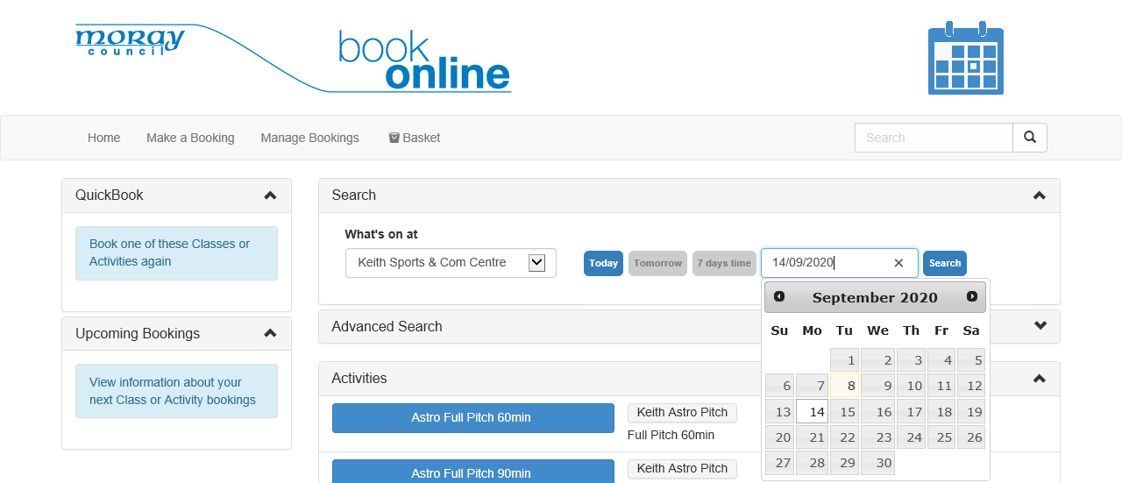

- The list of bookable sessions for your chosen date will appear under a heading called Classes.
- Swim sessions will appear at the top of the top of the list in time order with Gym Sessions following. Please see screenshot below:
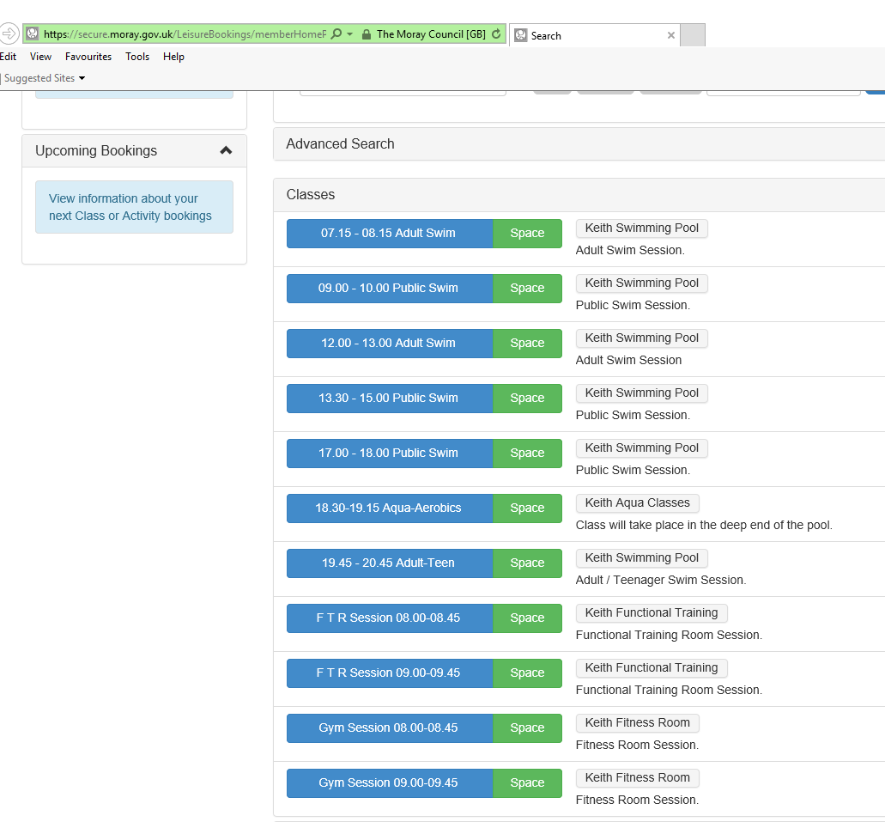

To book a session:
- Select the desired session button, coloured blue.
- You will then be taken to the following screen to complete the booking process:
- Double check that the time of the session is correct.
- Select the Green Book button.

- For Fitlife Members please go to Page 4 for further guidance.
- For Pay As You Go Members please go to Page 5 for further guidance.

At this point if you are a Fitlife Member you will be presented with the following screen:
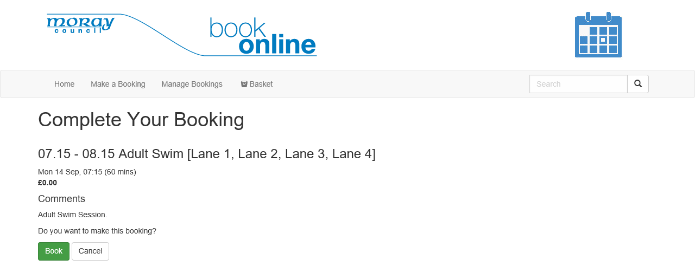

- You will notice that the price is set to £0.00 for the session as your login is correctly linked to your active Fitlife Subscription.
- Select the Green Book button to proceed.
- Your booking will then be complete see screenshot below.

At this point if you are a Pay As You Go Member you will be presented with the following screen:

- You will notice that there is a cost attached to the session.
- Select the Green Book & Checkout button to proceed.
- You will then be taken to Your Basket see screenshot below:
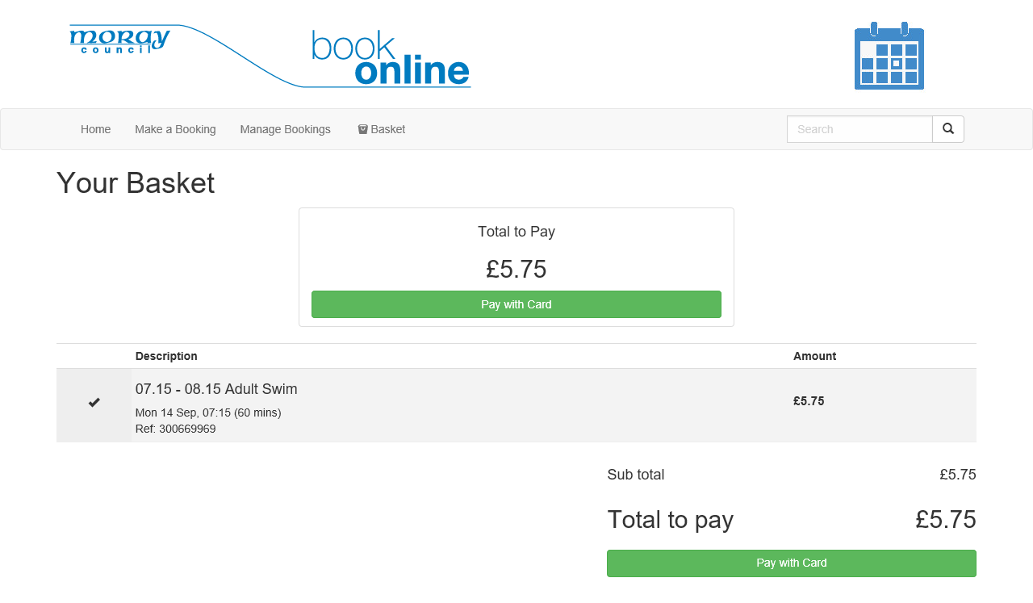

- Select the Green Pay with Card button. This will launch Moray Council’s Capita Payment system to enable you to process the payment for your booking.

- Once complete you will receive an email confirmation.

