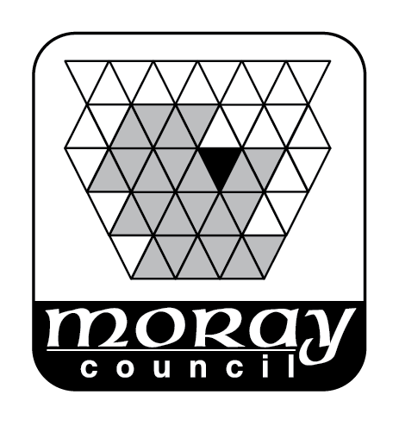

REPORT TO: THE MORAY LICENSING BOARD 2 DECEMBER 2020

SUBJECT: LICENSING (SCOTLAND) ACT 2005 - ANNUAL FUNTIONS REPORT

BY: CLERK TO THE BOARD

1. REASON FOR REPORT

  - This report is to seek approval to publish the draft functions report which incorporates a report from the Licensing Standards Officer.

- RECOMMENDATION

  - It is recommended that the Board:-

- note the draft annual functions report at Appendix 1, amend the same if the Board considers appropriate and agree the final report; and

- instruct the Clerk to publish the agree final report on the Board’s web pages.

- BACKGROUND

  - The Air Weapons and Licensing (Scotland) Act 2015 amended the Licensing (Scotland) Act 2005 (“the Act”) so as to require each Licensing Board to prepare and publish an annual report, within 3 months after the end of each financial year, on the following:

    - A statement as to how the Board has had regard to the licensing objectives and their statement of policy in exercising functions under the Act;
    - A summary of the decisions made;
    - Information about the number of licences held including the number of occasional licences issued; and
    - Such other information as the Board considers appropriate.

  - Following the introduction of the requirement to produce an annual functions report in 2018, the Board is invited to consider the draft report which has been produced for approval and is attached at Appendix 1.

  - The normal deadline for publication would be the end of June each year. This year’s report has been delayed by the COVID outbreak.

- SUMMARY OF IMPLICATIONS

- Corporate Plan and 10 Year Plan (Local Outcomes Improvement Plan (LOIP))
The provisions of alcohol licensing directly relate to the priorities within the 10 Year Plan in relation to healthier citizens, a growing and diverse economy and safer communities. Alcohol and alcohol dependency influence the health of the population. The alcohol industry in terms of production, retail and the positive effects on tourism all aid a growing economy. Regulation of the sale of alcohol contributes to a safer community.

- Policy and Legal
Policy and Legal implications have been explained above.

- Financial implications
None identified.

- Risk Implications
None identified. It is a legal requirement to publish the report. There is no stated action for failure to do so therefore any failure would be open to challenge by judicial review.

- Staffing Implications
Preparation of statistics involves considerable staff time and they are required annually buy statistics are also useful for other purposes e.g. the annual return to the Scottish Government. No additional resources are required.

- Property
None.

- Equalities/Socio Economic Impact
In considering individual decisions the Board should have regard to issues of equality and the subject’s (licence holders) rights under the European Convention on Human Rights (and the Human Rights Act 1998). It is not considered necessary to undertake an equalities and human rights impact assessment in connection with this report.

- Consultations
None.

5. CONCLUSION

  - It is proposed that the Board note the contents of this report and agree to publish the report.

Author of Report: Sean Hoath, Senior Solicitor, Depute Clerk to the Board
Background Papers:
Ref: SH

