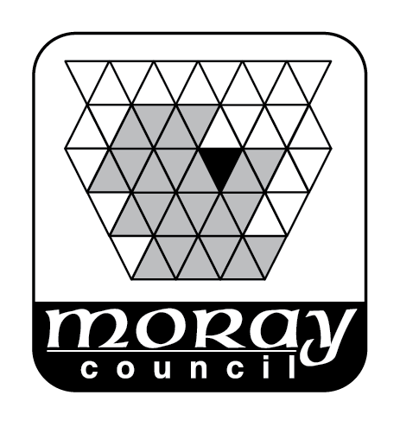

REPORT TO: THE MORAY LICENSING COMMITTEE 2 DECEMBER 2020

SUBJECT: CIVIC GOVERNMENT (SCOTLAND) ACT 1982-ANNUAL FUNTIONS REPORT

BY: DEPUTE CHIEF EXECUTIVE (EDUCATION, COMMUNITIES AND ORGANISATIONAL DEVELOPMENT)

1. REASON FOR REPORT

  - This report is to seek approval to publish the draft functions report which incorporates a report from the Licensing Standards Officer.

  - This report is submitted to the Committee in terms of Section III (H) (1) of the Council's Scheme of Administration relating to the exercise of the function of the Council as licensing authority for The Moray Council area.

- RECOMMENDATION

It is recommended that the Committee:-

  - Note the draft annual functions report at Appendix 1, amend the same if the Committee considers appropriate and agree the final report;

- BACKGROUND

It is mandatory that the Licencing Board produces an annual functions report. It was therefore though appropriate, for transparency and information, that an Annual functions report also be produced for the Licencing Committee. A draft has therefore been produced so as to include the following;

    - A statement as to how the Committee has had regard to the licensing legislative requirements in exercising functions under the Act;
    - A summary of the decisions made;

  - The draft report is produced at Appendix 1 for noting and for approval.

  - The normal deadline for publication of the Licenisng Board’s report is the 30 June 2019.end of June each year and it is intended that the report to the Licensing Committee will, as far as possible, follow the same schedule.

- SUMMARY OF IMPLICATIONS

- Corporate Plan and 10 Year Plan (Local Outcomes Improvement Plan (LOIP))

The provisions of alcohol licensing directly relate to the priorities within the 10 Year Plan in relation to healthier citizens, a growing and diverse economy and safer communities. Alcohol and alcohol dependency influence the health of the population. The alcohol industry in terms of production, retail and the positive effects on tourism all aid a growing economy. Regulation of the sale of alcohol contributes to a safer community.

- Policy and Legal

Policy and Legal implications have been explained above.

- Financial implications

None identified.

- Risk Implications

None identified. It is a legal requirement to publish the report. There is no stated action for failure to do so therefore any failure would be open to challenge by judicial review.

- Staffing Implications
Preparation of statistics involves considerable staff time and they are required annually buy statistics are also useful for other purposes e.g. the annual return to the Scottish Government. No additional resources are required.

- Property

None.

- Equalities/Socio Economic Impact

In considering individual decisions the Committee should have regard to issues of equality and the subject’s (licence holders) rights under the European Convention on Human Rights (and the Human Rights Act 1998). It is not considered necessary to undertake an equalities and human rights impact assessment in connection with this report.

- Consultations

None.

5. CONCLUSION

  - It is proposed that the Committee note the contents of this report and agree to publish the report.

Author of Report: Sean Hoath, Senior Solicitor
Background Papers:
Ref: SH

Signature:
Designation: Head of Governance, Strategy and Performance
Name: Alasdair McEachan

