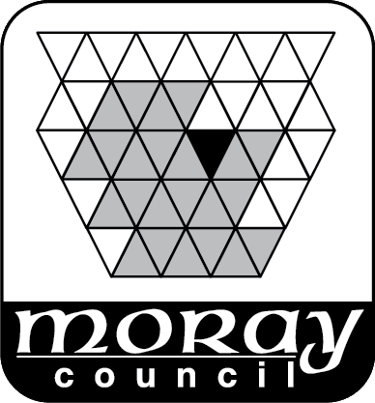 | ENVIRONMENTAL SERVICES  DIRECT SERVICES – TRANSPORTATION

List of Contractors Accredited to work on Moray Council Roads

Name Of Contractor | Contact Telephone No
Aaron’s Groundworks | 07884 497545
Ashfield Ground Works | 01343 544269/07765 197548
Breedon Aggregates Ltd | 01343 862130/07920 209169
Chap Construction (Aberdeen) Ltd | 01224 748500
GD Construction | 07760 176688
Highland Surfacing & Contracting Ltd | 01463 224456/07456 663703
Hunter Construction (Aberdeen) Ltd | 01467 627290/07836 639553
Charles A Innes & Sons Ltd | 01542 882870/07831 096458
Kerr-Nugent Ltd | 07598 720061
Leiths (Scotland) Ltd | 01309 671144/07771 557847
Brian Love | 07876 777027
Mark McAllister Groundworks Ltd | 01542 887830/07884 334978
Billy Miller Contractor & Plant Hire | 01343 547973/07967 010231
WD Mitchell | 07730 335345/01340 871408
Moray Council Roads Maintenance | 0300 1234565
Moycroft Contracting Limited | 01343 551056/07786 391559
Pat Munro | 01349 882377
Nicol of Skene Ltd | 01224 744473/07736 615502
Grant Nicolson & Co | 01309 611246/07778 804942
JS & R Rattray & Son | 01340 810454/07836 656602
Andy Reid Contractor | 01343 546564/07798 633564
Seivwright Bros Ltd | 01466 711316/07703 336256
Colin Smith Contractor | 01466 751347/07786 937413
D & M Smith Contractors | 01343 820588/07765 040142
Chris Spence Plant Hire | 01542 886536/07788 542154
Tulloch of Cummingston | 01343 835600/07539 350951
Alistair Young & Son | 01343 820598/07778 037729

