E N V I R O N M E N T A L AND COMMERCIAL S E R V I C E S
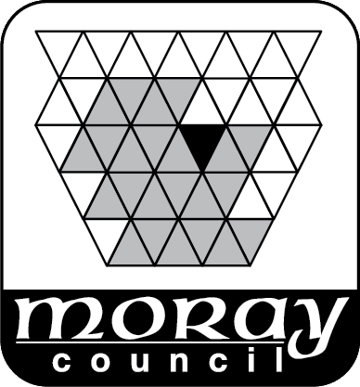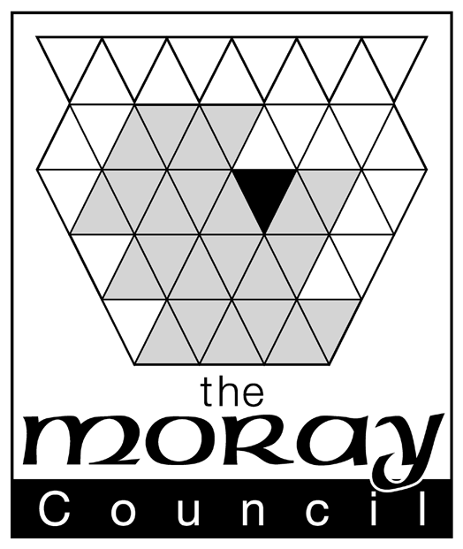

TRANSPORTATION

APPLICATION FOR PERMISSION
TO ERECT TEMPORARY ROADSIDE SIGNAGE/SIGNS

Signs and locations must be approved in writing by the Traffic Section of Moray Council. This application is restricted to signage within the road boundary, i.e the carriageway plus footways and roadside verges. Signs outwith the boundary are dealt with by the Planning Service. This policy is also restricted to roads within the control of The Moray Council as local roads authority, that is, it does not apply to private, unadopted or trunk roads (i.e the A95 between Keith and the boundary with Highland Council or the A96)

The Moray Council has expressed a desire to cater for the needs of local people who are organising and running events for the local community and the policy (which is available from the Transportation Section of the Moray Council or on the website) attempts to fulfil that desire whilst explaining where and when signs will NOT be authorised.

Applicant Details

Name:………………………………………………… Constituted Community Group………………………………………………………. Address: ……………………………………………………………………………
……………………………………………………………………………

……………………………………………………………………….…. Post Code ……………..
Contact Telephone No…………………………….(Day) ……………………..(Night) FAX No………………………………..
Email Address………………………………..

Application Details for SIGNS IN ROADSIDE VERGES

Road Name: (& town/village)...............................................................................................
Site Location: …………………………………………………………………………….

(Please return a plan with details)

Date of Event: …………………………Duration of Event:………………………………
For the purpose of: (Indicate as appropriate ./ )
D Community Event
D Charity Event
D Fundraising Event
D Other

Give full details ……………………………………………………………………………

Size of Sign…………………….mm wide…………mm high.
(The maximum size of sign should be A3 and the minimum letter height shall be 50mm)
Is this a recurring Event? (Indicate as appropriate ./ )
D No – Complete Application
D Yes – (Max 5 yrs)*

* Frequency? …………….
How long do you wish permission for? (Max 5 yrs)…………………………………
I/We agree to the conditions overleaf and to the General Conditions of Permission.

Signature of Applicant or Agent .................................................... Date ………..........

For Office Use Only

Approved By……………………………………… Date…………………………
Application No …………….……………………..

NOTES FOR GUIDANCE OF APPLICANT

1. The completed form should be submitted:

• By Post to: Transportation Manager, The Moray Council, P.O. Box 6760 Elgin, IV30 9BX
• By E Mail to : roadspermits@moray.gov.uk

2. FOR ROAD SIGNAGE AT LEAST 5 WORKING DAYS NOTICE IS REQUIRED
PRIOR TO PERMISSION BEING GIVEN.

3. For the purposes of the Act, the definition of "road" includes footway and verge.

4. Contact details should be provided on the back of all authorised signs.

5. Organisers of recurring events may request approval for up to 5 years at a time.

6. The General Conditions of Permission are available on the Council’s website.

7. This permission does not warrant the approved signs as safe. The responsibility for safety of the signs, including erection and removal, lies with the applicant.

8. Indemnity The applicant shall indemnify The Moray Council as Roads Authority for and against all actions, claims, demands, costs, charges, damages, losses and expenses of whatsoever kind or nature which may be brought or made against them or incurred by them in respect of the negligence, omission or default of the holder of this permission or those for whom the holder of this permission is responsible arising in respect of any operations authorised by this permission unless due to the negligence or other breach of legal duty on the part of the Council or of any person for whom the Council are responsible.

9. No sign should emulate or attempt to copy a recognised traffic sign.

10. No signs shall be fixed to any street furniture, including lighting columns or traffic signs.

11. Notwithstanding the above, The Moray Council retains the right to remove any sign or object, under any circumstances if it is felt to be unsuitable or dangerous.

12. No signs shall be permitted for commercial activities such as hotels, restaurants, commercial sales or any other profit making activity

13. Any organisation erecting signs in the verge will be responsible for any detriment or damage that the signs may cause any other road user and for the safety of members/staff/volunteers while they are erecting or removing the signs.

14. Community event signs will be permitted no more than 7 days before an event takes place and must be removed as soon as practicable, but no more than 3 days after the event.

15. No signs will be allowed at junctions or in the first 50 metres when exiting a junction.

16. Signs will not be permitted on the approach to a junction within 100 metres on A or B
class roads or within 50 metres on a C class or unclassified road.

17. The maximum height of any sign above the verge level (ie to the top of the sign) shall be
750mm and the minimum clearance from the edge of the carriageway to the nearest edge of the sign shall be 600mm.

18. The maximum size of sign should be A3 and the minimum letter size should be 50mm.
Larger signs may be considered in exceptional circumstances if appropriate.

19. Larger events will generate significant amounts of traffic and visitors could qualify for temporary direction signs and therefore verge-type signs would not be appropriate.

