Looking toward Forres Academy from Burdshaugh

Now:

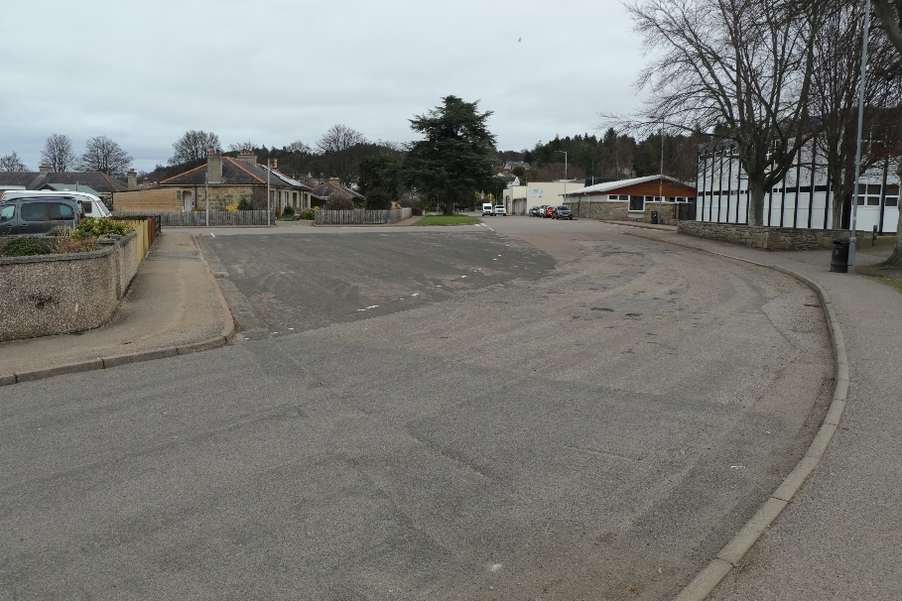

After:

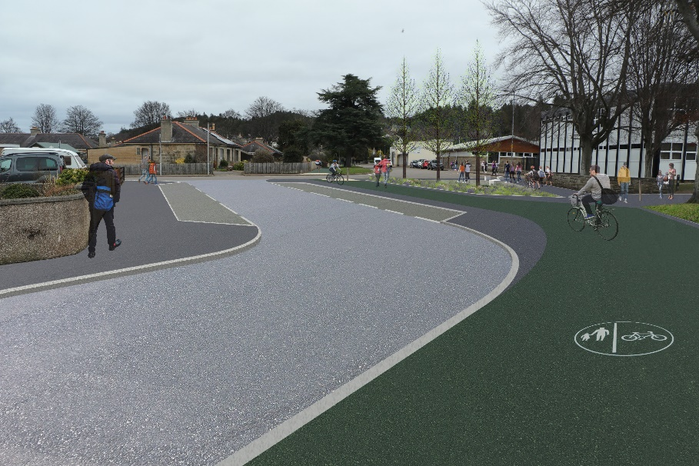

|  |  |
| --- | --- |
| **Forres – Sustrans Places for Everyone – Forres Academy, Roysvale and Burdshaugh** | A4 |

A number of different studies (Forres 2020 Vision; Forres Active Travel Audit (Feb 2012); Moray Council Active Travel Route Feasibility Study for Forres (March 2019) and Moray Local Development Plan 2020) have identified routes around Forres which would enhance the active travel network. This scheme was identified by analysing where people are walking and cycling from to get to the schools in Forres.

The footbridge across the Burn of Mosset was replaced by Springfield Properties in early 2020, as part of their planning obligations to provide a suitable link to Forres Academy from the houses on the south of Forres. An opportunity arose for the Council to further enhance the route to Forres Academy and Applegrove School through a funding application to Sustrans. Also, when we were building the cycletrack along Sanquhar Road beside Applegrove Primary School and through Roysvale Park to Forres Academy, there were a number of requests to upgrade the path from Applegrove to Roysvale Terrace and the Tennis court path. As a result of these request and with the connection to Fleurs Place we are proposing to build the following paths.

The proposed scheme will

* Widen the path along Burdshaugh from the new bridge towards Forres Academy. This will provide a path for both people walking and cycling
* Narrow the road at the end of the bridge, to allow drivers on Burdshaugh a view of cyclists coming from the bridge.
* Widen and improve the drainage on the path along the boundary of Applegrove School, from Sanquhar Road to Roysvale Terrace. This will be built away from the trees and will not damage them.
* Improve the crossing on Castle Street where the path from Roysvale Terrace crosses it.
* Widen the pavement and provide a cycletrack in front of Forres Academy on Burdshaugh, meaning that the main road will be Burdsyard Road into Castle Street with Burdshaugh being narrowed and parking bays provided outside the houses.
* Widen the path outside the 4 houses opposite the Academy on Burdsyard Road and join to the path already widened on Sanquhar Road, to allow people to cycle and walk on it.
* We are also seeking ideas on what you would like Burdshaugh to look like as it has few pavements between Sharpes Place and Orchard Road.

Feedback on this scheme would be welcomed **by 5pm on Monday 10th May 2021**

### Below are some photos showing what we are proposing.

Looking from Forres Academy towards new bridge

Now:

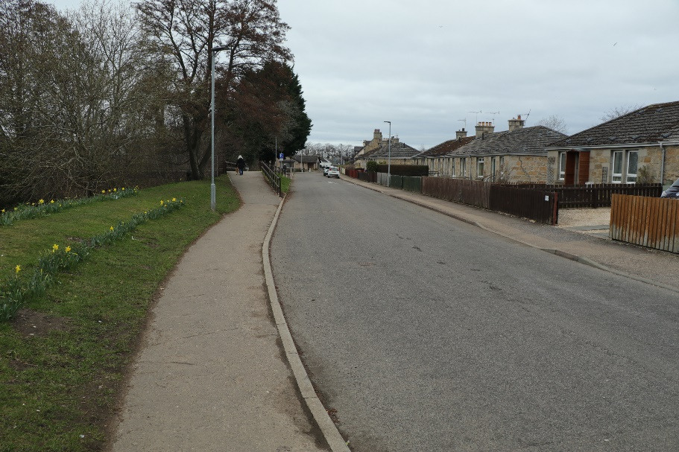

After:

