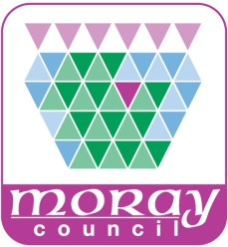 | COMMUNITY GROUP  ENQUIRY FORM
 | Please complete this form if you intend to carry out any community development works/projects to enable Development Management to give you guidance on what needs consent and if is likely to be acceptable.

Send the completed form to
Development Management, Environmental Services, Council Offices, High
Street Elgin, Moray IV30 1BX

Or E-mail: - Development.control@moray.gov.uk

Name of Community Group
Contact Name

Address
Telephone Number
Mobile Number

Email address

Address of development/site
Grid Reference of site | E |  | N
Is the property | Within a Conservation area |  |  | Listed building – category
Please provide a description of proposal and reason it would benefit the community
Please provide detailed plans showing the following information where relevant:
- A site location plan to a scale of 1:500 with the boundary of the proposal site outlined in red
- Sketch details of your proposal would be of assistance when considering your proposals
If you have any queries regarding eh completion of this form please contact Teresa Ruggeri, Planning Technical Assistant on 01343 563270 or email Teresa.ruggeri@moray.gov.uk

