SUSTAINABLE TRAVEL EVENTS CALENDAR 2024 – National Events

11th – 22nd March 2024 – The Sustrans Big Walk and Wheel
The UK’s biggest cycle and scoot to school event, by Sustrans to encourage children to cycle to and from school. Schools across the country compete to see who can earn the most points by cycling to school.
Find out more at www.sustrans.org.uk/our-blog/projects/uk-wide/schools/sustrans-big-walk-and-wheel

22nd April 2024 - Earth Day 2024
Earth Day Network is a non-profit organization whose mission is to diversify, educate and activate the environmental movement worldwide. More than 1 billion people now participate in Earth Day activities each year, making it the largest civic observance in the world. Earth Day Network works through a combination of education, public policy, and consumer campaigns.
Find out more at www.earthday.org

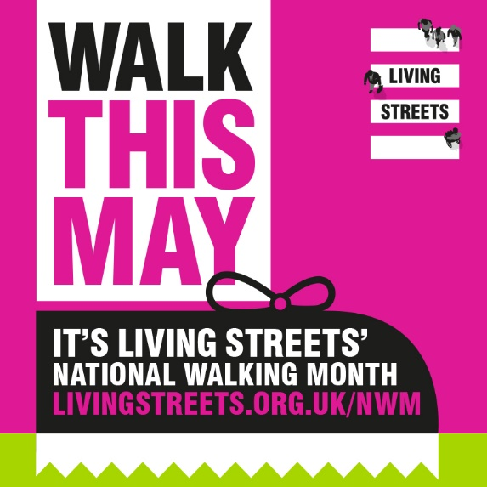
1st - 31st May 2024 - National Walking Month 2024
Awareness raising month aimed at promoting the benefits of walking.
Find out more at www.livingstreets.org.uk

29th April 2024 (for 8 weeks) - Paths for All Spring Step Count Challenge
Walk the walk. Find out more at www.stepcount.org.uk

20th – 24th May 2024 - Walk to School Week
Awareness raising week aimed at promoting the benefits of walking to school.
Find out www.livingstreets.org.uk/what-we-do/projects/walk-to-school-week

5th June 2024 - World Environment Day
A global day for positive, environmental action and to encourage support for sustainable development. Find out more at www.worldenvironmentday.global/

8th – 16th June 2024 - Great Big Green Week
A national week of events celebrating action on climate change. In September communities across the country will join together for the Great Big Green Week. It will be the biggest event for climate and nature ever in the UK, and everyone’s invited!
Find out more at www.greatbiggreenweek.com/about/

10th – 16th June 2024 – Bike Week
Bike Week, delivered by Cycling UK, is an annual celebration to showcase cycling. Thousands of people all over the UK enjoy the simple pleasure of riding a bike.
Find out more at www.bikeweek.org.uk
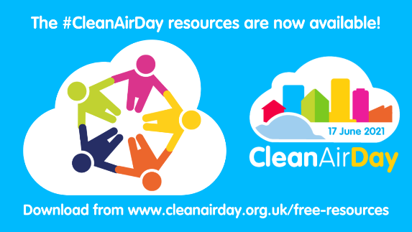
20th June 2024 - Clean Air Day 2024
Led by Global Action Plan, Clean Air Day brings together communities, businesses, schools and the health sector to improve public understanding of air pollution, build awareness of how air pollution affects our health and explain the easy actions we can all do to tackle air pollution, helping to protect the environment and our health. Find out more at www.cleanairday.org.uk

1st August 2024 – Cycle to Work Day 2024
Cycle to Work Day will be back on 1st August. This year, it’s all about giving your employees that Love to Ride feeling from now until the big day…
How can my employees take part? Via our free online Love to Ride community, where employees can share their experiences of trying a different commute, and upload their cycle rides for a chance of winning from our bumper haul of prizes. We’re running seven weeks of cycling challenges. So that’s seven separate opportunities for your employees to win. Find out more at www.cycletoworkday.org/

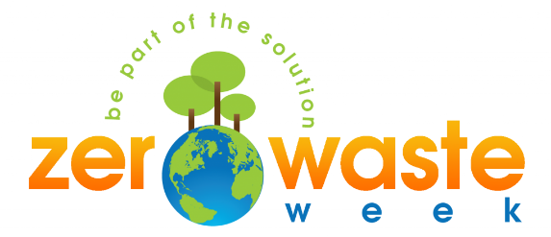
2nd – 6th September 2024 - Zero Waste Week
Zero Waste Week is an award-winning campaign, raising awareness about the environmental impact of waste. Whether you’re an individual, business or organisation, join in and reduce the amount you send to landfill.
Find out more at www.zerowasteweek.co.uk/zero-waste-week/

23rd – 29th September 2024 - Scotland's Climate Week 2024
Details TBC.
Find out more here about the events taking place or visit www.greenerscotland.org

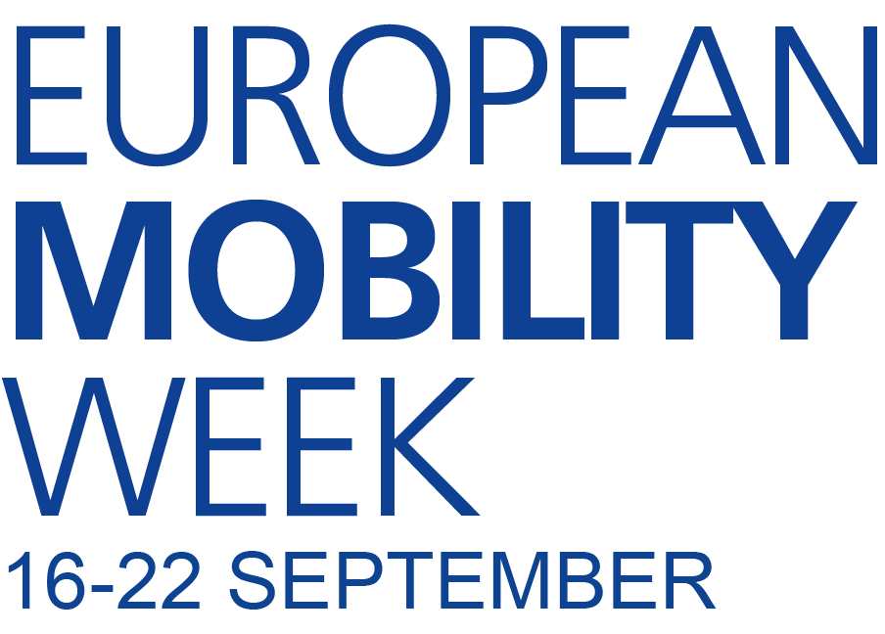

16th – 22nd September 2024 - European Mobility Week
This is a European festival promoting environmentally sensitive transport and raising awareness of the nuisances causes by the use of private cars in the city (Air, noise pollution, congestion etc). Good opportunity to promote active travel and public transport usage.
Find out more at www.mobilityweek.eu/home/

1-30 September 2024 - Love to Ride for Cycle September
Cycle September is the ideal time to engage businesses and their employees to try cycling for active travel! Signup at lovetoride.net

TBC October 2024 - National Liftshare Week
Encouraging people to join the liftshare network in order to save money cut their carbon footprint and meet like-minded people.
Find out more at www.liftshare.com/liftshareweek

Whole of October 2024- International Walk to School Month
Month long awareness raising event where schools across the world join forces to promote walking to school.
Find out more at www.livingstreets.org.uk/walk-with-us/walk- to-school

4th November – 1st December 2024 - Paths for All Step Count Autumn Challenge 2024
It all begins in October so sign up your team of five today and join us. Find out more at www.stepcount.org.uk

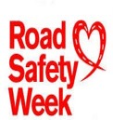

18th – 24th November 2024 - UK Road Safety Week
An annual community event aimed at inspiring people to promote road safety within their local community.
Find out more at www.roadsafetyweek.org.uk

