Appendix I
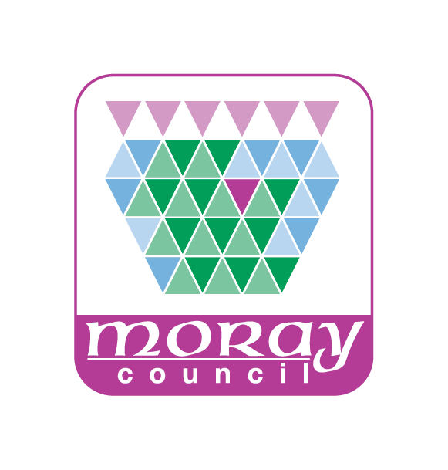

PUBLIC NOTICE OF APPLICATION FOR SHORT-TERM LETS LICENCE
THE CIVIC GOVERNMENT (SCOTLAND) ACT 1982 (LICENSING OF SHORT-TERM LETS) ORDER 2022

New application
Applicant name:
Applicant's address:
Postcode:
Has applied to Moray Council (as Licensing Authority) for a Short-term lets licence.
Short-term let premises address (if different from applicant's address)
…………………………………………………………………………………………….
Type of licence applied for:
(Tick only one option)
Secondary Letting ☐ Home Letting ☐
Home Sharing ☐ Home Letting and Home Sharing ☐

Date application lodged: ……………………………………
Day-to-day manager / agent details (if different from applicant)
Name:
Address:
Representations
Representations about the application may be made by any member of the public. Representations must:
- be in writing;
- specify the grounds of the objection or, as the case may be, the nature of the representation;
- set out the name and address of the person making it;
- must be signed by the person, or on their behalf; and
- be made within 28 days of public notice of the application being given.

Copies of any representations will be given to the applicant. If a representation is made to Moray Council after this date but before a final decision is taken on the application, then Moray Council may consider the late representation if it is satisfied that it was reasonable for the representation to have been made after the deadline.
Representations should be sent to: Moray Council, Council Offices, High Street, Elgin, IV30 1BX (where a copy of the application may be inspected) or emailed to Licensing@moray.gov.uk and require to be lodged by:
……………………………………………………………………………………….(Date)
- This Notice must be displayed on or near the short-term let property in a position where it can be easily read by the public.
- This Notice must be displayed for a period of 21 days from the date a valid application was lodged with the Moray Council.
- After the Notice has been displayed for 21 days, a Certificate of Compliance must be completed and the whole Notice returned to Moray Council at the address above. Alternatively, confirmation of display can be submitted in writing and signed, together with full applicant and property details.
Date……………………
Signature of Applicant ………………………………..
Or
Signature of Agent on behalf of Applicant ………………………………..

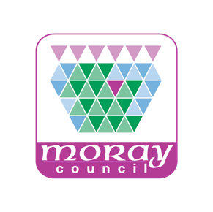

CERTIFICATE OF COMPLIANCE
SHORT-TERM LETS LICENCE – CONFIRMATION OF DISPLAY OF PUBLIC NOTICE

THE CIVIC GOVERNMENT (SCOTLAND) ACT 1982 (LICENSING OF SHORT-TERM LETS) ORDER 2022

This section must be completed by the applicant and the whole Notice returned to Moray Council at the above address at the end of the 21-day display period. Alternatively, please provide confirmation of display in writing with signature, along with full applicant and property details.
I ……………………………………………………………….(Full name of applicant)
Certify that the Notice of Application has been displayed as prescribed above for a period of not
less than 21 days from …………………………. ending on ………………………….

Date …………………………………..
Signature of Applicant ………………………………………………
Or
Signature of Agent on behalf of Applicant ………………………………………………

