Appendix 2
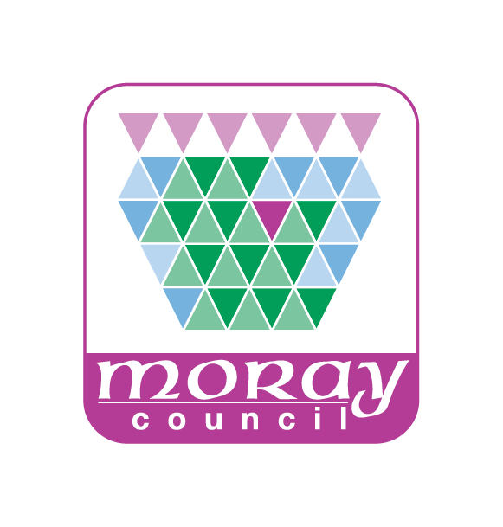
APPLICATION CHECKLIST
This list is intended to provide a helpful starting point for checking you have the relevant information required in order to submit an application for a short-term let licence. Getting your application right first time will make the process easier for you and will help you to get a decision more quickly.
Preliminary
I have read the guidance provided. Yes / No

I have identified the owners and those involved with the day-to-day
management of the premises I am seeking a licence for. Yes / No

I have the permission of the owners of the premises to use it for this
purpose. Yes / No

To the best of my knowledge, I and the other people named on my
application are fit and proper persons. Yes / No

Responsibility for the property
Agents
I have identified those involved with the day-to-day management of
the premises and know that I cannot change them without the licensing
authority’s approval. Yes / No

General safety and standards
General safety
I have taken all reasonable steps to ensure the premises are safe for
residential use. Yes / No

Occupancy
I know how many guests I want to accommodate and I consider that
I can do this safely. Yes / No

Repairing standard
I have worked out whether the premises is a dwellinghouse and whether Yes / No
the repairing standard applies to me.
[if relevant] – the premises meets the repairing standard. Yes / No

EPC
[if relevant] the premises has a valid EPC certificate issued within the
last 10 years. Yes / No

Fire Safety
There is satisfactory equipment to detect and warn against fire or suspected
fire, and carbon monoxide installed in the premises. Yes / No

Furniture and furnishings – all furniture and furnishings in the premises
comply with fire safety regulations and I have records that demonstrate
compliance. Yes / No

I have completed the Scottish Fire and Rescue Service checklist for short-term
lets and enclosed this with my application. Yes / No

Gas Safety
[if relevant] I have an up to date Gas Safety Certificate (dated within
the last 12 months). Yes / No

Electrical Safety
I have made sure the electrical fittings and items in the premises are in good
working order. Yes / No

I have arranged for an electrical safety inspection to be carried out by a
competent person. Yes / No

I have obtained an Electrical Installation Condition Report on any fixed
installations and provided a copy of it. Yes / No
I have obtained a Portable Appliance Testing Report on moveable appliances
to which guests have access and labelled inspected items. Yes / No

Water Safety
I have established that the premises are supplied with water by Scottish
Water or, that the premises has a private water supply. Yes / No

[if relevant] I have checked my responsibilities under the Water Intended For Human Consumption (Private Supplies) (Scotland) Regulations 2017 and taken any necessary action to comply with the Regulations e.g. obtained a satisfactory
water sample. Yes / No

Legionella
I have completed a legionella risk assessment. Yes / No

Other
Information for guests
I have prepared information for guests and know where I will put it for
them on the premises Yes / No

Planning Permission
I have established whether I need to submit evidence that I have planning
permission (or a certificate of lawful use of development) or have made an application. Yes / No

Listings
Licence number – I have made plans to display my licence number on
adverts and listings. Yes / No

[if relevant] I have made plans to display my EPC rating on adverts and
listings. Yes / No

Insurance
Buildings insurance – I have checked that there is valid buildings
insurance in place for the premises. Yes / No

Public liability insurance – I have checked that there is valid public liability
insurance for not less than £5 million in place for the premises for the
duration of each short-term let agreement. Yes / No

Other matters to consider
Food safety – I understand the food hygiene and safety rules that
apply to me. Yes / No (further information available on Moray Council’s website at http://www.moray.gov.uk/moray_standard/page_1788.html)

I comply with legal requirements that relate to fire safety set out in the
Fire (Scotland) Act 2005. Yes / No

I have checked the title deeds of my premises. Yes / No

I will declare my income from my short-term let activity for tax purposes. Yes / No

I have checked with the lender of any standard security held over the premises
that I am allowed to use my premises for short-term lets
Yes / No / NotApplicable

I am complying with other legal requirements that affect me, my business
or the premises Yes / No

I have considered engaging with my neighbours. Yes / No
Anyone can object to a short-term let licence so where relevant this may
make the application process more straightforward.

Fees
I know the fee that I will be charged and I am ready to pay it with my
application. Yes / No

I have submitted the following to Moray Council:-
Application Form Yes / No
Additional Information Sheet(s) Yes / No
Supporting Documentation Yes / No

Mandatory:
Detailed floor/layout plan of the premises Yes / No
Scottish Fire and Rescue Service Safety Checklist Yes / No
Legionella Risk Assessment Yes / No
Buildings Insurance Certificate Yes / No
Public Liability Insurance Certificate Yes / No
Licence Fee Yes / No

If relevant:
Owner(s) consent declaration Yes / No
Gas Safety Certificate for the premises Yes / No
Electrical Installation Condition Report Yes / No
Portable Appliance Testing Report Yes / No
Energy Performance Certificate Yes / No

I will complete and display the Public Notice form when the Council tells me my licence application is valid. Yes / No
I will submit the Certificate of Compliance to the Council at the expiry of the
statutory notice period. Yes / No

Full Name of Applicant ……………………………………………

Signature of Applicant ……………………………………………
Or
Signature of Agent on behalf of Applicant ……………………………………………

Full Name of Agent ……………………………………………

Date ……………………………………………

