Missing / Found / Vulnerable Person Policy and Procedure *

Missing Person Point: Enter Location of Tent / Area here

Missing Person Supervisor: Enter Event Director / Head of Security / Appointed Person etc. – NAME / CONTACT DETAILS

The text within blue and green boxes is the procedure an event steward will follow in the event of a missing or found person at the Event.

Text within the grey boxes is further information for the stewards and actions for the Missing persons Supervisor / Event Control.

- Reassure the parent /guardian / family / friend & Notify event management.

- Ask them to take you to where the missing person was last seen and assist them in their search.
- Remain with the Parent / Guardian / Family Member / Friend. If they refuse, ensure that you get a telephone number for them and obtain all possible details.
- Radio Event Liaison Team notifying them of circumstances being clear and precise details of location, time seen and current location.
- **DO NOT give out details of the missing person over the radio; name or personal details over the radio.

SITUATION ONE - Parent/Guardian notifies you that a person is missing

- Initial search and communications
- Contact Event Management via Telephone (DO NOT USE RADIO!!!)
- Head of Security – NAME and CONTACT DETAILS AT EVENT
- Provide details of the missing person; Name, Age, Description, Address, Parent/Carer Details, Distinguishing Features, language Spoken etc. Also provide time and place of last known sighting and contact details

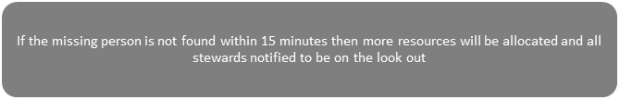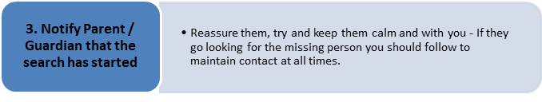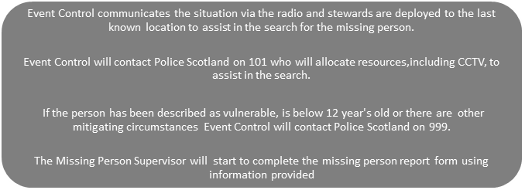
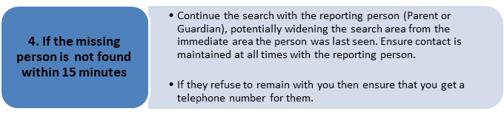
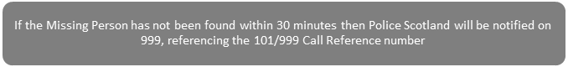

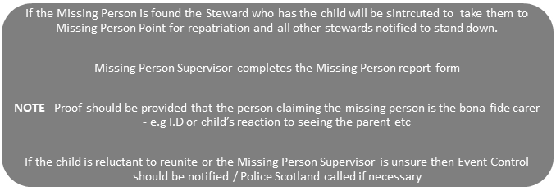
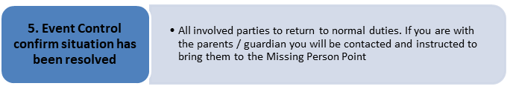
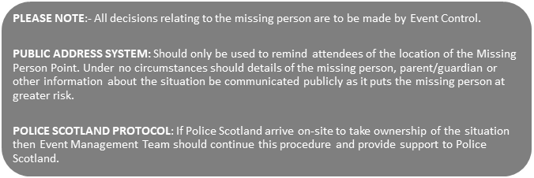

SITUATION TWO – A Person reports to you as lost or is found and brought to you

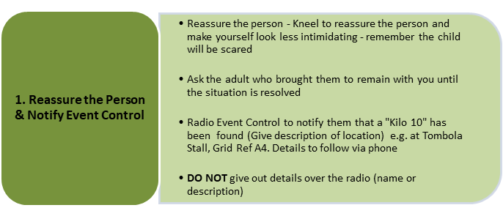

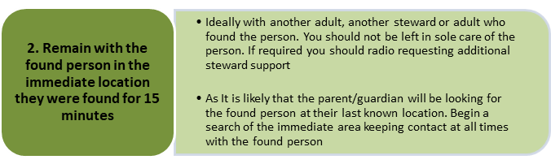
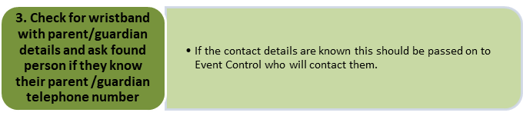
- CONTACT EVENT CONTROL VIA TELEPHONE (DO NOT USE RADIO!!!) Discreetly to prevent public overhearing any details that could endanger vulnerable person.

- Provide details of missing person to allow missing person supervisor to start completing found person report.
- Enter MISSING PERSON SUPERVISOR NAME AND CONTACT DETAILS here

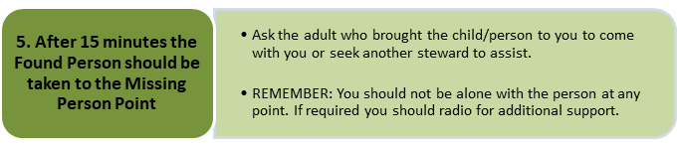

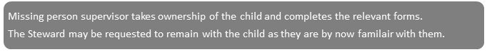
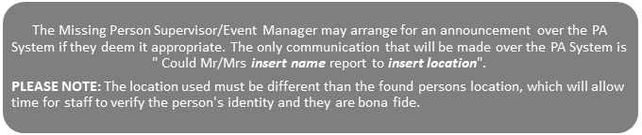

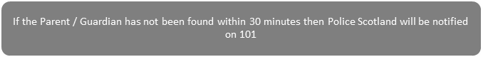

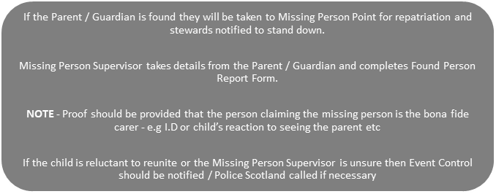
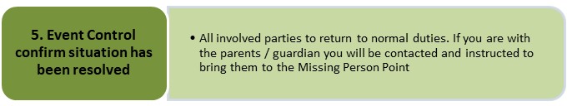
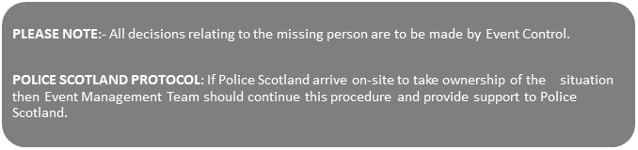

MISSING PERSON REPORT (FOR USE IN SITUATION ONE)
Please complete the following (in block capitals) as far as is possible/applicable
Event / Venue
Date
Name of Missing Person
Address
Tel No
Approximate Age
Gender
Description
Additional Information
Area Lost
Time Lost
Reported by
Signature
Form Completed by

REUNION DETAILS (FOR USE IN SITUATION ONE)
Please complete the following (in block capitals) as far as is possible/applicable
Reunited with | Print
 | Sign
Relationship with Child
Identification Shown
Action taken if not found
Missing Person released by
Time

MISSING PERSON DISCLAIMER
Please complete the following (in block capitals) as far as is possible/applicable
Event / Venue
Date
Name of Missing Person
I, the parent/guardian of the above missing person, having reported their absence now intend to leave the Missing Person Point and search for them myself. I confirm that I do this of my own accord, having been requested to remain at the Missing Person Point to await their arrival. I fully understand that it may be difficult to contact me should the missing person be escorted to the Missing Person Point in the meantime and accept that this could cause delay in reuniting me with the missing person.
Signed
Relationship
Missing Person Supervisor
Signed

FOUND PERSON REPORT (FOR USE IN SITUATION TWO)
Please complete the following (in block capitals) as far as is possible/applicable
Event / Venue
Date
Name of Missing Person
Address
Tel No
Approximate Age
Gender
Description
Additional Information
Area Lost
Time Lost
Reported by
Signature
Form Completed by

COLLECTION DETAILS
Please complete the following (in block capitals) as far as is possible/applicable
Collected by | Print
 | Sign
Relationship with found person
Identification Shown
Action taken if not collected
Found Person released by
Time

