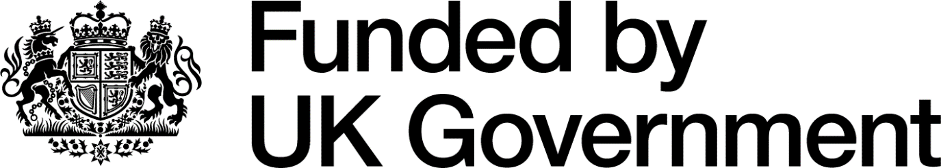

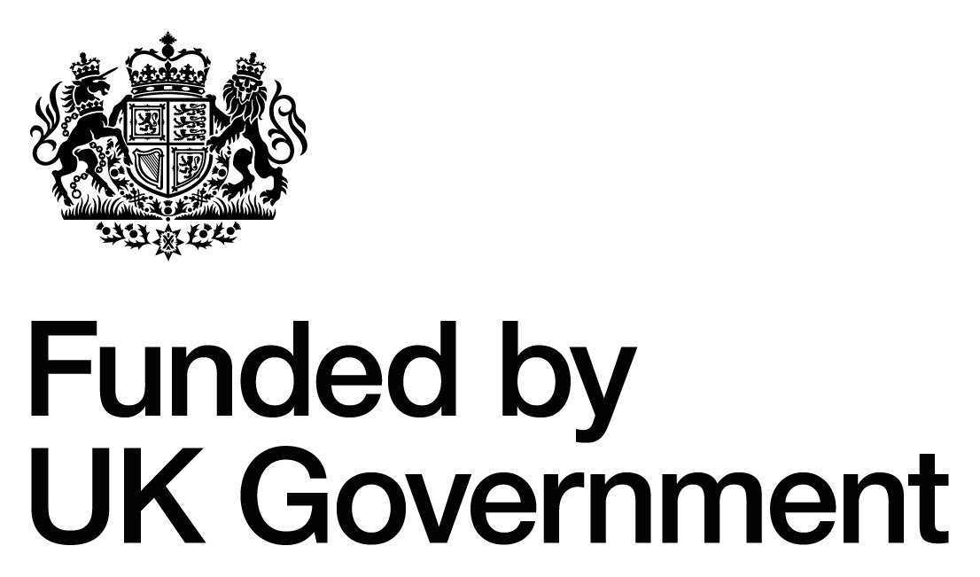

Note: Organisations can use either of the above two versions. These are the versions to be used in Scotland, with the unicorn on the left.
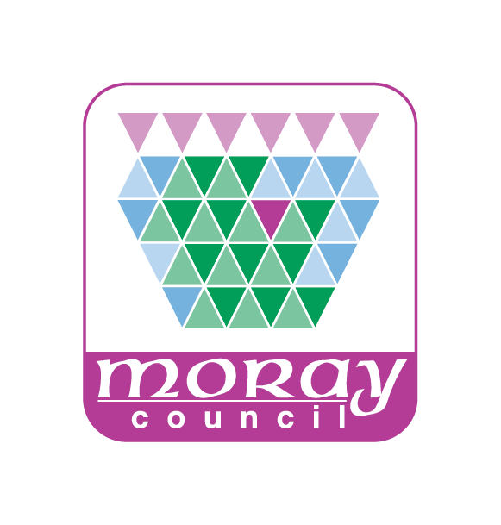
Please also use the Moray Council logo.

