Keith and Strathisla Community Action Plan

2024-2025

Contents
Keith and Strathisla Background 3
Population 4
History of the Area 4
Keith and Strathisla Regeneration Partnership 6
(KSRP) 6
Community Survey Results 7
Partnership Working Feedback 13
People 13
Place 13
Potential 13
People Place and Potential 14
Overview- The next two years 15
Priorities for People, Place and Potential 15
1.0 People 15
1.1 Community youth involvement. 15
1.2 Childcare. 15
1.3 Walking. 15
1.4 M.Connect. 15
1.5 Support Services 15
1.6 Litter picks 15
1.7 Climate change hub. 16
1.8 Discovery award for over 50’s 16
1.9 Support for elderly 16
2.0 Place 16
2.1 Improving Mid Street, Keith 16
2.2 Improve local bank situation. 16
2.3 Celebrate Auld Brig (Keith). 16
2.4 Tell the story of the area. 16
2.5 Improve signage. 16
2.6 Learn from other places 17
Potential. 17
Monitoring Progress 18
Get Involved 18

Keith and Strathisla Background

Keith and Strathisla is located to the east of Moray in the North East of Scotland. The town of Keith is equidistance from the cities of Inverness and Aberdeen, nestled in the Isla valley and is the fifth-largest community in Moray.
Map of Area
Keith is a classic historic town with two major roads passing through, the main A96 Aberdeen to Inverness trunk road and the A95 Banff to Grantown-on-Spey. Keith is known as the 'Friendly Town' and sits on the Speyside Malt Whisky Trail, home to Strathisla Distillery built in 1786 making it the oldest working distillery in Scotland.
“Keith is proud to have been bestowed the considerable honour of Scotland’s first Scots Toun, a Scottish Government accolade awarded to communities who celebrate and promote their linguistic culture, an important part of which is the ever-popular annual TMSA (Traditional Music & Song Association) Keith Festival, established in 1976”.

Strathisla is the area surrounding Keith and includes the communities of Newmill, Mulben, Grange, Drummuir and Rothiemay.
Newmill
Newmill is a planned village 1.2miles north of Keith. The resident population is 452 according to the 2001 census. Within the centre of Newmill square lies the war memorial, a 4-stage clock tower built in 1922-23. On July 22nd 2023 the village celebrated the 100 Years Commemoration of the war memorial.

Mulben
Mulben is a hamlet located on a set of crossroads on the A95 and lies 4 miles west of Keith

Rothiemay
Milltown of Rothiemay, known locally as Rothiemay is a small village located eight miles east of Keith and borders Aberdeenshire. It lies on the banks of the River Deveron, close to where it joins the River Isla.

Drummuir
Drummuir is a small village located between Dufftown (five miles to the west) and Keith (six miles to the East). Originally the village was known as Botriphnie which is also the name of the villages’ primary school.

Population
The table below shows the population from each postcode covered within the Keith and Strathisla area from the 2011 Census. Note that AB54 7 is for the Moray side only and does not include the Aberdeenshire population.

Table 1
Postcode | Location | Population | Female | Male
AB55 5 | Keith, Drummuir | 5,187 | 2,663 | 2,524
AB55 6 | Newmill, Mulben, Grange | 1,961 | 971 | 990
AB54 7 | Rothiemay | 635 | 318 | 317
 | Total | 7783 | 3952 | 3831

Within the AB55 5 postcode covering Keith and the area surrounding Drummuir, 3,908 people could speak Scots and 442 of them used Scots as a language other than English.

History of the Area
Keith can be divided into three parts: Old Keith, New Keith and Fife Keith.

Old Keith
Old Keith was established as a settlement around 700AD beside the River Isla, an ideal place, with food and water being readily available. Within this period the Monks of St Maelrubha arrived from Applecross bringing Christianity and education to this part of the town. The name Keith translated from the Gaelic means 'wind' or 'pure air'. The monks built a church on high ground above the hamlet and named it Kethmal Ruf, the name lives on in the latinized corruption of the Church of St Rufus. The official history of Old Keith began in 1195 with a mention in a charter from King William the Lion. The River Isla could be forded at Old Keith which gave rise to the 'Great Simmareve Fair' when traders and manufacturers from as far south as Glasgow and merchants from as far afield as Highlands, Orkney and the Western Isles congregated in Keith for the sale of black cattle and horses. The Simmareve Fair, in Mid September, lasted a week, this was the precursor of today's Keith Country Show which in 2024 will celebrate its 150th Anniversary.

New Keith
It was decided by the Earl of Findlater in 1750 to extend Keith eastwards, planning a new town with a layout of one central square and four parallel streets interlinked with a series of lanes - known as the classic 'grid iron' plan. This was the first planned town in the North East of Scotland. The Simmereve Fair was relocated to the Market Square and it became a very successful trading and market town. Today the Square carries the name of Reidhaven Square.

Fife Keith
In 1817 Fife-Keith was founded by James Duff, the Earl of Fife, it was developed and planned in a formal arrangement around a central square, now Regent Square. It was originally to be named Waterloo, however this didn’t happen but street names such as Wellington and Nelson Terraces link to this heritage.

In 1889 the three parts of Keith became one as a Police Burgh under a Town Council in the County of Banffshire. This united form lasted until the reorganisation of Local Government in 1975 when Keith moved into the Moray District. Keith are proud of their Banffshire roots and still have their own Lady Lord Lieutenant of Banffshire.

History of Keith and Strathisla Regeneration Partnership

(KSRP)

Keith & Strathisla Regeneration Partnership has a long history in the area having previously been known as Keith Initiative until December 2005 when it changed its name.
Keith & Strathisla Regeneration Partnership now better known as InKeith is here to benefit the community of Keith and Strathisla. The area is defined by the ASG (Associated School Groups of Keith Grammar School) Keith, Fife-Keith, Aultmore, Newmill, Rothiemay, Grange, Drummuir and Mulben
InKeith encourages and develops a spirit of voluntary commitment and co-operation with individuals, community organisations, corporate bodies, agencies, local authorities, and any groups willing to work with InKeith (KSRP) to achieve its purpose. InKeith meets its objectives by encouraging local networking and development through supporting self-help groups and providing representations on community forums.
Funding was received through The Moray Council Towns Partnership for a few years, and this allowed many projects to be supported, working together with organisations in the area.
There was also other funding opportunities e.g. CARS (Conservation Area Regeneration Scheme) that brought much needed funding to the town.
Unfortunately, the annual funding ceased and InKeith now must source project funding from various funders to allow projects to continue. We have been grateful to the local windfarms that have been supportive of our projects over the last few years. We have also received funding from Scotland loves local allowing us to improve the local environment and support businesses in the town.
For example :-
- The InKeith website and Facebook which supports all businesses and local organisation
- The Pop-Up-Shop available to encourage businesses to the town
- The flags that are erected in Mid St and Fife-Keith over the summer months
- Artwork erected on the empty shops provided by the school pupils

Community Survey Results
An online survey was conducted from July 2022 – November 2022. Results from this survey have inspired the heart of this community action plan, covering people, place and potential.
Demographics
Within the survey 654 responses were received, 65% of those were female, 33% male and 25% were from those under 16. The figures below demonstrate the age group, connections to the area and postcodes.
Figure 2
Figure 1

Figure 3

Respondents were asked to value how important certain factors were in relation to the area. Access to a GP and other medical services rated highest, closely followed by access to a dentist, and the third was feeling safe and secure in the community. Please see below for the full details and factors rated.
Figure 4

The survey then asked people to name their three favourite things about Keith and Strathisla. The most ranked were friends and family, friendly people and community spirit, food outlets / cafes and shopping/town centre.
Respondents were asked to provide other suggestions for the area. The majority of responses are displayed below with other comments in Figure ().
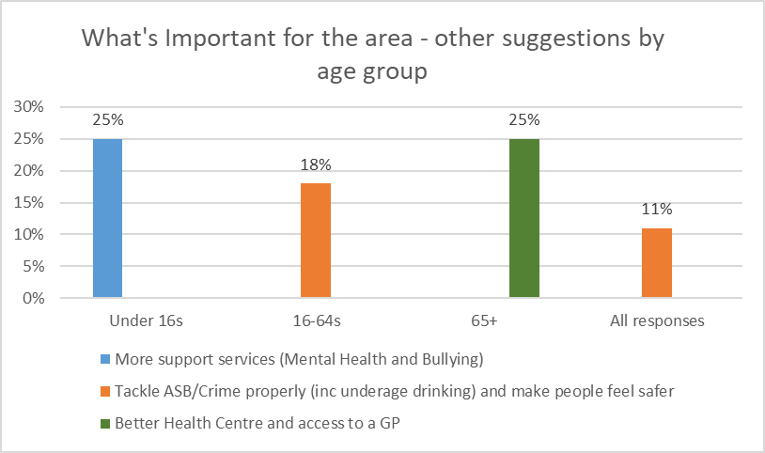
Figure 5

Figure 6
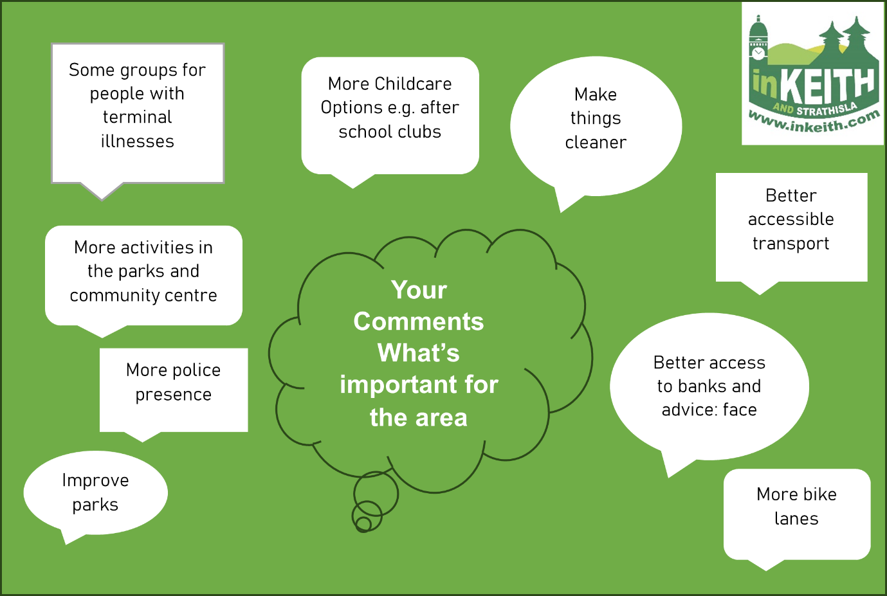
The next figure highlights the suggestions for improvement in the area.

Improving and cleaning up old buildings
Improve road junctions for safety and accessibility
Mountain bike trails
Community allotment – source of community food
Signage for walks and landmarks
More activities for Under 16s
Clean pavements, public areas
Better childcare
Encourage young people to join community councils
Your Comments What needs improved for the area
Figure 7

When asked to rate the importance of certain factors in relation to making Keith and Strathisla a better place to work, live and visit, a good range of shops and cafes was rated highest, followed by the availability of apprenticeships and having places to stay and things to do for tourists. The table below has the average for each factor.
Table 2
Please indicate how important the following factors are in your opinion (0-5)
A good range of shops and cafes | 4.35
Availability of apprenticeships and jobs for younger people | 4.19
Places to stay and things to do for increased tourism | 4.18
New business being encouraged to come to the area | 4.18
Public transport to get to work on time | 4.14
Availability of better paid jobs | 4.08
Help for existing businesses to develop | 3.99
Availability of higher skilled jobs | 3.92
Childcare to enable parents and carers to work or study | 3.91
Help to find work including learning and training opportunities | 3.88
Help to become self-employed/start a new business | 3.85

Respondents were asked to provide three ideas for how Keith and Strathisla can be made an even better place to live, work and visit. Across all three suggestions, the most popular was to deal effectively with weeds, litter, dog fouling and clean up the town.
Other suggestions for making Keith and Strathisla a better place to live, work and visit included:

- More cafes and shops
- Promote and develop tourism
- More training and job opportunities
- Encourage new businesses
- Safe place for kids to go
- Specific visitor attractions
- More local work experience for teens as part of the school day
- Safe stop for campers with a small fee.
- Improve the infrastructure to support new ventures
- Increase holiday accommodation
- Develop tourism, build on heritage

The penultimate question asked how to help the area thrive. The first suggestion was to attract more variety of shops to the area. The second suggestion was mix of improving public transport and encouraging new businesses/shops with incentives such as the pop up shop and lower rates. There were a few suggestions in the third suggestion presented below.
Figure 8

The final question asked respondents Is there anything that makes it difficult to become actively involved in support the local community.

Figure 9
Figure 10
Figure 11

Partnership Working Feedback
On the 24th August 2023 various organisations were invited to come along and input on the ideas of the survey results from the community in 2022. Thirty people attended the event and built on the ideas from the community. The organisations also expressed in an interest in being partners for the plan as their remits were available to help achieve some of the outcomes within the wider community action plan. The comments below have been divided into the sections which are the heart of the community action plan; People, Place and Potential.

People

- Upskill childcare in the area – provide training
- Active schools and more volunteers
- Link health walks to tourism
- Involve Keith Grammar School in community decisions e.g. Modern Studies class
- Big blue bus
- Provide outreach services
- Engage with youth council or create KSRP Youth Group
- Reduce unemployment
- NHS Volunteers available
- Churches interested in running mother/toddler group
- Create discovery award for over 50’s social groups
- Have creative support for schools and communities
- Have sessions on knowledge opportunities
- Create a health club
- Create more carer support
- Improve access to healthcare

Place

- Promotion of allotments available
- Create map of Keith and Strathisla – places to visit, what services are available in the area etc. and sister info guide.
- Improve signage for walks, attractions, businesses, toilets etc.
- Create more walking/cycle routes
- Promote Keith Library
- Have tourism information boards with leaflets
- Improve empty shops on mid street
- Power wash buildings and pavements on Mid Street
- Promote Auld Brig
- Keith Story Trail using QR Codes and display boards
- Learn from other towns – Huntly, Inverurie, Maid
- Have more banks available – not just mobile ones
- Improve lighting
- Work with Strathisla Distillery
- Create workshops on energy advice for businesses and homeowners
- Improve police presence

Potential

- Dog friendly scheme for businesses
- Get funding for various projects including signage, information boards, walking/cycle routes
- Promote TSI Newsletter
- Lobby council for emptying bins more, grass cutting, weeding etc.
- Create Keith Climate Change Hub
- More banks in the area
- Dog fouling needs addressed
- Work more with BALL groups
- Promote DofE
- Agritourism
- Create tourism network group
- Need for tourist shop
- Maximise uses of towns squares
- Digital promotion and inclusivity of tourist access
- M.Connect
- Improve Wifi and Rural Digital connectivity
- Use local influencers to learn from – have workshops to help others
- Improve the green economy
- Improve public transport
- Community pharmacy
- Seating on Mid Street
- Bring companies in for support

People Place and Potential

- Promote InKeith website as one stop shop for everything going on
- Create setting up/running a business session or signpost them to Business Gateway, Federation of Small Businesses, Moray Pathways etc.
- Community growing could link to creation of awards
- Weekly/fortnightly/monthly litter picks
- Churches want to support with groups
- Have an annual community conference
- Volunteer group for keeping area ‘bonnie’
- Bring companies in for support
- Renewables could provide a regular income stream for communities
- Community and businesses collaboration in the best interest for the area

Overview- The next two years
After gathering the feedback and from general discussion with members of the community, the three main themes are improvements for the people of Keith and Strathisla (i.e. services etc.), improvements for the physical place of Keith and Strathisla and potential projects for the area, some of which meet people and place, and others that stand alone. Whilst there are many different ideas, opinions and discussion within the feedback, we will not be able to deliver everything in the two year timescale but we need to start somewhere. The next section presents the outcomes of the community action plan and explains them in more detail.

Priorities for People, Place and Potential
The following outcomes for people, place and potential have been identified due to the number of instances they have either been mentioned in feedback or generally discussed. Please note these outcomes are to be achieved in the next two years and are subject to change depending on the future situation, however all feedback will be stored and revisited for inclusion in the next community action plan from 2025 onwards.
- People
We define people as anyone who lives, works, or visits the area of Keith and Strathisla. The priorities for people from 2024-2025 are presented below:
1.1 Community youth involvement. This priority sets out to encourage more young people to be involved in community events. This priority will be carried throughout the plan. Potential partners include Keith ASG, Active Schools and The Loft.
1.2 Childcare. Assist in improving childcare availability in the Keith and Strathisla area. We hope to achieve this by Summer 2025 and will partner with Moray Council and the local nurseries to achieve this.
1.3 Walking. This priority covers a few different aspects including encouraging people to walk in the area more and to improve signage for walks in the area. We hope to achieve this by October 2024.
1.4 M.Connect. this priority will focus on promoting the m.connect service in the area, this will also include work to create itineraries for people to understand how they can fully use the service. We will partner with Moray Council to achieve this by December 2024.
1.5 Support Services. This priority sets out to improve support services in the area, which will be done by either gathering support to create new support services and/or to support existing services. This will be monitored on a regular basis and one project to coincide with this will be completed by December 2025.
1.6 Litter picks. InKeith will organize quarterly litter picks for all to take part in whilst also supporting anyone that would like to litter pick with equipment we have that can be loaned. This will take place throughout the period of the plan with the first litter pick to be scheduled for Spring 2024.
1.7 Climate change hub. This priority will focus on having a climate change hub for the area which will work in partnership with Moray CAN (Climate Action Network) to deliver free advice and support regarding issues relating to climate change. Partnerships include TSI Moray, Moray Council and REAP. A physical climate change hub or regular meeting space will be in place by December 2024.
1.8 Discovery award for over 50’s. This priority includes creating an award for Over 50’s in the area to be recognized for their community efforts. We will be partnering with all local community organizations and looks for potential sponsorship of the award. We will launch this in June 2024.
1.9 Support for elderly. Within this priority we will look at supporting the elderly community more within the area, working with various local partners to achieve this.

2.0 Place
We define place as the area of Keith and Strathisla inclusive of the communities of Mulben, Drummuir, Newmill, Grange and Rothiemay. The priorities for 2024-2025 in place include:
2.1 Improving Mid Street, Keith. The main theme throughout a lot of feedback was to improve the cleanliness and overall appearance of Mid Street. We will work in partnership with Moray Town Centre Taskforce, Moray Council and United Keith to deliver an improvement implementation plan for Mid Street by March 2025.
2.2 Improve local bank situation. InKeith will explore the option of having a community banking hub within Keith for the local area to use, with the hope of replacing mobile bus banking with a physical banking hub. We will work in partnership with Moray Town Centre Taskforce, Moray Council and local banks to deliver this by June 2025.
2.3 Celebrate Auld Brig (Keith). This priority mainly sets out to promote and celebrate the Auld Brig in Keith, which will be ongoing with partnerships taking place with local members of the community and Keith Community Council.
2.4 Tell the story of the area. InKeith will seek funding to put together a storytelling trail together for the area, using QR Codes and signage. Potential partnerships for this project includes Keith Heritage Group, Moray Council, Visit Moray Speyside and local community organisations.
2.5 Improve signage. Some signs (both road and pedestrian ones) are out of date or non-existent across the Keith and Strathisla area. InKeith will seek funding and support to improve signage throughout the area. Potential partnerships for this project includes Moray Council, Community Councils, Town Centre Taskforce and Visit Moray Speyside.
2.6 Learn from other places. We will seek funding to visit other places that have excelled in community development to learn from them and discuss potential projects and advice. We hope to achieve this by March 2024 and partnership with TSI Moray, Moray Council and the Community Councils to achieve this.

3.0 Potential
This is what we would like to see differently in the area and what we can bring to improve it. This will be made of various projects encompassing:
3.1 New Businesses. We will work with various organisations to attract new businesses to the area. We already have the pop-up shop in Keith which is run by the directors of InKeith & Strathisla but we will continue to work with other potential partners including United Keith, Moray Council, Moray Town Centre Taskforce and Visit Moray Speyside to get new businesses in the area. The timeline for this is ongoing with the hope that Keith will see five new businesses in the period of this plan.
3.2 Promote longer stays. InKeith will work with Visit Moray Speyside and local businesses to encourage people to stay in the area for longer, this is something we will continue to work on throughout the course of the plan.
3.3 Raising awareness and promotion is an overall priority for the area and indeed within this plan.

3.4 Infrastructure to support GP’s.
3.5 Mid Street – Seating outside. Throughout the feedback process having more seating on Mid Street was raised. We will work with Moray Council and United Keith to explore the option of having more seating in the street. We hope to have a solution for this by August 2024.
3.6 Annual community development event for the area. For those that attended the partnership event in August 2023 it was suggested that InKeith and Strathisla host a community event annually. This would allow us to update everyone on the community action plan and be a safe place to share ideas and get support. We hope to seek funding to help us deliver this event and host the first one by December 2024.
3.7 Tourism opportunities. This priority looks at improving Keith and Strathisla as a tourist destination. As part of this we will aim to retrieve funding for the design and installation of statues in Keith, connecting to our Scot’s Toun heritage. We will also look at delivering a short tourism plan for the area, all of which we hope to achieve by April 2025. Potential partners include Visit Moray Speyside, Moray Council and Moray Town Centre Taskforce.
3.8 Wifi and digital connectivity. We will work with partners at Moray Pathways and REAP to improve Wi-Fi and digital support. We will also look to improve Wi-Fi and digital connectivity to the rural areas of Keith and Strathisla, and we hope to achieve this by October 2024.

Monitoring Progress

This plan is being launched in January 2024 and will be in place until 2025. The plan has been created by Keith and Strathisla Regional Partnership’s (KSRP) Local Community Development Officer with the support of the board of KSRP and various organisations within the area. To monitor the progress of this plan a quarterly update with scores against each outcome to determine the progress, will be issued in KSRP’s newsletter, website and social media channels. Once the time period has finished (December 2025), the plan will be reviewed and anything uncompleted will be considered for the next plan which will run for five years and encompass more of the feedback presented within this plan as well as any additional projects or feedback.

Get Involved

Thanks for taking the time to look over our plan for the next two years. Perhaps something caught your eye that you thought you would be interested in or help supporting.
We want to hear from you!
We’re always looking for volunteers to help us with our work, you may even be interested in joining KSRP’s board of directors. For more information please email our Development Officer bryony@inkeith.com

