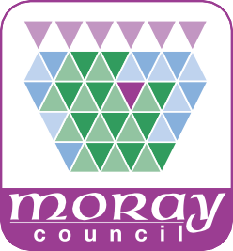

**Local Place Plan Template**



**Local Place Plan Template**

**Introduction**

A Local Place Plan (LPP) is a tool for local communities to come together and think about how to make their “place” better, agree priorities, and take action to make change happen.

It is important to recognise the commitment needed from the community to prepare a LPP. This template has been developed to help community groups create their own LPP. A format has been suggested which includes examples from other LPP, links to further information, prompts to guide community groups through the process and a checklist to ensure all required elements are addressed.

Engaging with as many and as broad a range of the community including harder to reach groups (e.g. young people, people with disabilities and the elderly) is essential to ensure the LPP is reflective of wider needs, priorities, and aspirations.

**What should be included within the LPP?**

This template identifies various sections that should be included within the LPP and provides ideas and suggestions of the type of content that should be added. It is important that the whole community understand the language used within the LPP, it should be kept simple using plain English.

[**www.plainenglish.co.uk/**](http://www.plainenglish.co.uk/)

**Cover Page**

The cover page should feature -

The title of your LPP

The years it will cover e.g. 2024 – 2029 The name of your geographic community

Add in local pictures of interest that represent your area or inspiring quotes from those you have engaged with.

**Contents Page**

Detail the sections within the LPP.

**Introduction**

Set out why you are producing a LPP including purpose of the plan (i.e. to identify community strengths, needs, areas for development and aspirations).

**Please fill in here**



**Context/Description of the Area**

You may wish to include information setting the context for the LPP.

**Example**

Sections within this could include:

History and Heritage Community Facilities Business and Economy Tourism

Transport

**Please fill in here**

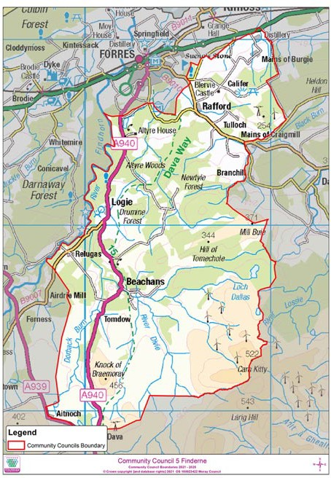

**Insert a Map of Your Community** (define the boundaries of the community you are consulting)

**Example Map**

**Community Council maps can be found here:** [**www.moray.gov.uk/moray_standard/page_45710.html**](http://www.moray.gov.uk/moray_standard/page_45710.html)

**Identifying community assets, needs, opportunities and challenges** Identify the needs of your area following discussion with the community. This is the core to the LPP and must be informed by extensive engagement with the local community to determine the range of views of local people around key questions.

It is important to recognise that the LPP must have regard to the [**National**](http://www.moray.gov.uk/moray_standard/page_148973.html) [**Planning Framework (NPF) 4,**](http://www.moray.gov.uk/moray_standard/page_148973.html)[**Moray Local Development Plan 2020**](http://www.moray.gov.uk/moray_standard/page_133431.html)and any Locality Plan(s). Communities need to understand the limits of LPP. The table below explains what they can do for your community, and what they are less suited for.

**A Local Place Plan is…..**

**A Local Place Plan is not……**

A statement of community aspirations.

A way of informing future planning policy and development proposals in your area.

A way of identifying and helping to deliver community projects.

Through links with the Local Development Plan, a way of helping to deliver a community’s development proposals.

An opportunity to guide developers, local authorities, and others towards community objectives, and to deliver projects or services which support the local community.

Information for other organisations to adapt their activities or proposals to support delivery of community aspirations.

A tool for collaborative working, within the community and with Moray Council.

A wish list to demand unrealistic investment from others.

A top-down way of imposing change.

Means of stopping live development proposals.

An opportunity to promote individual interests of specific people or organisations.

An easy way of getting what you want.

The [**Place Standard Tool**](https://www.ourplace.scot/tool)can help guide discussions with the community. This engagement needs to involve all sections of your community (i.e. harder to reach groups such as young people). It is important that a statement on your view of the level of community support for proposals is included within the LPP.

**Examples of opportunities** – A strong heritage and culture. High quality townscape and scenic setting and lots to interest visitors. An active and capable community. Access to high quality open spaces and walks for diﬀerent ages and abilities. Local shops that support community and community facilities that support a range of activities.

**Examples of challenges** – Lack of provision of a range of good quality accommodation for residents and visitors. Lack of aﬀordable housing and varied types of housing. Ageing population. Lack of space/activities for young people.

Outline the engagement activities that your community group has conducted and a summary and analysis of the feedback you have received. Examples of engagement tools include social media campaigns, surveys, community workshops, dedicated websites, and face to face meetings.

[**Scottish Government draft how to guide for LPP**](https://www.gov.scot/publications/circular-1-2022-local-place-plans/)provides further information on who and how to engage.

**Please fill in here**

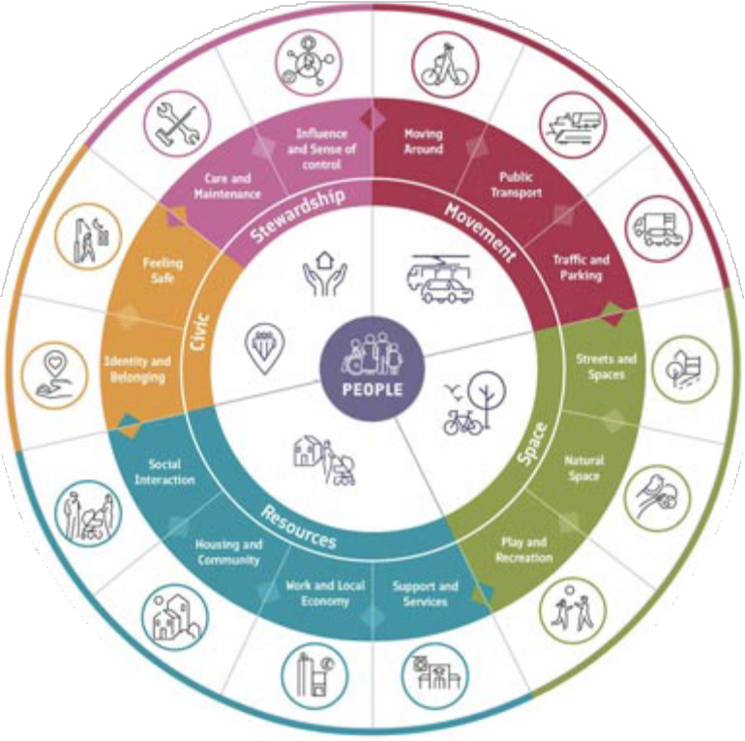

**Community/Local Place Plan Objectives and Priorities**

This is your vision statement. What does the community want and need? What does it value? What does it want to improve? What diﬀerence will this make?

What are the community’s priorities and aspirations?

The vision must reflect the underlying priorities and objectives the LPP is seeking to achieve. The principles of Local Living are recommended when thinking about priorities, objectives, and the overall vision. Priorities could be identified and set out in themes taking account of the principles of Local Living. The Local Living diagram below sets out key themes around movement, space, resources, civic and stewardship with prompts of issues to consider. These themes could be used to capture community views.

**An example for a vision**

X is well-established as a hub for renewable energy technology, as a location for the arts, and a high-quality tourist destination. Its rich heritage and

deep-rooted fishing and marine history have been embraced and enhanced for the benefit of all.

**Please add your Vision Statement here**

**Action Plan**

The Action Plan should identify and list potential projects with timescales as well as any required resources. Importantly, the LPP is owned by the community and projects must be focused and reflective of what can be delivered by the community. If there are projects intended for others to deliver or in partnership, then the LPP should identify what engagement there has been with the bodies that will do this.

Consideration must be given to ranking priorities which then feeds into the action plan with short, medium and long term projects with timescales. A short term action could be introducing or reintroducing a community event like a gala day. Medium term action could be a Community Asset Transfer (CAT) of a building. Long term action could be redevelopment of a brownfield site.

The LPP must explain how the actions identified will be monitored and reviewed

i.e. by whom and when. Also, what are the plans for continued engagement with the community and keeping them informed of progress (e.g. newsletter every 3-6 months, website updates, press articles etc).

It is important that the actions relate to the community objectives identified. The LPP must also identify and explain the reasons for any proposed changes to the Local Development Plan that the community believe are required based on the LPP objectives and actions.

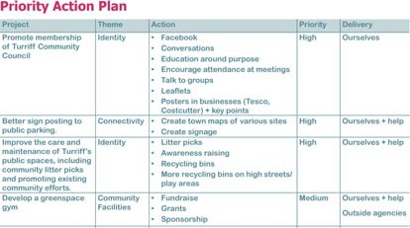

**Example**

Ideas for action could include - sites for renewable energy, local community food growing spaces or active travel routes. Sites for housing, new tourism, or community facilities. Identification of areas of greenspace and play spaces that need new equipment, or more equipment to cater for a wider range of ages ranges or additional planting to enhance appearance or benefit biodiversity. Improvements in the town or neighbourhood centre.

Examples of actions that should not be included are litter management, dog fouling, improvements to public transport (routes and timetables) and any proposals which do not fundamentally impact on the long-term use of land.

**Please add your Action Plan here**

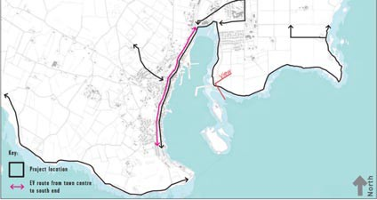

**Project Mapping**

A map/s must be provided marking any land and properties that the LPP indicates should be retained or developed and supporting text included to explain proposals. This again should be linked to identified actions.

**Example project** - develop path routes within the town centre, along the coast from the east to the west.

**Explanatory Text**

Improve visitor signage in and from the town centre Encourage walking, with joined up paths linked to bus stops.

Create a business directory of shops and opening times linked to signage strategy.

Create and sign a range of accessible path loops.

Develop a wider network of themed cycling/walking trails.

Other examples could include identification important spaces, community assets, things that are historically or culturally important to the community

e.g. Duﬀtown Clock Tower, Alice Littler Park, and Keith/Duﬀtown Railway.

**Please add your project here**

**Registration Checklist**

To ensure your LPP is valid and will be accepted you must provide all the information in the table below.

If you need any further help with this, contact [**localplaceplans@moray.gov.uk**](mailto:localplaceplans@moray.gov.uk)

**Confirmation of the community body’s status**

**Contact details for the community body/organisation**

**A map showing the area referred to throughout the LPP with defined boundaries**

**Demonstrate regard to National Planning Framework, Local Development Plan, and Locality Plan(s)**

**Confirmation you have sent an information notice to Councillors and Community Councils**

**A statement of your desired development proposals or use of land within the area**

**Map(s) showing proposals for development or use of land/building(s)**

**A statement setting out the reasons for amending the Moray Local Development Plan**

**A statement on your view of the level and nature of community support for the LPP**