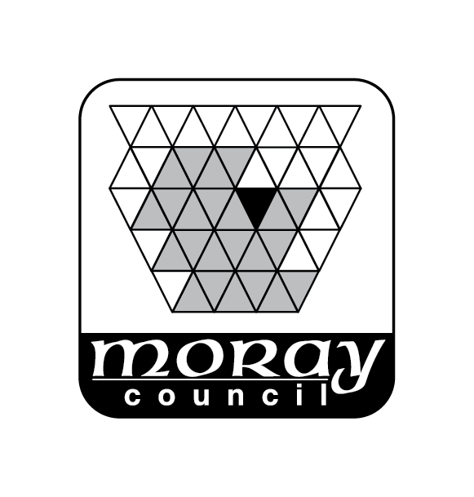
Environmental Services Department
Moray Council
For Official Use Only

Ref No …………………………

Date Rec ……………………….
PO Box 6760
Elgin
Moray
IV30 9BX
Telephone: 0300 1234561
Email: devmanadmin@moray.gov.uk

Application for Section 50 Certificate(s)
(Planning – Building Standards – Food Hygiene)
Licensing (Scotland) Act 2005
Section 50
Application for: (Please tick relevant box)

Grant of a New Premises Licence (see note 1)

Provisional Premises Licence (see note 2)

Confirmation of Provisional Premises Licence (see note 3)
Provisional Premises Licence reference if applicable …………………………………….

A copy of the plan to be submitted to the Licensing Board must accompany this application along with the correct fee (see notes 1,2 and 3). Submitting the incorrect fee may delay the issue of your certificate(s).

Name of Applicant

Address of Applicant
Address of Premises to which the Certificate Relates
Telephone No.
Mobile No.
Email
Name of Agent (if applicable)
Address

Telephone Number
Mobile
Email

Planning (If Applicable)

- Date and reference of outline or full planning permission (if applicable)

Date………………………………Reference………………………………………………….

- Date and reference number of any Certificate of Lawfulness under Section 150 of the Town and Country Planning (Scotland) Act 1997

Date………………………………Reference………………………………………………….

Building Standards (If Applicable)

- Date and reference of building warrant approval (if applicable)

Date…………………………….Reference………………………………………………

- Date and reference number of Completion Certificate (if applicable)

Date……………………………Reference………………………………………………..

Environmental Health (If Applicable)

Has the premises been registered in terms of the Food Hygiene YES / NO / Not Applicable (Scotland) Regulations 2006?

Signature …………………………………………………………………Date…………………………...

Please send application to

Development Services
Moray Council
PO Box 6760
Elgin
Moray
IV30 9BX

Telephone: 0300 1234561
Email: development.control@moray.gov.uk
Moray Council – www.moray.gov.uk

Note 1:
- The fee for the Grant of a New Premises Licence is £238.35. Your application will be considered by all 3 services and the relevant certificates issued.

Note 2:
- The fee for a Provisional Premises Licence is £68.00. Your application will be assessed by the Planning Service only.

Note 3:
- A Confirmation of Provisional Premises Licence is only required by Building Standards and Environmental Health providing a Provisional Premises Licence has previouly been provided by Planning the fee will then be £170.35.

If you are a holder of a Provisional Premises licence please ensure you quote your Provisional Premises Licence number.

Fees required

Building Standards: | £68.00
Environmental Health: | £102.35
Planning Department: | £68.00

