ADVICE TO SCHOOLS

GAS MASKS AND ASBESTOS

At the end of last year, the Health and Safety Executive (HSE) advised that it was not appropriate for children or teachers to wear or handle a Second World War gas mask unless it can be clearly demonstrated that the particular mask does not contain asbestos.

Since issuing this advice, HSE has analysed a number of vintage masks for the presence of asbestos. HSE has also had discussions with IWM (Imperial War Museums) about their policy and control of artefacts containing asbestos.
This work has confirmed that no gas masks should be worn or handled by children or teachers for the following reasons:
- The analysis showed that the majority of vintage masks did contain asbestos and often the more dangerous crocidolite, or blue, asbestos. Only a minority did not, and it is not possible to say which types or models do, or do not, contain asbestos.
- It is very difficult to decide whether or not a mask contains asbestos from a simple visual examination, and in addition it is likely that some masks will be in very poor condition.
- IWM advise that their policy is to assume any mask, whatever the vintage, contains asbestos as well as potentially other toxic or otherwise hazardous materials, and so should not be worn and only handled if clearly certified as safe to do so.

Gas Masks
There are a wide range of makes and models of gas masks both from Britain and abroad. It is therefore difficult to provide a definitive list of models that contain asbestos. In view of this it should be assumed that the item contains asbestos (unless there is strong evidence that they do not).

First World War Helmets
The IWM have reviewed the collections selected for their First World War Galleries and they discovered that the majority of the British Army (‘Brodie’) helmets below, issued during the First World War, contain chrysotile (white) asbestos in the helmet liner. Accordingly, the advice in relation to these items is the same as for gas masks - it is not appropriate for children or teachers to wear or handle any artefacts that potentially contain asbestos.

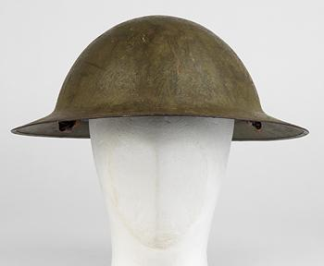

Advice on how to remove items containing asbestos
Schools that have any of these items of war memorabilia that are suspected to contain asbestos should remove them from use. They should be double bagged in plastic which should be taped shut, appropriately labelled and securely stored while arrangements are made for either disposal through your Local Authority’s licensed disposal site, or made safe by a licensed contractor by for example encapsulation such that they can be safety displayed e.g. in an appropriate labelled cabinet.

It is possible for ‘Brodie’ Helmet liners (and the asbestos pad) to be removed, leaving the metal helmet. This work would need to be undertaken by a licensed contractor. The Licensed contractor would also need to clear the Helmet as free from any asbestos contamination.

Information on how to go about disposing of asbestos material and labelling can be found here http://www.hse.gov.uk/pubns/guidance/em9.pdf

The Registration, Evaluation, Authorisation and Restriction of Chemicals (REACH) Regulation prohibits almost all importation, manufacture, supply and use of asbestos fibres, or articles containing asbestos fibres. Therefore selling or supplying gas masks that contain asbestos, including ‘not for profit loan’ of articles, is a breach of this Regulation.

Replica gas masks and ‘Brodie’ Helmets that do not contain asbestos are available as teaching aids.

General information on asbestos matters can be found on HSE’s website at http://www.hse.gov.uk/asbestos/index.htm

