Community Asset Transfer



Annual Report: 1 April 2024 to 31 March 2025

Contents

Introduction 4

Promotion and support 4

Asset transfer requests 6

Simplified arrangements 7

Contact Us 7

Appendix 1 8

Appendix 2 10

Completed by: Emma Dawson Role: Asset Management Officer Date of completion: 04/04/2025

# Introduction

From 23 January 2017 the Community Empowerment (Scotland) Act 2015 (the Act) gave eligible community bodies a right to make asset transfer requests to public authorities. A request can be made in respect of any land or building that is owned or leased by the relevant authority. The Act requires public authorities to agree to the request unless there are reasonable grounds for refusal.

Section 95 of the Act requires each authority to publish a report annually covering the number of asset transfer requests processed through the year together with details of what actions it has taken to promote the use of asset transfer requests and to support community bodies through the process. There is no requirement that all asset transfer requests be made under the Act. In the interests of transparency and completeness, details of requests dealt with outside of the Act are included in this report.

# Promotion and support

The following actions have continued to promote and support the Community Asset Transfer process during the period 1 April 2024 to 31 March 2025.

## Empowering communities

Community empowerment refers to the process of enabling communities to increase control over their own lives. Communities are groups of people who share common interests, concerns or identities. Empowerment refers to the process by which people gain control over the factors and decisions that shape their lives.

Moray Councilhas long recognised the important role that the transfer of property assets can play in empowering communities and strengthening their resilience. The Council’s Community Asset Transfer (CAT) Scheme supports its Corporate Plan priority of building thriving, resilient and empowered communities and the Local Outcomes Improvement Plan priority of empowering and connecting communities. Where appropriate, the Council will use the transfer of assets to give more control to communities, helping to inspire them to find local solutions to community needs and become more sustainable in the long term.

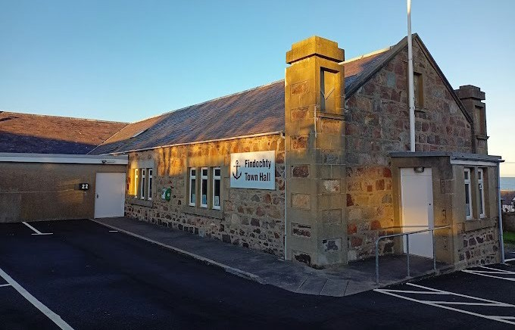

Findochty Town Hall

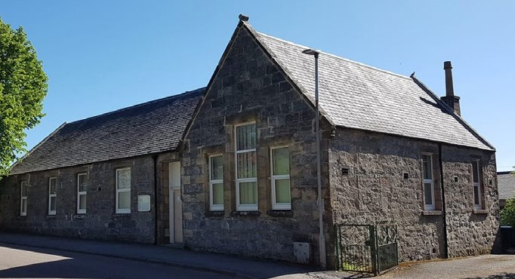

Dufftown Community Centre

## Supporting communities

The Council’s Community Support Unit (CSU) provides capacity building support to all community groups throughout the CAT process. Officers from the CSU carry out initial assessments of groups submitting an expression of interest. This assessment identifies if the group has the skills and experience necessary to take on an asset and considers any community engagement that has been done by the group. From this, CSU officers can work with the groups on addressing any issues that come to light, e.g. governance, consultation, business planning, etc. The same level of support is available to those taking advantage of the simplified arrangements covered by the CAT scheme.

Officers from the CSU encourage groups to consider the requirements of those most in need in their community. The CSU will work with the Council’s Research and Information Officers to provide relevant data and statistical information to help groups understand the demographics and needs of their communities. They also work with other partners who can provide support to groups – notably the Development Trusts Association Scotland’s Community Ownership Support Service (COSS) and Highlands and Islands Enterprise (HIE). HIE have provided funding for community groups to commission options appraisals and a Social Return on Investment report in support of potential CATs.

## Continuous action

The Councils dedicated Community Asset Transfer Team continue to deal with Asset Transfer enquiries.

The Council’s website has a Community Asset Transfer section which includes guidance on the CAT process, forms, details of successful Community Asset Transfers within Moray and provides useful links to Scottish Government guidance, legislation and other related information. There is also a dedicated mailbox for Asset Transfer enquiries.

Communities can also find out more about the Council’s land and building assets from its map-based Asset Register. The full register is available to search or download through the Council’s Open Mapping Data Portal.

Open Mapping Data Portal



<https://data-moray.opendata.arcgis.com/>

# Asset transfer requests

This report covers the period 1 April 2024 to 31 March 2025. During this time there were no asset transfer requests received. No validated asset transfer requests were awaiting a decision and there were no decisions which were the subject of a review or appeal during the reporting period.

Previously successful asset transfers completed since the introduction of the Act in January 2017 are shown in Appendix 1. The Council is currently in the process of transferring one more asset and a decision relating to one further request has been deferred while an alternative site is investigated as shown in Appendix 2.

## Approved Transfers

Lossiemouth’s Coulardbank Playing Fields are held by the Council on an inalienable Common Good title. In January 2020, the Lossiemouth Community Development Trust submitted an asset transfer request for a 25-year lease of a site within the playing fields for the purpose of developing a skate park. In October that year, the Council agreed to the requested lease subject to the courts granting consent and to the Trust obtaining the necessary planning consent for the development. Decree was granted by the court on 12 January 2021 and planning consent was granted on 21 March 2024 allowing the proposed lease of the site to proceed. The lease is now in the process of being completed.

Keith’s Longmore Hall is held by the Council as part of the Longmore Trust. In 2018, the Council took the decision to seek a community group to take over responsibility for the day-to-day running of the hall. In response to that decision, the community established Longmore Community Hall as a Scottish Charitable Incorporated Organisation (SCIO) for the purpose of running the hall. The SCIO has occupied the hall under a short-term lease since July 2018. The community body’s application for longer term lease was approved by the Council in November 2023. The new lease is now in the process of being completed.

## Expressions of Interest

The Council’s CAT Scheme involves a two-stage process. Community bodies are encouraged to take advantage of the pre-application stage by completing an Expression of Interest (EOI) for any land or buildings in which they have an interest. On receipt of an EOI, the Council’s CAT Team will:

* check the community body’s eligibility under the scheme,
* check that the Council has the ability to transfer the relevant property rights,
* identify the Council’s current and future operational requirements for the property,
* identify as far as possible any other material considerations that should be taken into account in determining an asset transfer request for the property, and
* exchange information related to the community body, the asset, and the potential transfer.

The EOI stage is designed to help the community body avoid abortive work and prepare a robust business case in support of its asset transfer request. Not all community bodies that submit an EOI will progress to making a formal asset transfer request and some will choose to go straight to making a formal request without first submitting an EOI. The Council has dealt with five EOIs during the period covered by this report, all of which remain current.

# Simplified arrangements

The Council’s former Community Rental Grant Scheme was brought within the purview of its CAT Scheme. The extended scheme provides an opportunity to all existing voluntary and community organisations that lease property from the Council to apply for a Community Rent Rebate whenever their rent falls due to be reviewed. This element of the scheme is not covered by the Community Empowerment legislation and all applications are considered entirely at the Council’s discretion. Applications must be supported by a robust business case demonstrating ongoing benefits commensurate with the rebate being applied for.

The community response to the pandemic led to an increase in requests from voluntary and community organisations seeking short term arrangements for the use of temporarily unoccupied Council assets. Given the nature of such requests, a swift turnaround is often necessary and adherence to committee timescales does not facilitate an agile response. Recognising that the level of justification should be proportionate to the nature of the request, a simplified process is now available to organisations seeking a short term or low value concessionary lease.

# Contact Us

### Further information on the scheme is available from the Council’s CAT team or its Community Support Unit (CSU).

### by post:



### Moray Council, High Street, Elgin IV30 1BX

### by phone: 01343 543451



### by email:



### [CAT@moray.gov.uk](mailto:CAT@moray.gov.uk%20) or [CSU@moray.gov.uk](mailto:CSU@moray.gov.uk)

### on the web: <http://www.moray.govuk/CAT>



Appendices

# Appendix 1

The following assets were transferred prior to the current reporting year but after Part 5 of the Community Empowerment (Scotland) Act 2015 came into force on 23 January 2017. No asset transfers were completed between 23 January 2017 and 31 March 2017.

Table 1. Asset transfers completed from 1 April 2023 to 31 March 2024

|  |  |  |  |  |
| --- | --- | --- | --- | --- |
| Property | Community Body | Type | 2015 Act | Transferred |
| Fishermen’s Hall, Buckie | Fishermen’s Hall Trust | Ownership | Yes | 19/05/2023 |

Table 2. Asset transfers completed from 1 April 2022 to 31 March 2023

|  |  |  |  |  |
| --- | --- | --- | --- | --- |
| Property | Community Body | Type | 2015 Act | Transferred |
| Findochty Town Hall | Findochty Town Hall (SCIO) | Ownership | Yes | 21/07/2022 |
| West Dunes Toilets, Findhorn | Findhorn Village Conservation Company | Ownership | Yes | 12/10/2022 |
| Garmouth Water Tower | Garmouth and Kingston Community Association | Ownership | No | 19/12/2022 |

Table 3. Asset transfers completed from 1 April 2021 to 31 March 2022

|  |  |  |  |  |
| --- | --- | --- | --- | --- |
| Property | Community Body | Type | 2015 Act | Transferred |
| Cullen Community and Residential Centre | Three Kings Cullen Association | Ownership | Yes | 05/11/2021 |

Table 4. Asset transfers completed from 1 April 2020 to 31 March 2021

|  |  |  |  |  |
| --- | --- | --- | --- | --- |
| Property | Community Body | Type | 2015 Act | Transferred |
| Dufftown Sports and Community Centre | Dufftown Community Centre (SCIO) | Ownership | No | 05/03/2021 |
| Forres Town Hall | Forres Area Community Trust | Ownership | Yes | 26/02/2021 |
| Land, Lesser Borough Briggs, Elgin | Elgin Sports Community Trust | Lease | Yes | 23/11/2020 |

### Table 5. Asset transfers completed from 1 April 2019 to 31 March 2020

|  |  |  |  |  |
| --- | --- | --- | --- | --- |
| Property | Community Body | Type | 2015 Act | Transferred |
| Portknockie Bowling Green | Portknockie Bowling and Tennis Club | Ownership | No | 08/11/2019 |
| Marine Park, Lossiemouth | Action Marine Park | Ownership | No | 05/06/2019 |

### Table 6. Asset transfers completed from 1 April 2018 to 31 March 2019

|  |  |  |  |  |
| --- | --- | --- | --- | --- |
| Property | Community Body | Type | 2015 Act | Transferred |
| Cabrach School and Community Hall | Cabrach Trust | Ownership | No | 24/10/2018 |
| Abbeylands School, Kinloss | Morayvia | Ownership | No | 05/10/2018 |

### Table 7. Asset transfers completed from 1 April 2017 to 31 March 2018

|  |  |  |  |  |
| --- | --- | --- | --- | --- |
| Property | Community Body | Type | 2015 Act | Transferred |
| Tomintoul Bowling Green | Tomintoul and Glenlivet Bowling Club | Ownership | No | 25/05/2017 |
| Tomintoul Youth Hostel | Tomintoul and Glenlivet Development Trust | Ownership | No | 19/04/2017 |
| Tomintoul Museum | Tomintoul and Glenlivet Development Trust | Ownership | No | 19/04/2017 |

# Appendix 2

The following assets are awaiting completion or are currently deferred pending a Council decision.

Table 1. Approved Asset Transfer Requests Awaiting Completion

|  |  |  |  |  |
| --- | --- | --- | --- | --- |
| Property | Community Body | Request | 2015 Act | Approved |
| Land, Coulardbank Park, Lossiemouth | Lossiemouth Community Development Trust | Lease | Yes | 06/10/2020 |
| Longmore Hall, Keith | Longmore Community Hall (SCIO) | Lease | No | 07/11/2023 |

### Table 2. Deferred Asset Transfer Requests

|  |  |  |  |  |
| --- | --- | --- | --- | --- |
| Property | Community Body | Request | 2015 Act | Deferred |
| Land, Grant Park, Forres | Forres Skate Park Initiative | Lease | No | 27/09/2023 |

