Appendix C
2004

FIRST AID FOR SEIZURES - GUIDELINES FOR SCHOOLS

MAJOR SEIZURES

A tonic-clonic seizure involves an initial stiffening phase followed by loss of consciousness and convulsive, jerking movements. The seizure may appear dramatic and frightening but the person affected normally feels no pain during the seizure and will probably have no memory of it afterwards.

- keep calm and reassure the class

- note the time: a doctor may need to know exactly when the seizure started

- observe carefully: the information may be important

- do not move the pupil unless he/she is in danger (eg at the top of stairs, at the edge of a swimming pool, near a hot radiator )

- put something soft under the pupil’s head (eg firm cushion or a rolled up jacket )

- loosen clothing around the neck, remove glasses if worn, and make sure that airways are clear

- do not try to restrict the pupil - let the seizure take its natural course. Keep a clear space around the pupil

- do not force anything into the mouth or attempt to give anything to drink

- as soon as possible, turn the pupil on to his/her side into the shock recovery position so that the mouth can drain of saliva, blood or vomit

- reassure the pupil during the period of confusion that follows the regaining of consciousness
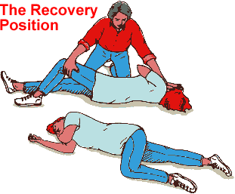
- allow the pupil to rest

- notify the parents that the pupil has had a seizure

OTHER SEIZURES

eg Complex partial seizures, absences

- keep calm and reassure the class

- observe the seizure carefully

- let the seizure run its natural course, protecting the pupil firmly but gently from sources of danger

- give reassurance when full consciousness is regained and allow to rest

- notify parents – directly or via a school/home notebook as previously agreed with parents

