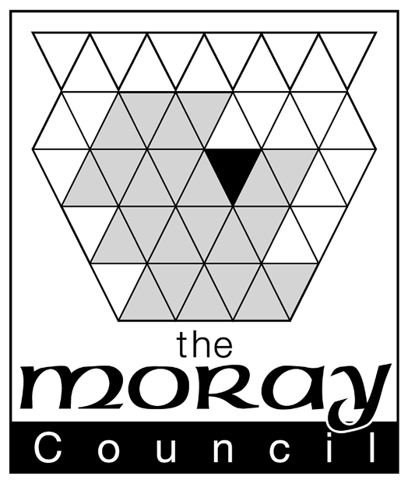
APPLICATION FOR THE CONVERSION OR NEW GRANT/CHANGE OF NAME OF AN UNLICENSED FAMILY ENTERTAINMENT CENTRE GAMING MACHINE PERMIT
(FOR USE BY OCCUPIERS/PROPOSED OCCUPIERS OF PREMISES INTENDED TO BE USED BY THE APPLICANT AS UNLICENSED FAMILY ENTERTAINMENT CENTRES)

Please refer to guidance notes at the back of this form before completing

To: The Clerk to the Licensing Board
Moray Licensing Board
Council Offices
High Street
Elgin
IV30 1BX
SECTION A – What do you want to do?  - Please indicate what you would like to do:  a) Apply to convert an existing Section 34 permit issued under the Gaming Act 1968, into an unlicensed family entertainment centre gaming machine permit  (if you choose this option then please complete sections B, D and E)  b) Apply for a new unlicensed family entertainment centre gaming machine permit  (if you choose this option then please complete sections B, D and E)  c) Request that the licensing authority changes the name on the permit due to the existing permit holder’s change of name or wish to be known by another name  (if you choose this option then please complete sections C, D and E) |  | □  □  □
SECTION B – Application for grant (includes both new and conversion applications)  2. Do you have an existing Section 34 permit issued under the Gaming Act 1968?  If “yes” the permit should be enclosed.* Existing Section 34 permit enclosed  3. Are you aware of any premises licence, issued under the Gambling Act 2005, which exists in relation to the premises to which this application relates? If “yes” please provide details (eg premises licence reference number)  ………………………………………………………………………………………… |  | Yes/No  □  Yes/No

SECTION C – Change of name

4. What is the name of the permit holder on the existing permit? ……………………………………………………………………………………………………………
5. What is the reference (eg number) of the existing permit? ……………………………………………………………………………………………………………
6. What name change is requested by the permit holder? ……………………………………………………………………………………………………………
7. Why is this change of name being requested? (see guidance note 8)
……………………………………………………………………………………………………………
…………………………………………………………………………………………………………….

* Please keep a copy of your existing permit on the premises to which it relates.
APPLICATION FOR THE CONVERSION OR NEW GRANT/CHANGE OF NAME OF AN UNLICENSED FAMILY ENTERTAINMENT CENTRE GAMING MACHINE PERMIT
(FOR USE BY OCCUPIERS/PROPOSED OCCUPIERS FO PREMISES INTENDED TO BE USED BY THE APPLICANT AS UNLICENSED FAMILY ENTERTAINMENT CENTRES)

SECTION D – General Information

8. Name of premises ……………………………………………………………………………………………...
9. Address of premises …………………………………………………………………………………………...
10. Telephone number of premises ………………………………………………………………………………..
11. Name of applicant ……………………………………………………………………………………………..
12. Address of applicant ………………………………………………………………………………………………………………………
………………………………………………………………………………………………………………………
13. Telephone number (daytime) of applicant …………………………………………………………………….
14. E-mail address of applicant ……………………………………………………………………………………
15. Name, address, telephone and e-mail of agent (eg solicitor) if submitted on behalf of the applicant
………………………………………………………………………………………………………………………
………………………………………………………………………………………………………………………
………………………………………………………………………………………………………………………
SECTION E – Fee and Signature(s)

I enclose a sum of £…….(cheques should be made payable to the Moray Council) □

I confirm that I occupy/propose to occupy the premises to which this application relates. □

I confirm that I am 18 years of age or older. □

Please note: It is an offence under section 342 of the Gambling Act 2005 if a person, without reasonable excuse, gives to a licensing authority for a purpose connected with that Act information which is false or misleading.

Dated …………………………………………………………………………………………………………….

Signed (by or on behalf of applicant/permit holder) ………………………………………………………….

Print Name ……………………………………………………………………………………………………….

APPLICATION FOR THE GRANT / CHANGE OF NAME OF AN
UNLICENSED FAMILY ENTERTAINMENT CENTRE GAMING MACHINE PERMIT
(FOR USE BY OCCUPIERS / PROPOSED OCCUPIERS OF PREMISES INTENDED TO BE USED BY THE APPLICANT AS UNLICENSED FAMILY ENTERTAINMENT CENTRES)

Guidance notes:
- This form is to be used for an application for a grant (or to request a change of name) of a unlicensed family entertainment centre gaming machine permit under the Gambling Act 2005 Section 247 and Schedule 10. This form can be used for both new applications and for applications to convert an existing Section 34 permit under the Gaming Act 1968 in accordance with the Gambling Act 2005 Statutory Instrument 2006 / 3272.
- An unlicensed family entertainment centre is entitled to provide an unlimited number of category D gaming machines available for use on the premises. Category C (adult) gaming machines CANNOT be made available for use and thus there will be no ‘designated adult areas’ required at the premises.
- The permit’s duration is 10 years. A renewal application must be made 2-6 months before the expiry date of the permit (Schedule 10 paragraph 18 Gambling Act 2005).
- The fee for a new application for grant is £300. The fee for the conversion of an existing Section 34 Gaming Act 1968 permit is £100. The fee for a change of name is £25.
- Applicants should be aware that this Licensing Board has published a ‘Statement of Principles’ under Schedule 10 paragraph of the Gambling Act 2005. The Statement of Principles is available via the Licensing Board’s pages on the Moray Council’s website or via a request made to the contact details provided at the top of this form.
- This Licensing Board must notify the applicant of its grant / refusal of the application for a permit as soon as is reasonably practicable after that decision to grant / refuse has been made.
- If an application has been made to convert an existing Section 34 Gaming Act 1968 permit before 31st July 2007, then the applicant can assume that, even where a decision has not been formally made by this Licensing Board, his/her application is to be treated as granted from September 2007. Following this, a permit must be provided by this authority as soon as reasonably practicable.
- These permits cannot be transferred. Change of name is only permitted where the permit holder changes his / her name or wishes to be known by another name (Schedule 10 paragraph 11(2)).

