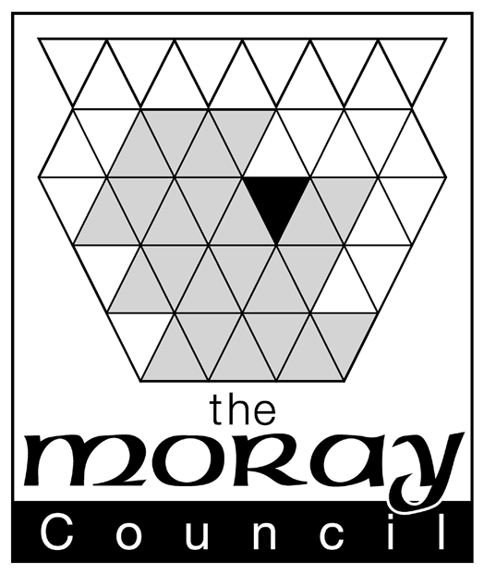
The Gambling Act 2005
Notice to the Moray Licensing Board of an intention to make 1 or 2 gaming machines available under section 282 of the Gambling Act 2005

This form is made available by the Moray Licensing Board in accordance with section 282(2) of the Gambling Act 2005 (“the Act”) to those premises that wish to register for an automatic entitlement to provide gambling facilities in the form 1 or 2 gaming machines of category C or D only.

Section 278(1) of the Act applies section 282 only to those premises in respect of which an on-premises alcohol licence has effect AND which contain a bar at which alcohol is served for consumption on the premises (without a requirement that alcohol is served only with food).

Tick the boxes to confirm (all boxes must be ticked to be eligible)
The premises benefits a relevant on-premises alcohol licence
The premises contains a bar where alcohol is served for consumption on the premises(without a requirement that alcohol is served only with food)
There is no club gaming or club machine permit in force

To register for an automatic entitlement under section 282 of the Act the person who holds the on-premises alcohol licence must sends the Moray Licensing Board written notice of his intention to make gaming machines available and the prescribed fee.
Automatic Entitlement to Gaming Machines on Alcohol Licensed Premises
This notification is provided by:-

(name of licence holder)
I intend to make gaming machines, of the category and number specified below, available for use on the following premises

(address of premises, including postcode)
Number of Category C* gaming machines:- (if no machines of this category are being offered, insert ‘0’)
*Category C machines have a maximum stake of 50 pence and a maximum prize of £35 and are for over 18’s only
Number of Category D gaming machines:- (if no machines of this category are being offered, insert ‘0’)
*Category D machines have a maximum stake of 10 pence and a maximum prize of £5 (or 30 pence and £8 for non monetary prizes and there is no age limit
Tick the boxes to confirm:
I have read and will comply with all relevant codes of practice about the location and operation of gaming machines (this is a pre-requisite for offering any machines)
I enclose the relevant fee of £50
I attach a copy of my existing section 34 permit (if applicable)

Signed:
Date:

To:
The Clerk to the Moray Licensing Board
Council office
High Street
Elgin
Moray
IV30 1BX

___Fold here

