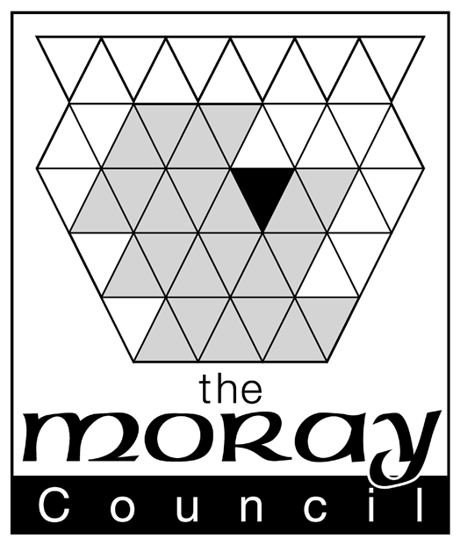

OFFICE USE

ONLY

APPLICATION FORM FOR GRANT OR RENEWAL

OF METAL DEALERS LICENCE
 | DATE
PLEASE READ GUIDANCE NOTES SUPPLIED BEFORE COMPLETING FORMS | RECEIVED
A. - PERSONAL DETAILS
- Full Name ………………………………………………………………
 | FEE PAID
- Home Address ………………………………………………………………
………………………………………………………………
 | code: 74307 1313
Postcode ………………………………………………………………
 | ANITE
 | INPUT
Tel. No. ………………………… Email…………………………………………………… | DATE
Age ………………. years
Date of Birth ………………………………. Place of Birth ………………………………
 | DATE OF
B – BUSINESS DETAILS | DECISION
- Business Name: …………………………………………………………
- Business Address ………………………………………………………..
(Principal Registered Office)
………………………………………………………… | DECISION
- Names, Private Addresses ……………………………………………………...
and Dates of Birth of Directors
or Partners of Business …………………………………............................
(incl Tel no and email)
………………………………………………………. | NO. OF
 | LICENCE
………………………………………………………. | ISSUED
- Name of employee responsible ………………………………………………………..
for day to day management of business
- Home address of employee …………………………………………………………. |  | RENEWAL
 |  | DATE
…………………………………………………………..
Tel no: …………………………….. Email: ……………………………………………….
Date of birth of employee: ………………………………….
Place of birth of employee: …………………………………………………..
C - PREMISES DETAILS
- Address of premises for which ……………………………………………………….
Licence is required
………………………………………………………
………………………………………………………
Tel no: …………………………………… Email: …………………………………………….
D – LICENCE DETAILS
- Tick one box only Grant
Renewal

If renewal – licence no: ……………………………………………………

State metals in which it is proposed to deal ………………………………………….
- State nature of activity engaged in ………………………………………………….
………………………………………………..
- State address or addresses ……………………………………………….
of the premises at which the metals
will be stored until the expiry of …………………………................................
48 hours after acquisition
- Are the metal to be disposed
of in the same condition in which they YES/NO

were received?

Indicate (i) the nature of and (ii) the place (i) …………………………………….

at which any process or processes are to be

carried out in relation to metal received. (ii) ………………………………

If not Renewal:

Have you previously held a metal

dealers licence in this area or any other in the UK? YES/NO

If yes Area ……………………………………………..

Dates & Duration of licence ……………………………………………..

Reason no longer licensed ……………………………………………...

If not Renewal:
Have you previously been refused a
metal dealers licence in this area or any other YES/NO
in the UK?
Area ………………………………………………….
Reason for refusal ………………………………………………….
Date(s) of refusal ……………………………………………………
E – CRIMINAL CONVICTIONS
Have you ever been convicted of
Any crime or offence including YES/NO
Contraventions of metal dealing?
If yes, details ……………………………………………………………………………………………………………
…………………………………………………………………………………………………………………………

See Guidance Notes for reference to “spent convictions”

Data Protection Act 1998 - The Moray Council will use the information about you on this form to process your licensing application. In processing your application, the information you have provided may be shared between Council departments and with other agencies where necessary. By signing this form you consent to the Council sharing your information in this way. The Council has a duty to process your information fairly and in accordance with the provisions of the Data Protection Act 1998. We will ensure that the information we hold is accurate, up to date, is kept only for as long as is necessary and is otherwise shared only where we are legally obliged to do so. You have a legal right to obtain details of the information that we hold about you and you can do so by making a “subject access request”. A request of this kind should be made in writing to the PPR & Communications Officer, Corporate Policy Unit, the Moray Council, High Street, Elgin. The Council has a Data Protection Policy which can be viewed at www.moray.gov.uk

I declare that the particulars given by me on this form are true and I hereby make application to The Moray Council for the grant or renewal of the licence applied for.

Date ……………………………… Signature of applicant ……………………………………………….
or
Signature of Agent on behalf of applicant ……………………………….

Agent's Address ……………………………………………………...

……………………………………………………..

N.B. It is an offence for any person to make any statement which he knows to be false in this application or in connection with the making of this application

