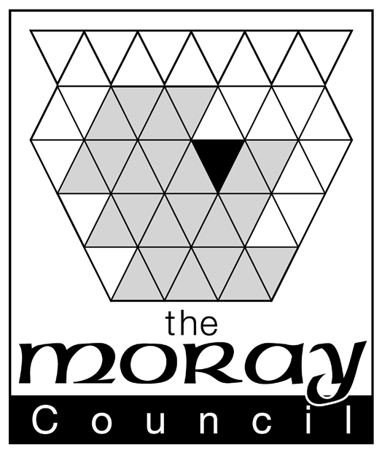

CERTIFICATE OF DISPLAY

GRANT/RENEWAL OF A MARKET OPERATOR'S LICENCE
I/WE

Applicant for Grant/Renewal*¹ of a Market Operator's Licence Hereby Certify that a Notice in the form prescribed by The Moray Council has been posted at or near the premises at

from (Date) to

Where the said Notice was removed, obscured or defaced during the above mentioned period. I/We certify that this was without any fault or intention on my/our part and I/we took reasonable steps for its protection
and replacement as follows*²:-

_____________________________________________________________________________________

_____________________________________________________________________________________

_____________________________________________________________________________________

_____________________________________________________________________________________

DATE

SIGNATURE

*¹ Delete as appropriate
*² Delete this paragraph if not applicable otherwise specify periods when Notice removed, obscured or defaced, relevant circumstances, and steps taken for protection and replacement.

