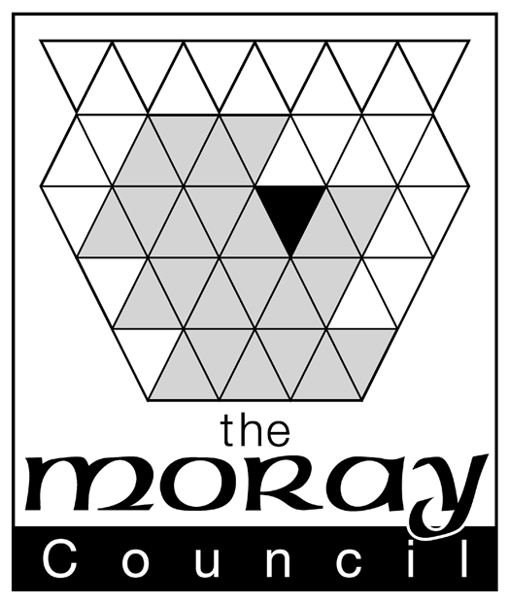

SUBSTITUTION OF VEHICLE, OR, VARIATION | OFFICE USE
OF TAXI OR PRIVATE HIRE LICENCE | ONLY

OR NOTIFICATION OF MATERIAL CHANGE IN CIRCUMSTANCES
PLEASE READ GUIDANCE NOTES SUPPLIED BEFORE COMPLETING FORMS | DATE
 | RECEIVED

- CURRENT LICENCE DETAILS -Please provide details of the licence you currently hold
- Tick one box only Taxi Licence ◻ Private Hire Licence ◻
- Licence No. ……………………………………….. Plate No ………………………
- Current vehicle registration …………………………………………………. | FEE PAID
- If Taxi, in which zone do you operate?
Tick one only Zone 1 ◻ (Elgin)
Zone 2 ◻ (outwith Elgin) | code: 74403 1313 (t)
 | 74404 1313(ph)

- PERSONAL DETAILS
 | DATE

Christian Names Surname
- Full Name …………………………………………………………………….
- Home Address …………………………………………………………………….

DATE OF
DECISION
…………………………………………………………………….
Postcode …………………………………………………………………….

Tel. No. ………………………………….. Email………………………………………………..
 | DECISION
- Moblie No. ………………………………….
- Age: ………… years Date of Birth: ………………………….
- Place of Birth: ………………………………. | NO. OF
 | LICENCE
- Do you intend to operate the vehicle yourself? YES/NO | ISSUED
- Business/Trading Name …………………………………………………………
C. – BUSINESS DETAILS | RENEWAL  DATE

Full Name of Business ……………………………………………………………………..
- Business Address …………………………………………………………………………
(Principal Registered Office)
………………………………………………………………….
Postcode ………………………………………………………………….
Tel No…………………………….. Nature of Business: Firm ◻
Partnership ◻
Limited Company ◻
Email………………………………………………

Please complete details of all Directors, Partners or other persons responsible for the
management of the business
(1)
- Full Name ……………………………………………………….
- Home Address ……………………………………………………………...
(include postcode)
……………………………………………………………...
- Age: …… years Tel No …………………………. Email……………………………………….
- Date of Birth: …………………………. Place of Birth: ……………………………
(2)
- Full Name ……………………………………………………….
- Home Address ……………………………………………………………...
(include postcode)
……………………………………………………………...
Age: …… years Tel No ………………………………. Email………………………………………
- Date of Birth: …………………………. Place of Birth: ……………………………
[Continue on separate sheet if necessary]
Please complete details of employee or agent who is to carry on day to day management of business
- Full Name ……………………………………………………………………
- Home Address …………………………………………………………………….
…………………………………………………………………….
Postcode …………………………………………………………………….

Tel. No. ………………………………….. Email……………………………………
- Age: …….. years
- Date of Birth:…………………………. Place of Birth: ………………………………

D - NEW VEHICLE DETAILS - Complete if you wish to substitute the vehicle currently licensed with
another vehicle
- Registration Number: ………………………………………….
- Date of first registration: Day …………….. Month ……………… Year ……………..
- Description of vehicle: Make …………… CC Rating …………… No. of Passenger Seats ………..
Model ………………….. Colour …………………… Chassis No. ………………………………...
- Registered Owner of Vehicle:
Name: ……………………………………………………………….
Address: ……………………………………………………………….
(include postcode)
……………………………………………………………….
- Address of premises where vehicle is to be kept: …………………………………………………….
(include postcode)
………………………………………………………………

E.- CRIMINAL CONVICTIONS
- Have you or any of the persons named as directors, partners or persons responsible for the management of the business ever been convicted of any crime or offence including driving endorsements or penalties?
YES/NO
If yes, details ……………………………………………………………………………………………………
……………………………………………………………………………………………………………………
Has the person named as the employee or agent who is to carry on the day to day management
of the business ever been convicted of any crime or offence including driving endorsements or penalties?
YES/NO
- See Guidance Notes for reference to "spent convictions"

Data Protection Act 1998 - The Moray Council will use the information about you on this form to process your licensing application. In processing your application, the information you have provided may be shared between Council departments and with other agencies where necessary. By signing this form you consent to the Council sharing your information in this way. The Council has a duty to process your information fairly and in accordance with the provisions of the Data Protection Act 1998. We will ensure that the information we hold is accurate, up to date, is kept only for as long as is necessary and is otherwise shared only where we are legally obliged to do so. You have a legal right to obtain details of the information that we hold about you and you can do so by making a “subject access request”. A request of this kind should be made in writing to the PPR & Communications Officer, Corporate Policy Unit, the Moray Council, High Street, Elgin. The Council has a Data Protection Policy which can be viewed at www.moray.gov.uk

I declare that the particulars given by me on this form are true and I hereby make application to The Moray Council for the grant or renewal of the licence applied for.

Date…………………………………… Signature of applicant or agent …………………………………………………

Agent's Address …………………………………………………….………….

………………………………………………………………

N.B. It is an offence for any person to make any statement which he knows to be false in this application or in connection with the making of this application

