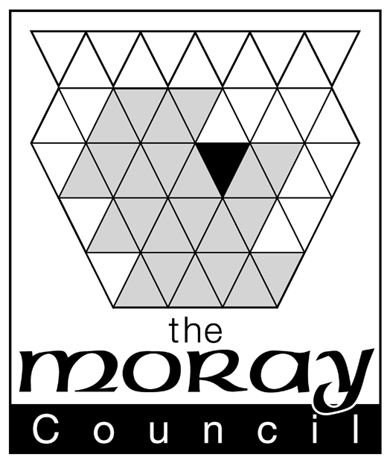

The Gambling Act 2005
Applicant’s Declaration in Respect of a Small Society Lottery

To the Moray Licensing Board:

The ……………………………..………………………………………………………………………. (name of society)
This declaration is to be completed by the applicant alongside the application for registration of a small society lottery. This declaration is required by the Moray Licensing Board in accordance with it’s policy on the running of small society lotteries. The declaration is acceptable evidence that the society qualifies as such under the Gambling Act 2005 as being non commercial i.e. established and conducted: for charitable purposes; or for the purpose of enabling participation in, or of supporting, sport, athletics or a cultural activity; or any other non-commercial purpose other than that of private gain.
If the Moray Licensing Board is not satisfied as to the society’s status in this regard then registration may be refused.

Declaration as to the status of the Society | I the undersigned declare that the Society represented by this application that is requesting registration with the Moray Licensing Board for the purpose of promoting small society lotteries is a bona fide non commercial society that was established and is being conducted for the following non commercial purpose(s):  (insert purpose(s) that must qualify as charitable purposes or for the purpose of enabling participation in, or of supporting, sport, athletics or a cultural activity or any other non-commercial purpose other than that of private gain – continue on a separate sheet if necessary)
Declaration as to persons associated | I the undersigned declare that the following person(s) will or may be connected with the promotion of the lottery and that any such person(s) has not been convicted of a relevant offence:
Declaration as to persons associated |  | Name | Conviction? Yes/No & Give Details if any
Declaration as to persons associated | 1
Declaration as to persons associated | 2
Declaration as to persons associated | 3
Declaration as to persons associated | 4
Declaration as to persons associated | 5
Declaration as to persons associated | (insert names, addresses and dates of birth of those person(s) engaged in promoting the lotteries - relevant offences are detailed in Schedule 7 to the Act and may be further prescribed under Regulations. Schedule 7 offences are repeated on the reverse of this form – continue on a separate sheet if necessary)
Data Protection Notice | Relevant convictions form a ground for refusal of registration. The information on this form may be used for the purpose of checking with Grampian police that no relevant convictions exist but will not be used for any other purpose.

A copy of the Society’s constitution is attached
Signature (member 1) |  | Name (block caps)
Date

Relevant Offences as listed in Schedule 7 to the Gambling Act 2005

Gambling offences
1 An offence under—
(a) this Act,
(b) the Betting, Gaming and Lotteries Act 1963 (c. 2),
(c) the Gaming Act 1968 (c. 65),
(d) the Lotteries and Amusements Act 1976 (c. 32),
(e) the National Lottery etc. Act 1993 (c. 39), or
(f) the National Lottery Act 1998 (c. 22).

Theft, &c.
2 An offence under any of the following provisions of the Theft Act 1968 (c. 60)—
(a) section 1 (theft),
(b) section 8 (robbery),
(c) section 9 (burglary),
(d) section 10 (aggravated burglary),
(e) section 11 (theft from exhibition, &c.),
(f) section 12A (aggravated vehicle-taking),
(g) section 13 (abstracting electricity),
(h) section 15 (obtaining property by deception),
(i) section 15A (obtaining money transfer by deception),
(j) section 16 (obtaining pecuniary advantage by deception),
(k) section 17 (false accounting),
(l) section 19 (false statement by director, &c.),
(m) section 20 (suppression of document, &c.),
(n) section 21 (blackmail),
(o) section 22 (handling stolen goods),
(p) section 24A (retaining wrong credit), and
(q) section 25 (going equipped for stealing, &c.).
3 An offence under section 1 or 2 of the Theft Act 1978 (c. 31) (obtaining services, or evading liability, by deception).
4 An offence under section 170 or 170B of the Customs and Excise Management Act 1979 (c. 2) (evasion of duty).
5 An offence under section 58(1) of the Civic Government (Scotland) Act 1982 (c. 45) (convicted thief in possession).
6 Both in England and Wales and in Scotland, the offence at common law of conspiracy to defraud.
7 In Scotland the offences at common law of—
(a) theft,
(b) robbery,
(c) theft by housebreaking,
(d) fraud,
(e) extortion, and
(f) reset.

Miscellaneous
8 A sexual offence within the meaning of section 161(2) of the Powers of Criminal Courts (Sentencing) Act 2000 (c. 6).
9 A violent offence within the meaning of section 161(3) of that Act.
10 An offence under—
(a) the Firearms Act 1968 (c. 27), or
(b) the Firearms (Amendment) Act 1988 (c. 45).
11 An offence under any of the following provisions of the Misuse of Drugs Act 1971 (c. 38)—
(a) section 4(2) (production),
(b) section 4(3) (supply),
(c) section 5(3) (possession with intent to supply), and
(d) section 8 (permitting activity on premises).
12 An offence under the Forgery and Counterfeiting Act 1981 (c. 45), except for sections 18 and 19 (reproduction and imitation notes and coins).
13 An offence under section 3 of the Private Security Industry Act 2001 (c. 12) (unlicensed activity).
14 An offence under section 70 of the Army Act 1955 (c. 18) in so far as it relates to an offence listed elsewhere in this Schedule.
15 An offence under section 70 of the Air Force Act 1955 (c. 19) in so far as it relates to an offence listed elsewhere in this Schedule.
16 An offence under section 42 of the Naval Discipline Act 1957 (c. 53) in so far as it relates to an offence listed elsewhere in this Schedule.
17 An offence under section 52 or 52A of the Civic Government (Scotland) Act 1982 (offences relating to indecent photographs of children).
18 An offence under any of the following provisions of the Criminal Law (Consolidation) (Scotland) Act 1995 (c. 39)—
(a) section 1 (incest),
(b) section 2 (intercourse with a stepchild),
(c) section 3 (intercourse with child under 16 by person in position of trust),
(d) section 5 (unlawful intercourse with a girl under 16),
(e) section 6 (indecent behaviour towards girl between 12 and 16),
(f) section 8 (detention of woman in brothel or other premises),
(g) section 10 (person having parental responsibilities causing or encouraging sexual activity in relation to a girl under 16), and
(h) section 13(5) (homosexual offences).
19 In Scotland, the offences at common law of—
(a) rape,
(b) clandestine injury to women,
(c) abduction of a woman or girl with intent to rape or ravish,
(d) assault with intent to rape or ravish,
(e) indecent assault,
(f) lewd, indecent or libidinous behaviour or practices,
(g) shameless indecency,
(h) sodomy,
(i) murder,
(j) culpable homicide, and
(k) assault.
20 In Scotland, the offence at common law of uttering and fraud.
21 An inchoate offence relating to an offence listed elsewhere in this Schedule.
22 A reference in this Part of this Schedule to an offence under an Act or a provision of an Act includes a reference to an offence under subordinate legislation made under that Act or provision.

