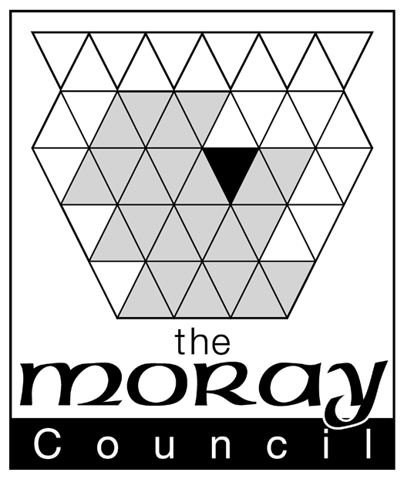

The Gambling Act 2005
Return by the Promoter of a Small Society's Lottery under Paragraph 39 of Part 4 of Schedule 11

To the Moray Licensing Board:

The ………………..………………………………………………………………………. (name of society)
lottery held on …………………………………… (insert date of draw).
This return is required by paragraph Paragraph 39 of Part 4 of Schedule 11 to the Gambling Act 2005. A Return must be submitted after each draw to be received by the Moray Licensing Board no later than 3 months from the date of the draw (or last draw) (or for instant win draws like scratch cards 3 months from when the last card was made available). Failure to provide returns will be treated as a serious matter and the society will be the subject of investigation which may lead to its registration being revoked. This form must be signed by 2 members of the society who are over 18 and authorised, in writing by the society or its governing board to promote lotteries. A copy of the authorisation must also be attached.
Further forms can be obtained from the Moray Council’s website or by request from the Licensing Dept. Photocopies and electronic submission of returns will be accepted.

Lottery Arrangements
Please describe here how the lottery was run including the dates when tickets were available, ticket prices, the number sold, the nature and amount or value of any prizes, date(s) of draws and any arrangements for a rollover. Continue on a separate sheet if necessary
Whole Proceeds of the Lottery
Please insert here the total amount of the lottery proceeds being the number of tickets sold multiplied by the price of each.
Prize Fund
Please insert here the total amount deducted from the whole proceeds to provide prizes (including prizes for a rollover).
Expenses
Please insert here the total amount deducted from the whole proceeds to cover expense of organising and running the lottery.
Money for Good Causes
Please insert here the amount gained and used by the society to promote the purpose(s) for which the society was formed.
Purpose
Please insert here the purpose(s) to which proceeds of the lottery were applied.
Other Expenses  Please detail here any expenses that were met otherwise than out of the proceeds of this lottery. Each expense should be separately detailed and the list must also identify the source of the funds used to meet each expense.  Continue on a separate sheet if necessary. | Nature & Amount of Expense | Source of Funds

We, the undersigned being two members of the above-named society of full age, duly appointed in writing by the governing body of the society, certify that the above return is correct.
A copy of our written appointment is attached
Signature (member 1) |  | Name (block caps)
Signature (member 2) |  | Name (block caps)
Date

