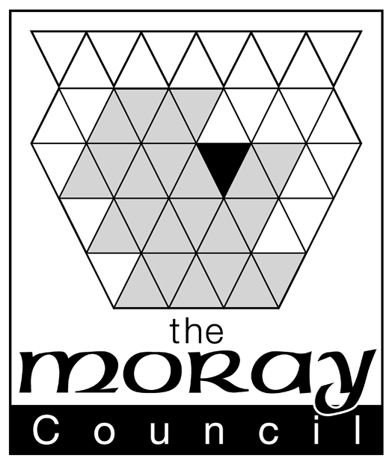 |  | Roderick D Burns  Chief Legal Officer  The Moray Council  Council Office, High Street, Elgin IV30 1BX  Tel: (01343) 563011 Fax: (01343) 540183  DX No 520666 Elgin  www.moray.org  e-mail: roddy.burns@moray.gov.uk  .

Our ref: RDB/ Your ref:

Dear Parent/Guardian

THE DUKE OF EDINBURGH’S AWARD

PARENTAL GUIDANCE/CONSENT ARRANGEMENT (2009 EDITION)

I am delighted that your son/daughter is taking part in the Duke of Edinburgh’s Award.

The Moray Council is responsible for operating the Award and we want to ensure your son/daughter gets a thoroughly enjoyable and quality experience.

To this end, all Council staff working on the Award are vetted to ensure that they are suitably qualified and competent. When activities are organised by the Council, we will always ensure that the individuals or organisations involved are also vetted and meet necessary standards. All Council staff, volunteers and the young people taking part in activities organised by the Council are covered by personal accident and third party insurance.

As a parent you may wish your son/daughter to take part in the Award by arrangement with other agencies such as voluntary organisations, commercial organisations or local groups eg a badminton club or guitar tutor. Any such arrangements are not covered by the Council’s insurance and the Council does not vet these bodies, their staff or volunteers, or the standards of work that they provide.

If you do make such arrangements with a provider other than the Council, you are strongly advised to:-

- arrange private insurance cover for your son/daughter and/or
- seek written assurances from the provider with regard to safety standards, the qualifications and competencies of instructors, and the insurance cover in the event of a young person suffering an accident or loss during those activities.

If you have any questions about any of the above please contact me at the above address.

Please complete the attached enrolment form and return it to the Award Group Leader who issued this letter.

Yours sincerely

Roderick D Burns
CHIEF LEGAL OFFICER
AWARD OFFICER FOR MORAY

