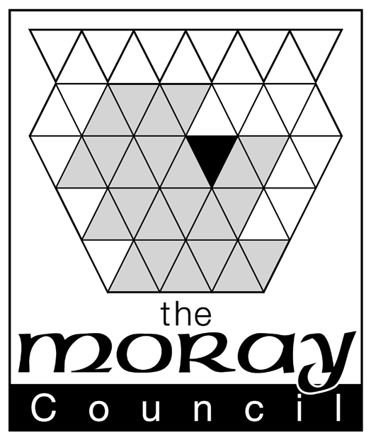 |  | Clerk to the Board  Moray Licensing Board  Council Office, High Street, Elgin IV30 1BX  DX No 520666 Elgin
Licensing (Scotland) Act 2005
Application for Occasional Licence
Before completing this form please read the guidance notes at the end of the form. If you are completing this form by hand please write legibly in block capitals. In all cases ensure that your answers are inside the boxes and written or typed in black ink. Use additional sheets, if necessary. You may wish to keep a copy of the completed from for your records.
On submitting an application you receive an acknowledgement letter. We require a minimum of 28 calendar days prior to the event to process an Occasional Licence application. Applications received less than 28 days prior to the event CANNOT be processed and will be returned to you.

1. LICENCE DETAILS (see note 1)
Premises licence number (if applicable)
Personal licence number (if applicable)
Name of voluntary organisation (if applicable)

2. PERSONAL DETAILS
TITLE (delete as appropriate): Mr Mrs Miss Ms Other (please state)
Surname
Forenames
DATE OF BIRTH |  |  | Day | Month | Year
ADDRESS WHERE ORDINARILY RESIDENT TO BE USED FOR CORRESPONDENCE PURPOSES
Post Town |  | Post code
TELEPHONE NUMBERS
Daytime
Evening
Mobile
FAX NUMBER
EMAIL ADDRESS (if you would prefer us to correspond you by e-mail)

3. THE PREMISES
Description of Premises

Description of activities to be carried on the premises

Full postal address of premises which this application refers to

4. DURATION OF LICENCE
From:
To:

5. Is alcohol to be sold on & off the premises YES/NO* - Provide relevant details as to hours requested when alcohol will be sold on/off the premises-* delete as appropriate
Times for sale of alcohol for consumption on premises | Times for sale of alcohol for consumption off premises

Statement of the times at which any activities other than the sale of alcohol will be carried on the premises

6. CHILDREN (see note 2)

This section must be completed where alcohol is for sale for consumption on the premises
Are children or young persons permitted entry? YES/NO (if answered yes the remainder of this section must be completed)
Ages of children or young persons permitted entry | Times at which children or young persons permitted entry
Parts of premises to which children or young persons permitted entry

7. CHECKLIST
I have

Please tick yes
- Made or enclosed payment of the fee for the application

8. Signature and declaration by applicant (see note 3)

DECLARATION

IT IS AN OFFENCE TO MAKE A FALSE STATEMENT IN OR IN CONNECTION WITH THIS APPLICATION

(Criminal Law (Consolidation) (Scotland) Act 1995 Section 44(2)(b))

The contents of this Application are true to the best of my knowledge and belief.
SIGNATURE |  | DATE

NOTES

- Section 56 of the Licensing (Scotland) Act 2005 Provides that only :-

  - The holder of a premises licence;
  - The holder of a personal licence; or
  - A representative of any voluntary organisation

is eligible to apply for an occasional licence.

- Where alcohol is to be sold for consumption on the premises, the Act requires that a clear statement be made as to whether children or young persons are to be allowed entry and, if they are, a statement of the terms on which they are allowed entry

- Data Protection Act 1998

The information on this form may be held on an electronic register which may be available to members of the public on request.

- Information on the Licensing (Scotland) Act 2005 is available on the website of the Scottish Parliament (http://opsi.gov.uk/legislation/scotland/acts2005/20050016.htm)

