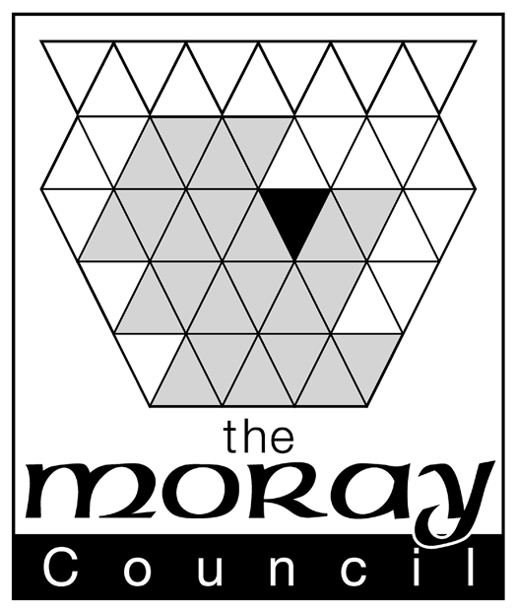 |  | Fee £10  Clerk to the Board  Moray Licensing Board  Council Office, High Street, Elgin IV30 1BX  DX No 520666 Elgin
Licensing (Scotland) Act 2005
Application for Extended Hours
Before completing this form please read the guidance notes at the end of the form.
If you are completing this form by hand please write legibly in block capitals. In all cases ensure that your answers are inside the boxes and written or typed in black ink. Use additional sheets, if necessary. You may wish to keep a copy of the completed from for your records. On submitting an application you receive an acknowledgement letter. We require a minimum of 28 calendar days prior to the event to process an Extended Hours application. Applications received less than 28 days prior to the event CANNOT be processed and will be returned to you.

1. LICENCE DETAILS (see note 1)
Premises licence number
Premises name
Premises address
(including postcode)
Premises licence holder

2. APPLICANTS DETAILS
Name of individual
Company/Partnership
Other
ADDRESS TO BE USED FOR CORRESPONDENCE PURPOSES
Post Town |  | Post code
TELEPHONE NUMBERS
Daytime
Evening
Mobile
FAX NUMBER
EMAIL ADDRESS (if you would prefer us to correspond you by e-mail)

3. THE EVENT AND ACTIVITIES
Description of activities to be carried on the premises

4. DURATION OF LICENCE
From:
To:

5. Is alcohol to be sold on & off the premises YES/NO* - Provide relevant details as to hours requested when alcohol will be sold on/off the premises-* delete as appropriate
Times for sale of alcohol for consumption ON premises |  |  | Times for sale of alcohol for consumption OFF premises
Day | Commencement Time | Terminal Hour | Day | Commencement Time | Terminal Hour
Monday |  |  | Monday
Tuesday |  |  | Tuesday
Wednesday |  |  | Wednesday
Thursday |  |  | Thursday
Friday |  |  | Friday
Saturday |  |  | Saturday
Sunday |  |  | Sunday

Statement of the times at which any activities other than the sale of alcohol will be carried on the premises

6. CHILDREN (see note 2)

This section must be completed where alcohol is for sale for consumption on the premises
Are children or young persons permitted entry? YES/NO (if answered yes the remainder of this section must be completed)
Ages of children or young persons permitted entry | Times at which children or young persons permitted entry
Parts of premises to which children or young persons permitted entry

Describe arrangements as to how the applicant will promote the licensing objective of protecting children from harm

7. CHECKLIST
I have

Please tick yes
- Made or enclosed payment of the fee for the application

8. Signature and declaration by applicant (see note 3)

DECLARATION

IT IS AN OFFENCE TO MAKE A FALSE STATEMENT IN OR IN CONNECTION WITH THIS APPLICATION

(Criminal Law (Consolidation) (Scotland) Act 1995 Section 44(2)(b))

The contents of this Application are true to the best of my knowledge and belief.
SIGNATURE |  | DATE

see reverse for notes

NOTES
- Section 68 provides that :-
(1) The appropriate Licensing Board may—
(a) on the application of the holder of the premises licence in respect of any licensed premises, and
(b) if the Board consider it appropriate to do so in connection with—
(i) a special event or occasion to be catered for on the premises, or
(ii) a special event of local or national significance,
extend the licensed hours in respect of the premises by such period as is specified in the application or such other period as the Board consider appropriate.
- The applicant must be the licence holder.

- Please describe in detail the event for which the extension is required and all activities that will take place as part of the event. Note in paragraph 1 above that the event must be a special one to be catered for on the premises or one of local or national significance.

- Insert the inclusive dates during which the extension is required. Note that as s.68(2) provides that “An extension of licensed hours under subsection (1) has effect for such period as is specified in the application or such other period as the Board consider appropriate; but in either case the period must not exceed one month.”

- Insert the extended hours sought. Your operating plan will detail the core hours during which the premises will be open anyway. Insert here the hours required over and above those core hours e.g. a premises normally opens between 11am and 11pm but wishes to host a wedding with a bar until 1am on a Saturday. Insert here against Saturday a commencement time of 11pm and a terminal hour of 1am.

Also detail here the times for planned activities.

- Detail here the arrangements proposed for children. You may have child provisions within the operating plan but they may not cover the period of the extended hours. Where hours are extended at the end of core hours then special consideration should be given to the licensing objective of protecting children from harm.

- Data Protection Act 1998 - The information on this form may be held on an electronic register which may be available to members of the public on request.

