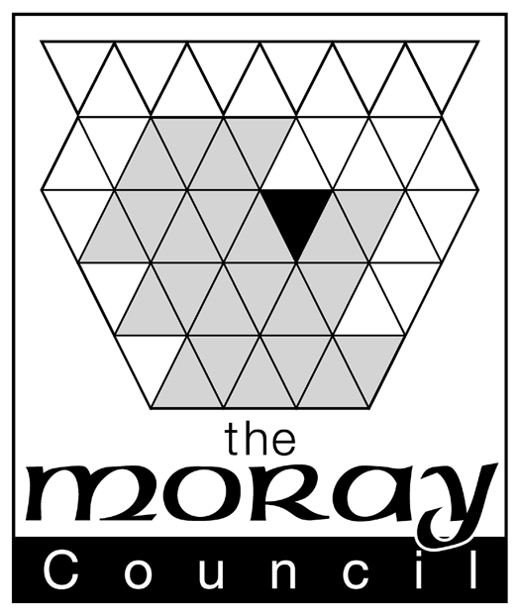

Prize Gaming Permits and the Gambling Act 2005 (the Act)

This guidance does not constitute legal advice. It is a general description that is not intended to be definitive in particular situations. If you have any queries over and above this guidance then you should seek advice from a solicitor. Please see the general exclusion of liability.

The Gambling Act 2005 came into force on the 1st September 2005 and replaced all pre-existing legislation. The Act created a new regulator for all gambling business in Britain being the Gambling Commission (the Commission). More detailed information about anything to do with gambling is available from the Gambling Commission website at:
http://www.gamblingcommission.gov.uk

Prize competitions which are not otherwise betting, gaming or lotteries and free draws are exempt from regulatory control under the Gambling Act. Therefore there are no licensing requirements for activities that genuinely fall within these categories.

Being outside of the scope of the Act, prize competitions and free draws can therefore be organised commercially for private benefit and profit. For further information on the conditions that must be satisfied for a matter to qualify as a prize competition or a free prize draw please see the Council’s website for a copy of our separate leaflet “Prize Competitions Free Draws and the Gambling Act 2005”.

Where the Commission believes that a competition or draw is in fact an illegal unlicensed lottery it will have the power to investigate and prosecution may result. A lottery is loosely defined as any scheme whereby persons are required to pay to participate and one or more prizes are allocated to the participants in the scheme by a method that relies wholly by chance or by a series of methods the first of which relies wholly on chance. For more detailed information about operating lawful lotteries under the Gambling Act 2005 please see the Council’s website for a copy of our leaflet “Lotteries and the Gambling Act 2005”.

Prize Gaming

Prize Gaming is defined as being gaming where neither the nature nor the size of the prize is determined by the number of people playing or the amount paid for or raised by the gaming. The prizes are determined by the operator before the play commences.

Applicants are advised to satisfy themselves that there is no need to apply to the Gambling Commission for an operating licence.

Children and young persons may participate in equal chance prize gaming only.

It is important to note that provisions of the new Act which relate to prize gaming do not authorise the use of any gaming machines.

Automatic Entitlement to Offer Prize Gaming

Prize gaming is permitted in certain premises as an automatic entitlement without the need for further permissions. The automatic exemptions are for adult gaming centres, licensed family entertainment centres, premises with a family entertainment centre gaming machine permit*, premises with a bingo premises licence and travelling fairs*†. Casinos can offer prize gaming other than bingo.

*these entitlements are limited to equal chance prize gaming only
†gambling must be ancillary to the fair and not the main source of amusement

For the automatic exemption to apply all operators other than bingo premises must also comply with the conditions:
- All chances to participate (tickets) may only be sold or supplied on the premises where the game is taking place and only at the time when the game is taking place;
- The game must be played entirely on that day;
- The result must be announced as soon as reasonably practicable after the game and in any event the same day;
- Prizes must not exceed prescribed amounts (in money or value);
- Participation cannot entitle a person to engage is any other gambling.

Non-Commercial (Prize) Gaming

Part 14 of the Act authorises non commercial prize gaming as long as certain conditions are met. This envisages low level gaming for the benefit of good causes (not necessarily charitable). Non-commercial gaming may only take place at events, typically fund raising events. The event must not be on premises where a gambling premises licence is in force. None of the proceeds from the event itself can be used for private gain. It will be considered to be private gain where the idea is to hold an event to attract people and thereby sell food etc as ancillary to the event for individual profit. Private gain in this sense would not be restricted to just profiting from the event itself e.g. from ticket sales. All proceeds must be for purposes other than private gain. There are two types of non-commercial gaming.
Prize gaming: where the prizes are put up in advance, and are not dependent on the number of players taking part or the amount of money staked. There are no statutory limits on stakes, prizes, participation fees or other charges for this type of gaming.
Equal chance gaming: where the amount or value of the prizes varies according to the number of players who participate and/or the amount of money they stake. Here a single payment of £8 per day may be charged to cover admission, stakes and any other charges for playing. The total value of prizes must not exceed £600 in one day. Where an event is the final one of a series in which all of the players have previously taken part, a higher prize fund of no more than £900 is permitted.
In all cases the players participating in non-commercial bingo must be told what “good cause” is to benefit from the profits from the gaming.

Prize Gaming Permits

Premises other than those above may still offer prize gaming but only if they hold a prize gaming permit. Application cannot be made for a prize gaming permit for a vehicle, a vessel, premises where a premises licence is in force or premises holding a club gaming permit.
Application can be made (by an individual over 18 or company occupying the premises) to the licensing authority in whose area the premises are wholly or partly situated and must be in such form and manner as the licensing authority may direct.
Anyone wishing to apply for a prize gaming permit should go to the gambling section of the Moray Council’s website for an application form. The website also gives details of the fees.

All applications will be referred to the police for comments. Any application will be considered by the Moray Licensing Board which need not (but may) have regard to the licensing objectives, and must have regard to any relevant guidance issued by the Commission. The Board may only grant or refuse the application and may not attach conditions to a permit. Where the Board proposes refusing the application then the applicant will first be given an opportunity to make representations.

A permit will last for ten years unless it ceases to have effect in that time (e.g. if the permit holder ceases to occupy the premises or surrenders the permit or dies or if a Court orders its forfeiture following a relevant conviction etc) and can be renewed at the end of the period. The permit should be kept on the premises and be made available for inspection.
An application for renewal of a permit must be made during the period beginning six months before the licence expires and ending two months before it expires. The procedure for renewal is the same as for an application. A permit will not cease to have effect while a renewal application is pending.

