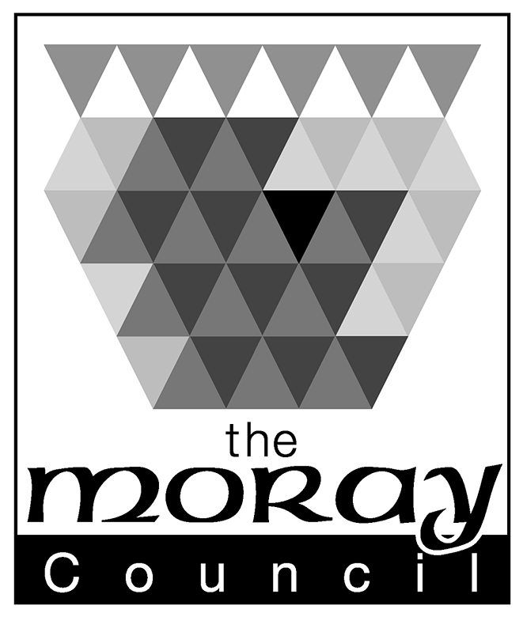

The Moray Council

Corporate Services

Instruction to your Bank or Building Society to pay by Direct Debit
Please fill in the whole form including official use box using a ball point pen and send it to: |  |  |  |  |  |  |  |  |  |  |  |  |  |  |  |  |  |  |  |  |  | Originator's Identification Number
Payments Section  Corporate Services  Moray Council  High Street  Elgin  IV30 1BX |  |  |  |  |  |  |  |  |  |  |  |  |  |  |  |  |  |  |  |  |  | 5 | 0 | 0 | 0 | 7 | 7
FOR MORAY COUNCIL USE ONLY
This is not part of the instruction to your Bank or Building Society.

Your direct debit payment will be collected on the 10th day of the month following production of the invoice. Except when the 10th falls on a weekend or bank holiday, when they will be collected on the next working day.
Name(s) of Account Holder(s)
Bank/Building Society account number
Branch Sort Code |  |  |  |  |  |  |  |  |  |  |  |  |  |  |  |  |  |  |  |  |  | Instruction to your Bank or Building Society  Please pay The Moray Council Direct Debits from the account detailed in this Instruction subject to the safeguards assured by the Direct Debit Guarantee. I understand that this Instruction may remain with The Moray Council and, if so, details will be passed electronically to my Bank/Building Society.
Name and full postal address of your Bank or Building Society
To: The Manager |  |  |  |  |  |  |  |  |  | Bank/Building Society
Address |  |  |  |  |  |  |  |  |  |  |  |  |  |  |  |  |  |  |  |  |  | Signature(s)
 |  |  |  |  |  |  |  |  |  |  |  | Postcode |  |  |  |  |  |  |  |  |  | Date
Customer Number (Found on your invoice)
0 | 2 |  | -
Banks and Building Societies may not accept Direct Debit Instructions from some types of account

This guarantee should be detached and retained by the Payer.


The Direct Debit Guarantee
- This Guarantee is offered by all banks and building societies that accept instructions to pay Direct Debits
- If there are any changes to the amount, date or frequency of your Direct Debit The Moray Council will notify you 10 working days in advance of your account being debited or as otherwise agreed. If you request The Moray Council to collect a payment, confirmation of the amount and date will be given to you at the time of the request
- If an error is made in the payment of your Direct Debit, by The Moray Council or your bank or building society, you are entitled to a full and immediate refund of the amount paid from your bank or building society
- If you receive a refund you are not entitled to, you must pay it back when The Moray Council asks you to

- You can cancel a Direct Debit at any time by simply contacting your bank or building society. Written confirmation may be required. Please also notify us.

