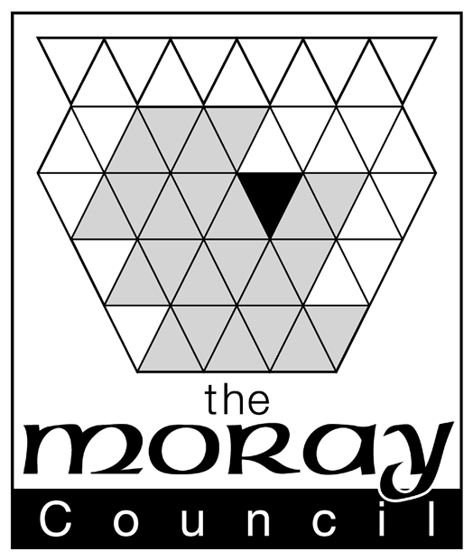

APPLICATION FORM FOR DISPENSATION FROM PROHIBITION ON THE USE OF FIREWORKS DURING NIGHT HOURS | OFFICE USE
 | ONLY

BY INDIVIDUAL PERSON
(NOT A COMPANY/PARTNERSHIP) | DATE
 | RECEIVED

PLEASE READ GUIDANCE NOTES SUPPLIED BEFORE COMPLETING FORMS
- - PERSONAL DETAILS

Christian Name Surname
 | FEE PAID
- Full Name …………………………………………………………………….
- Home Address …………………………………………………………………….
……………………………………………………………………. | ANITE INPUT
……………………………………………………………………. | DATE
Tel. No. ……………………………… Email……………………………………….. | DATE OF
 | DECISION
- Age: ……………….. years
- Date of Birth: ………………………….
- Place of Birth: ………………………………. | DECISION
I am: (you must tick 1 box)
- Employed by a professional organiser or operator of firework displays ◻
- In business as a professional organiser or operator of firework displays ◻ | NO. OF

Full Name of business/department/establishment ……………………………………………………………
……………………………………………………………………………………………..
Address …………………………………………………………………………………… | RENEWAL  DATE
…………………………..……………………………………………
Tel No ………………………… Nature of Business Firm ◻
Partnership ◻
Email…………………………………………… Limited Company ◻

B.- DISPLAY DETAILS
- Name of place/site ………………………………………………………………
for which a dispensation
is required ………………………………………………………………
- State date of firework display ……………………………………………………………….
……………………………………………………………….
- State description of event at ……………………………………………………………….
which fireworks are to be
used ………………………………………………………………

- State name of person for whom ……………………………………………………………….
display is being run
- State maximum number of ……………………………………………………………….
persons to be admitted to the
premises/site/event at any ……………………………………………………………….
one time
- State name of person in charge ……………………………………………………………….
of firing display Contact details: ………………………………………………
………………………………………………………………..
- State hours during which the ………………………………………………………………..
The display will take place ………………………………………………………………..
- Provide description of the ………………………………………………………………..
firework display
………………………………………………………………..
- Provide description of all ………………………………………………………………..
fireworks (effects) to be
used during the display ………………………………………………………………..

Where are the fireworks to ………………………………………………………………

be kept prior to use?

Distance between nearest ……………………………………………………………….

residential building and

point at which fireworks ……………………………………………………………….

be used

C. - INSURANCE DETAILS

Specify the public liability insurance which you have in force, giving details of the insurance company and amount of cover

…………………………………………………………………………………………………

…………………………………………………………………………………………………

…………………………………………………………………………………………………

…………………………………………………………………………………………………

NOTE: Please enclose with the application the insurance certificate or other proof of insurance cover

D.- CRIMINAL CONVICTIONS
Have you, or any other person named in this application, been
convicted of any crime or offence YES/NO
If yes, details: ………………………………………………………………………………………………………...
…………………………………………………………………………………………………………
…………………………………………………………………………………………………………
- See Guidance Notes for reference to "spent convictions".
Data Protection Act 1998 - The Moray Council will use the information about you on this form to process your licensing application. In processing your application, the information you have provided may be shared between Council departments and with other agencies where necessary. By signing this form you consent to the Council sharing your information in this way. The Council has a duty to process your information fairly and in accordance with the provisions of the Data Protection Act 1998. We will ensure that the information we hold is accurate, up to date, is kept only for as long as is necessary and is otherwise shared only where we are legally obliged to do so. You have a legal right to obtain details of the information that we hold about you and you can so by making a “subject access request”. A request of this kind should be made in writing to the PPR & Communications Officer, Corporate Policy Unit, the Moray Council, High Street, Elgin. The Council has a Data Protection Policy which can be viewed at www.moray.gov.uk

I/we declare that I/we shall, at least 7 days prior to the display taking place, give public notice in a local newspaper of my/our intention to use fireworks

I/We declare that the particulars given by me on this form are true and I hereby make application to The Moray Council for the grant of the dispensation applied for.

Date …………………… Signature of applicant or agent ……………………………………...
or
Signature of Agent on behalf of applicant …………………………..

Agent's Address ……………………………………………………..
.
N.B. It is an offence for any person to make any statement which he knows to be false in this application or in connection with the making of this application

