Moving On 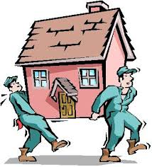

- What do you see as the positive things in your life just now?

Good | Not so good

- What do you hope the future holds for you?

______________________________________________________________

______________________________________________________________

2a. From the above make a list of things you want for your future starting with the most important

- ________________________________________________________

- ________________________________________________________

- ________________________________________________________

- ________________________________________________________

- ________________________________________________________

- ________________________________________________________

- ________________________________________________________

- ________________________________________________________

- Have you had an opportunity to watch the TCAC DVD and what did you think about it?

____________________________________________________________

- What do you think you will need help with when you leave care?

List Headings in this box Yes No

- On the chart below please note the good and not so good things about leaving care.

Good | Not so good

- What do you enjoy doing in your spare time?

______________________________________________________________

______________________________________________________________
- Are there any interests or groups you would like to be able to start?

Yes No

- List below any activities/hobbies to be looked into and indentify who you would like to help you do this.

Activity | Helped By | When/How

- Important people in my life.

Name | What support do they offer now? | Will you stay in contact with this person?

- When you eventually move to your own place, will you stay in contact with these people and accept any support they offer?
_____________________________________________________________

_____________________________________________________________

Young Person _________________________________________________
Where Next Action Plan

Section _______________________________________________________

What needs to be done? | Who will do these things? | When will these things be done by?

