TRUST FUNDS

GRANT APPLICATION FORM

Trust Fund (To which you are applying, if known)

TELL US ABOUT YOURSELF/YOUR GROUP

Question 1
Name of Group
This is the name of the group or organisation that is applying for a grant. If you are applying as private individual, put your name here.

Name of main contact in the group (to whom correspondence will be sent)
Title |  | First Name |  | Surname

Position held in group

Full Address for Correspondence

Email address
For the primary contact

Question 2
What type of group are you?
If applying as an individual skip to Question 4.

Registered Charity |  |  | Scottish Registration Number
Voluntary |  |  | Do you have a constitution? | Yes | No
Other

If Other Explain

Question 3

What are the main activities, objectives and aims of your group?
TELL US ABOUT THE AWARD

Question 4

a) How much money are you applying for and briefly describe your project, proposal or activity? Please include (where appropriate) evidence of need for this project.
 | Total Cost (£) | Amount Requested (£)

b) If the grant is needed for an on-going project, what are your plans for future/ongoing funding

Question 5

How many people will benefit from the grant? (approximately)

Where geographically will the benefit of the grant be delivered.

Question 6

What are the main benefits the grant award will achieve

Other Details

Question 7

a) Give details of any fundraising you have done for the project described in this application?
Total (£)

b) Have you applied for, or do you intend applying for funds from other bodies for the project described in this application? If so, tell us how much you have applied for, or intend applying for.
Amount (£)

c) Have you applied for a Trust Fund Grant before? | Yes | No

If yes, when did you apply and for what

Question 8

Please give information relating to your most recent accounts (audited if applicable)
Applicable to groups and organisations only

Year Ending
Total Income |  |  | £
Minus Total Expenditure |  |  | - £
Equals Surplus/Deficit for the Year |  |  | = £
Savings (Cash, Investments, Reserves) |  |  | £

PLEASE INCLUDE WITH YOUR APPLICATION A COPY OF YOUR MOST RECENT AUDITED ACCOUNTS

I confirm, on behalf of (insert name of group below)

That I am authorised to sign this declaration on it's behalf, and that to the best of my knowledge and belief all replies are true and accurate.
Signed |  | Date

Should the purchase or event not be carried out, repayment of the full amount will be requested.

Please forward completed form to Trust Accountant, The Moray Council, Council Offices, High Street, Elgin, IV30 1BX.

Contact details: telephone no. 01343 563125, e-mail: accountancy.support@moray.gov.uk

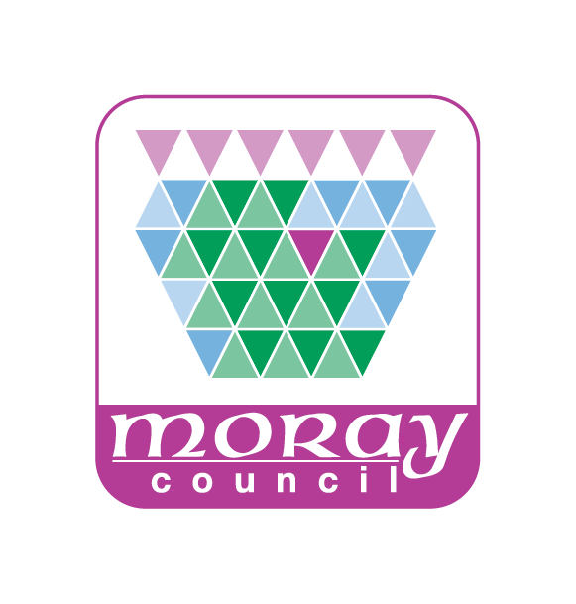
PRIVACY NOTICE – Trust Fund Applications

How we use your information
The Charity & Trustee Investment (Scotland) Act 2006 specifies that the Council has a fiduciary duty to manage its Trust portfolio and to distribute trust funds. In order to ensure that grants from the fund are properly managed applications to the Trust Funds are considered by elected Councillors, who decide on grant awards in keeping with the Trust purpose and deeds. Your personal information is required as Councillors may need to contact you to talk about your trust fund application to allow them to reach a decision.
Our legal basis
Whenever the Council processes personal data we need to make sure we have a legal basis for doing so. We understand the Council’s basis in data protection law to be Article 6(1)(e) of the General Data Protection Regulation (GDPR) as the data is collected in necessary for a task carried out in the public interest or in the exercise of official authority invested in the Council (i.e. under the Charity & Trustee Investment (Scotland) Act 2006). If you do not provide your personal data the Council will be unable to process your application.
Who we share your information with
Your personal data may be shared internally with authorised officers of the Council if having access to personal data is a necessary part of their roles to ensure records are accurate and up to date which improves the standard of the services we deliver. It may also be shared with other relevant Council departments where applicable.
As part of the processing your personal data may be shared with third parties. These third parties include, but are not limited to, elected members (i.e. local Councillors).
The Council may also share your personal data with other relevant Council departments and third parties, where we are under a legal obligation to do so. For example this may be with Police, UK Border Agency or other Registered Professional Bodies.
The Council is required by law to protect public funds against fraud. It may share personal data with other relevant Council departments and third parties responsible for auditing and administering public funds, or who otherwise have responsibility for preventing and detecting fraud.
How long the information is held for
Your personal data will be held by Moray Council for a pre-determined length of time. You can find all the information about how long we retain personal data for on our website:
http://www.moray.gov.uk/moray_standard/page_92820.html (found on the Moray Council website under Section 5 of the Records Management Plan)

Your rights
Moray Council is the Data Controller for this personal data. You have legal rights about the way the Council handles and uses your personal data. These include the right to ask for a copy of it, to ask us to correct it and to ask us to stop doing something with your personal data. For more information about these rights please contact the Council’s Data Protection Officer at info@moray.gov.uk or 01343 562633.
As so far as the legislation permits, you also have the right to request the deletion of your data and to object to the processing.
You also have the right to make a complaint to the Information Commissioner’s Office. They are the body responsible for making sure organisations like the Council handle your personal data lawfully.
Information Commissioner’s Office
Wycliffe House, Water Lane, Wilmslow, Cheshire, SK9 5AF
Telephone: 0303 123 1113
Email: casework@ico.gov.uk
Website: www.ico.org.uk

