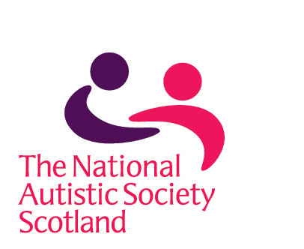
Letter for GP/other relevant NHS Professional/Social
Work Department/Education Professional.

Dear Sir/Madam,

I have applied to The National Autistic Society for an Autism Alert Card.

This card has nine partner organisations involved, The National Autistic Society, Grampian Police, NHS Grampian, Moray Council, The Grampian Autistic Society, Aberdeen City Council, G4S, Aberdeenshire Council and Autism Initiatives.

It aims to support people with autism spectrum disorder or Asperger Syndrome when dealing with the police, emergency services or public services.

In order to ensure that only people with ASD receive the card I require confirmation of diagnosis from a professional.

In the absence of a diagnosis, a letter which will support that the individual named below, demonstrates traits and behaviours similar to those on the spectrum, would be acceptable.

I wondered if you could provide a letter to support my application.

If you require any further information, please contact: One Stop Shop, 9 Queens Gardens, Aberdeen, AB15 4YD or e-mail oss.northeast@nas.org.uk or wendy.minty@nas.org.uk

My name is _____________________________________________

The card is for ___________________________________________

Yours sincerely,

