

Environmental Monitoring Report – Falconer Museum & Store

28th May 2026
1/02/2026 – 28/05/2026 data

*Note tiny tags calibrated October 2022
Handheld thermo-hygrometer weekly readings
Museum Ground Floor (GF) | 22.4°c | 51.4%
Museum mezzanine | 22.6°c | 48.6%

Museum store GF | 20.1°c | 49.1%
Museum store 1st Floor | 20.1°c | 50.6%

Data logger download data
Museum
Museum Mezzanine
The battery ran out, so confused the data logger, which appears to have time travelled when replacing the battery and downloading the data.
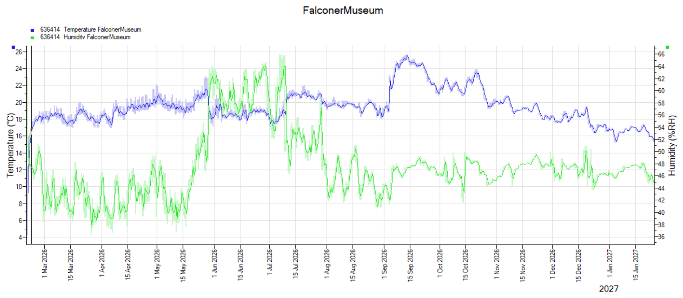

Museum Mezzanine | Temp °c | Relative Humidity %
Min | 4.2°c | 36.2%
Max | 25.6°c | 65.9%
Average | 19.4°c | 47.6%

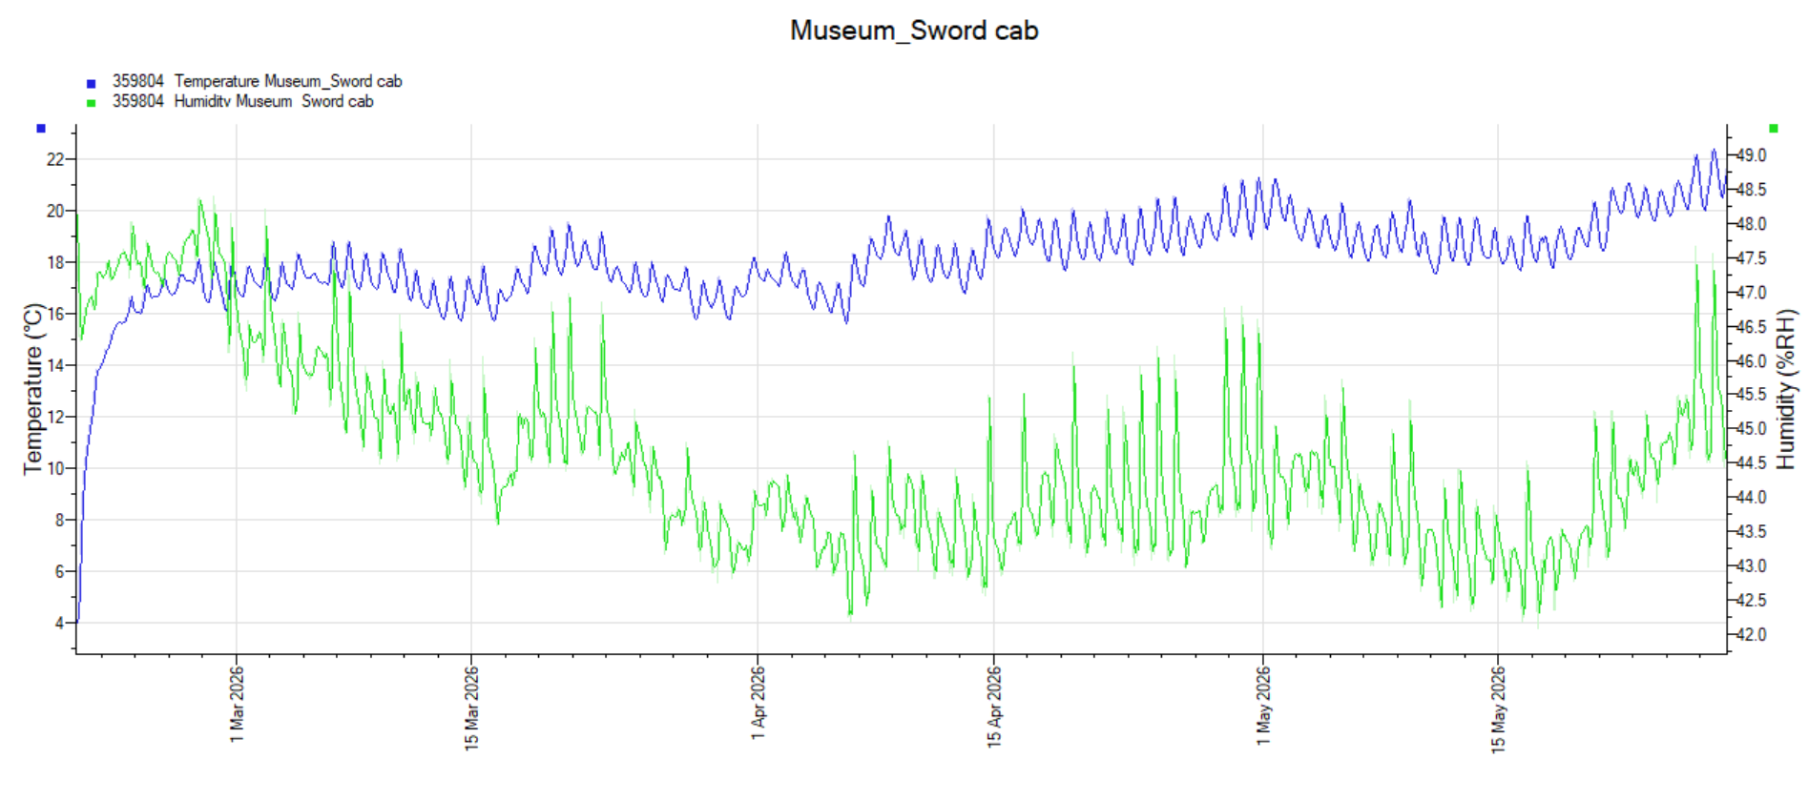

Museum Archaeological Cabinet | Temp °c | Relative Humidity %
Min | 3.7°c | 42.1%
Max | 22.4°c | 49.1%
Average | 18.1°c | 44.6%

Museum Store GF
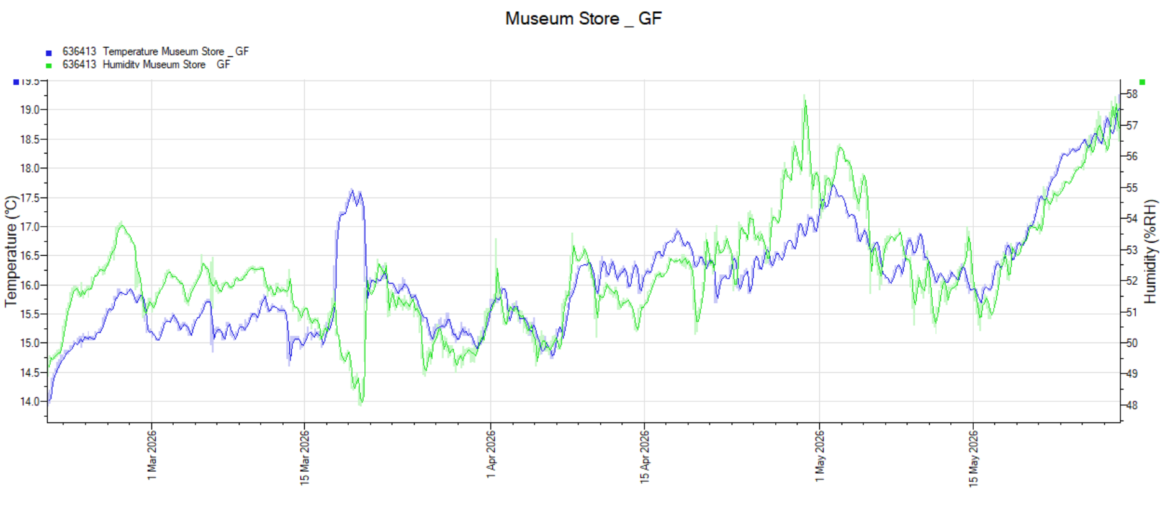
Museum Store GF | Temp °c | Relative Humidity %
Min | 13.9°c | 47.9%
Max | 19.3°c | 58.0%
Average | 16.1°c | 52.3%
Museum Store 1st Floor
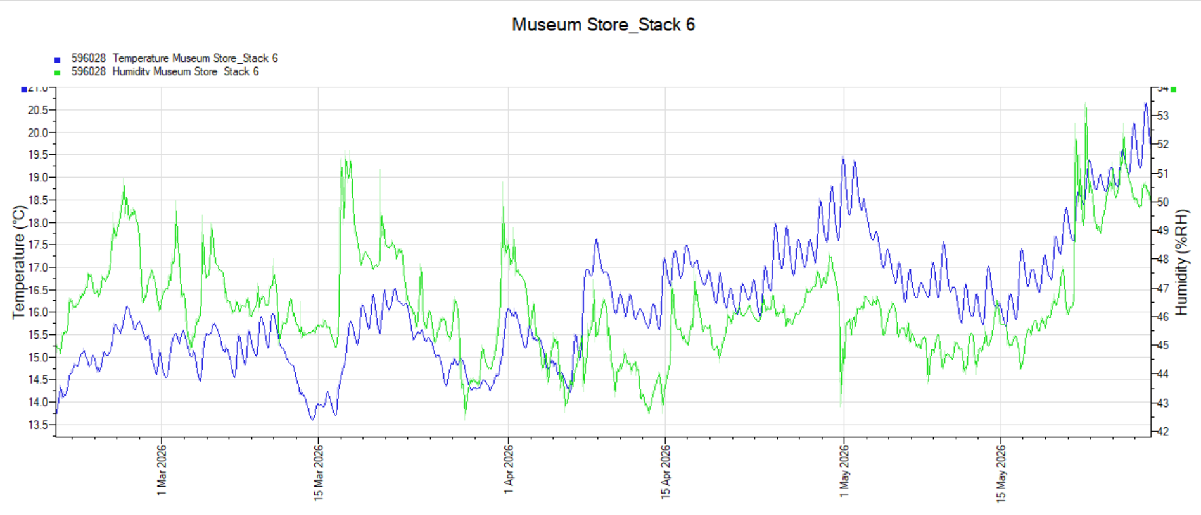

Museum Store 1st Floor stack 6 | Temp °c | Relative Humidity %
Min | 13.6°c | 42.4%
Max | 20.7°c | 53.5%
Average | 16.2°c | 46.4%

All traps vacant of insects in museum store
Replaced all traps

1 carpet beetle Falconer Room
Replaced all traps

Richard Aitken ACR
High Life Highland Conservation Service
High Life Highland & Registration Centre.

