

Environmental Monitoring Report – Falconer Museum & Store
19th September 2024
02/05 – 19/09/2024 data
Handheld thermo-hygrometer weekly readings
Museum Ground Floor (GF) | 18.4°c | 59.5%
Museum mezzanine | 18.4°c | 66.8%

Museum Archaeological Cabinet – off data logger | 18.2°c | 62.6%

Museum store GF | 15.7°c | 71.0%
Museum store 1st Floor | 16.1°c | 65.5%

Data logger download data
Museum
Museum | Temp °c | Relative Humidity %
Min | 17.4°c | 45.2%
Max | 23.3°c | 66.4%
Average | 19.3°c | 57.0%

Museum Archaeological Cabinet | Temp °c | Relative Humidity %
Min | 16.2°c | 45.2%
Max | 23.0°c | 56.9%
Average | 19.0°c | 52.5%
See graph below
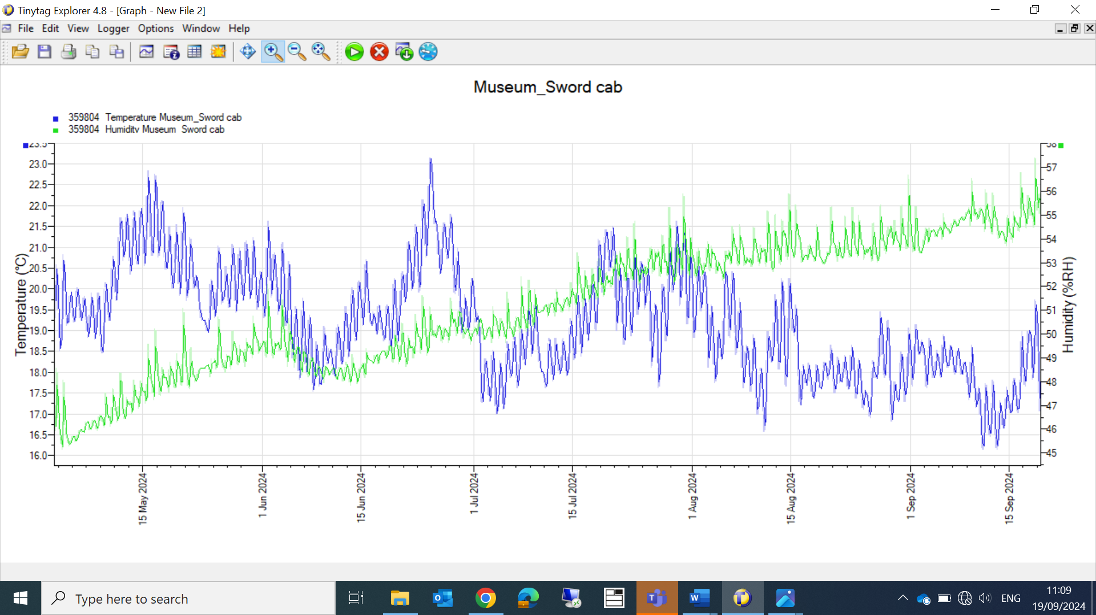

Museum Store
Museum Store GF | RH% | Temp °c
Min | 59.8% | 14.1°c
Max | 72.5% | 18.7°c
Average | 68.0% | 16.5°c

Museum Store 1st – stack 6 | RH% | Temp °c
Min | 53.4% | 13.1°c
Max | 70.4% | 21.3°c
Average | 59% | 17.0°c

Note
Museum Store 1st floor; been quite humid for sometime, I would recommend a dehumidifier is installed.

Traps
Falconer museum
GF
Guitar cabinet 2 slaters
Falconer bust 0

Mezzanine
Mirror, Trap 3 17 slaters (poss due to damp external walls)
Soldier, Trap 4 2 slaters, 2 silverfish

Museum store
All blunder and moth traps

Richard Aitken ACR
High Life Highland Conservation Service
High Life Highland & Registration Centre.

Action
Tyvek tape for cabinets in museum

