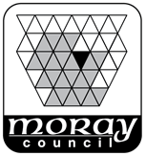 | APPLICATION FOR THE YOUNG PERSON’S FREE BUS TRAVEL SCHEME TO BE ADDED TO A NATIONAL ENTITLEMENT CARD  This form is for a young person who:-  - is 16 years of age or over and attending a Moray secondary school  The information gathered is subject to the terms of the Data Protection Act 2018

PART 1: Personal Details |  | Card number (if you already have a card):
Name of child: |  |  | Date of birth:
Address: |  |  | Postcode:
School name:

PART 2: Young Person’s Free Bus Travel Scheme

By requesting a card using this form, you will be issued with a Young Scot National Entitlement Card, giving you access to free bus travel within Scotland.

PART 3: Young Scot branding

The card will have the Young Scot logo, giving you access to all of the Young Scot information services, as well as discounts and special offers across Scotland and over 30 Europe countries. Please select one option below:-
☐ I do want the Young Scot logo on my National Entitlement Card
☐ I do NOT want the Young Scot logo on my National Entitlement Card

PART 4: Photograph (only if a new photograph is needed)  If you wish to update the photograph on your card, please provide one passport type colour photograph.  The photograph should be a close-up of your head. Please do not wear a hat or head covering (unless for religious reasons) or have your hood up or wear dark glasses.  Please write your name on the back of the photo and attach it securely to the form (no staples please). Alternatively you can email a photo to your school office. | 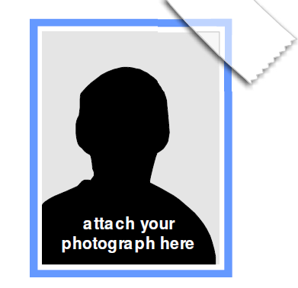

PART 5: Declaration

I have read the information on this form and the Terms and Conditions at www.nec.scot and agree to the processing of the personal details on this form to the extent necessary for the administration of the National Entitlement Card scheme and for the Young Persons’ Free Bus Travel Scheme.

I confirm I would like Free Bus Travel added to cards provided to my card as a result of this application.

If providing a photograph, I confirm that the photograph is a true likeness of myself and that I understand that making a false declaration is a criminal offence.

Signature: |  | Date:

GUIDANCE NOTES & PRIVACY STATEMENT
______________________________________________________________
ABOUT THE NATIONAL ENTITLEMENT CARD
The National Entitlement Card (NEC) is Scotland’s National Smartcard, offering access to many public services across the country. You may recognise or know the NEC as a bus pass, library card or Young Scot card, however, this one card may be able to grant you access to multiple other public services as well. Already over two million people can use their card for Concessionary Travel, Library Membership, Young Scot, and various school services including School Meals Payments.

Your application for a card uses personal data and photograph held by your child's school. If you are applying on behalf of a child under the age of 11 years using this form, no photograph will be used.
______________________________________________________________
Young Persons’ Free Bus Travel Scheme
All under 22s resident in Scotland will have access to free bus travel from 31 January 2022. Those eligible will receive access to the Young Persons’ Free Bus Travel Scheme using their National Entitlement Card, allowing them to travel for free on buses across Scotland.

However, children under the age of 16 MUST have approval from their parent or guardian before free travel is added to their card. You are giving approval by signing PART 5 of this form. You can find out more information online at www.transport.gov.scot
______________________________________________________________
YOUNG SCOT (for those aged over 11 years old)
Young Scot is the national youth information and citizenship charity in Scotland. Your child's National Entitlement Card will normally be issued as a Young Scot Card with their date of birth and a PASS (National Proof of Age Standards Scheme) hologram, meaning it can be used as a proof of age across the UK.

The Young Scot card helps your child access all the Young Scot information services, as well as discounts and special offers in places across Scotland and over 30 other European countries. Young Scot holders aged over 16 but less than 19 years old are also eligible for additional concessionary travel benefits. You can find out more information online at www.young.scot
______________________________________________________________
PRIVACY NOTICE
Privacy Notices are available to explain how personal information may be collected, used, stored, shared and securely disposed of, the legal basis for doing so, and what your Data Subject Rights are. Privacy Notices are available from our website at www.moray.gov.uk/moray_standard/page_142831.html

SCHOOL USE ONLY – PHOTO REFEREE DECLARATION (if replacement photo is provided)

Photograph referee details & declaration
The photograph referee must know the applicant (for example, guidance teacher or class teacher)

School Name:
Name of staff member verifying the likeness of the submitted photograph:
Job title of staff member verifying the likeness of the submitted photograph:

DECLARATION
I confirm that the photograph attached to this form is a true likeness of the applicant and that I understand that making a false declaration is a criminal offence*

Referee’s Signature: |  | Date:

School Office: Please send this form to Business Support, Education, Moray Council, High Street, ELGIN, IV30 1BX
- if photo attached, ensure name is written on back of photo
- if photo is emailed, forward with electronic referee declaration

