OPERATIONS AND ENVIRONMENT
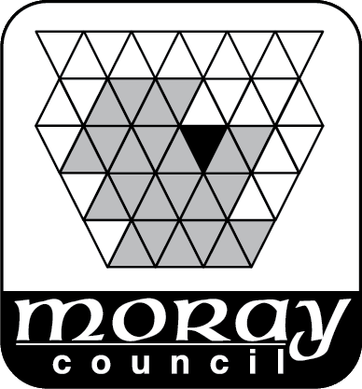

TRANSPORTATION

APPLICATION FOR PERMISSION
TO ERECT TEMPORARY DIRECTIONAL SIGNAGE

This application is for companies and organisation seeking to erect temporary directional signage on the public road for events or housing developments.

Signs and locations must be approved in writing by the Transportation Section of Moray Council. This application is restricted to signage within the road boundary, i.e. the carriageway plus footways and roadside verges. This policy is also restricted to roads within the control of Moray Council as local roads authority, that is, it does not apply to private, unadopted or trunk roads (i.e. the A95 between Keith and the boundary with Highland Council or the A96). The applicant must confirm that they have appropriate insurances in place to indemnify the Council against any damage caused to persons or property.

APPLICANT DETAILS:

Name:………………………………………………… Company/Organisation: ………………………………………………………
Address: ……………………………………………………………………………
……………………………………………………………………………

……………………………………………………………………….…. Post Code: ……………..
Contact Telephone No: …………………………….(Day) ……………………..(Night) FAX No………………………………..
Email Address: ………………………………..

Road Name: (& town/village)...............................................................................................
Site Location (s): …………………………………………………………………………….

Applicants must attach a plan and schedule of locations along with appropriate sign designs for each sign type.

Date of Event: ………………………… Duration of Event:………………………………
For the purpose of: (Indicate as appropriate)
Event
Housing development
Other

I attach fee of £195.00 | BACS/Credit/Debit Card (Please call 0300 1234565 during office hours for Card Payment)
 | Cheque

I/We agree to the conditions overleaf and to the General Conditions of Permission.
Signature of Applicant or Agent .................................................... Date ………..........

Please allow at least 21 days for the processing and issue of permission for the temporary directional signage.

The completed form should be submitted:

Either, by Post to: The Transportation Manager, The Moray Council, P.O. Box 6760 Elgin, IV30 9BX,
or by E Mail to: roadspermits@moray.gov.uk

For Office Use Only

Approved By……………………………………… Date…………………………
Application No …………….……………………

CONDITIONS AND NOTES FOR GUIDANCE OF APPLICANT

- The completed form should be submitted:

Either, by Post to: The Transportation Manager, The Moray Council, P.O. Box 6760 Elgin, IV30 9BX,
or by E Mail to: roadspermits@moray.gov.uk

- In terms of the Roads (Scotland) Act, 1984, the definition of "road" includes footway and verge.

- All signs shall be compliant with Diagrams 2701 or 2701.1 shown in Schedule 13, Part 6 of the Traffic Signs Regulations and General Directions 2016.

- No sign shall remain in situ any longer than its required purpose.

- The responsibility for safety of the signs, including safety of members of the public and members/staff/volunteers during erection and removal, lies with the applicant.

- Indemnity: The applicant shall indemnify The Moray Council as Roads Authority for and against all actions, claims, demands, costs, charges, damages, losses and expenses of whatsoever kind or nature which may be brought or made against them or incurred by them in respect of the negligence, omission or default of the holder of this permission or those for whom the holder of this permission is responsible arising in respect of any operations authorised by this permission unless due to the negligence or other breach of legal duty on the part of the Council or of any person for whom the Council are responsible.

- Moray Council retains the right to remove any sign or object, under any circumstances, if it is considered to be non-compliant, unsuitable or dangerous.

