T H E M O R A Y C O U N C I L
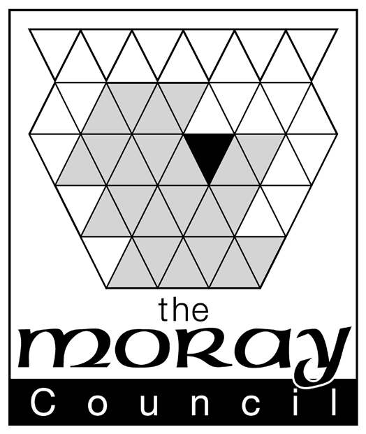

Safety Management System

Section: 5.16
Title: Smoking

Date: June 2014

Revision: 2

1.0 INTRODUCTION
1.1 It is widely recognised that smoking and passive smoking damages health. The risks to health include lung cancer (90% of which is caused by smoking), it also causes cancer of the mouth, lips, throat, voice box, oesophagus, bladder, kidney, liver, stomach and pancreas. It also increases the risk of other conditions such as coronary heart, disease and strokes.
Second hand smoke (or passive smoking) causes the same risk (of the conditions given above) to those who breathe in second hand smoke. For example, it can increase a non-smokers risk of lung cancer by 24% and heart disease by 25%.

1.2 The Council fully accepts its legal and moral duties under The Smoking, Health and Social Care (Scotland) Act 2005 and The Prohibition of Smoking in Certain Premises (Scotland) Regulations 2006.
The Moray Council recognises and accepts its responsibilities as an employer for providing a safe and healthy work place and working environment for all its employees in accordance with the Health and Safety at Work Act, etc 1974. This duty is further enhanced by the Management of Health and Safety at Work Regulations 1999, which require employers to assess the risks to which employees are exposed and to take preventative and protective measures to eliminate or control them. The Workplace (Health, Safety and Welfare) Regulations 1992 require employers to ensure that non-smokers are protected from the dangers of tobacco smoke in rest areas.

2.0 PURPOSE

  - To define the Council’s policy on smoking within areas it controls.

POLICY STATEMENT

2.1 In order to protect individuals from tobacco induced ill health and injury directly or passively and from the effects of smoking other substances, the Council has established a non-smoking environment within all Council buildings, vehicles and the areas around the buildings under its control.

3.0 RESTRICTIONS

3.1 Smoking (which includes the use of ‘e-cigarettes’) is prohibited in all Council buildings, offices, depots, schools, workshops, libraries and vehicles.

3.2 Smoking is also prohibited in the vicinity of public entrances/access points to Council premises, etc, referred to above.

Date of Review: June 2014
Policy Approved:
Version Effective From:
Next review Date: May 2019
  - Any person who wishes to smoke must do so outwith core time and must key/book themselves out of the flexi-time system before doing so. Where flexi-time is not in operation, smoking must be restricted to authorised breaks (i.e. meal breaks).

  - Any member of staff who may be exposed to tobacco smoke in areas of which the Council is not in direct control (i.e. a domestic premise), must inform their manager and action will be taken to eliminate exposure.

4.0 SCOPE

  - The policy applies to all employees, staff, volunteers, visitors, clients, contractors and elected members of the Moray Council. Any breach of the policy will be dealt with under the normal disciplinary procedures.

  - Information is contained within the signs on each building defining action to be taken to report on non-compliance.

5.0 RECRUITMENT

5.1 Prospective employees are advised of this policy via:

- information for applicants
- contractual documentation
- Corporate Induction course

6.0 SUPPORTIVE ACTION

Smokers who want to take advantage of the restrictions to give up may request information, advice or counselling via Human Resources. Further information is available in Appendix 1.

APPENDIX 1

For help to stop smoking please call the NHS Grampian Smoking Advice Service on freephone 0500 600 332

The NHS Grampian Smoking Advice Service was launched in 2000. We aim to provide a smoking cessation service which is free and available to all smokers in Grampian who want to give up.

The Smoking Advice Service has three main functions:

- Depending on what the individual wants, we can provide different levels of support. This could range from a brief discussion to coming along to a structured smoking cessation programme.

The programme sessions are:

- 6 group sessions
- one hour a week
- led by trained smoking cessation advisors
- provided throughout Grampian at different times and locations

We make every effort to accommodate the individual needs of clients when setting up new sessions.

There is evidence to suggest that taking part in this smoking cessation programme is extremely beneficial when trying to stop smoking. Our data shows the more sessions you attend, the more likely you are to successfully stop smoking. The NHS Grampian Smoking Cessation Service is nationally recognised as an example of best practice. It is very important that people in Grampian are aware of the help that is available to help them stop smoking.

- We act as a point of contact and provide information to health staff and the general public on smoking cessation.

- We provide training for smoking cessation advisors and to other health care staff who provide smoking cessation support to their patients.

You can also contact your GP for advice and help on giving up.

The councils Healthy Working Lives group also has information available on the subject.

You can also visit www.nhsgrampian.org for online advice.

