Local Links and Services

Agency | Area | Target Group | What the Service Offers | Referral Requirements | Contact Details
Aberlour Youth Point   | Moray Wide | 12-18 years - Intensive Community Support Service.  12-25 years - Mentoring Service | We help children and young people in Moray who may be struggling with their emotions and behaviour  We also offer a mentoring service which matches volunteers with young people who would benefit from extra support. | Anyone can make referrals to our mentoring service.  Requests for support from the intensive community support service can only be made by the Social Work department. | Office - 01343 546214  Kelly Blackmore - 07772226615  Anne Grant - 07717 53923  Email - morayyouth@aberlour.org.uk  Facebook - www.facebook.com/AberlourCC/
Action for Children   | Moray Wide | 13-25years | Provide family support services and programmes for marginalised young people to improving mental health and wellbeing. Includes:  Youth Employability Service (16 years+), The Blues Programme - coping strategies for anxiety and depression (13 – 19 years) | Self referral and referral through services working with young people | Phone - 01343 549557/ 07921 936778  E-mail - sheila.erskine@actionforchildren.org.uk  Web - www.actionforchildren.org.uk
Agency | Area | Target Group | What the Service Offers | Referral Requirements | Contact Details
Children 1st  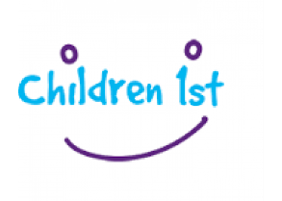 | Moray Wide | All children and young people | Forces Families Support Service – trauma-informed support for families.  Stronger Safer Families - Support for families with domestic violence, neglect or abuse.  Advocacy service | Self-referral or referral through services working with children and young people | Phone – 01343 564170 Or 07960 779913  E’mail - moray@children1st.org.uk  Web - www.children1st.org.uk  Facebook - www.facebook.com/groups/children1stHEM
Elgin Youth Development Group   | Elgin | Young People | Online virtual youth project. Drop-ins, 1-2-1s, award groups, challenges, games, workshops, support. Weekly programme of activities advertised across all our social media platforms. | N/A | Phone - 01343 548300  E’mail - carol@elginyouthcafe.org  youthwork@elginyouthcafe.org  Web - http://www.elginyouthcafe.org
Grampian Child Bereavement Network  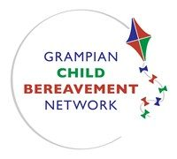 | Grampian Wide | All children and young people | Resources, advice and information around bereavement. Family support and direct work with children and young people is offered through their Responder Service. | Self-referral or referral through services working with children and young people. | Phone - 01224 594099  E’mail - gcbn@mhaberdeen.org.uk  Web - www.gcbn.org.uk
Agency | Area | Target Group | What the Service Offers | Referral Requirements | Contact Details
Grampian Psychological Resilience HUB   | Grampian Wide | Whole  Community | The hub was set up to directly respond to the COVID-19 pandemic. It’s a completely virtual hub, with support available by telephone.  The hub is not just for adults, it is also a pre-CAMHS service where children and young people can receive support. | You can self refer - you don’t need your GP or other clinician to refer you. | The referral form is available at: http://covid19.nhsgrampian.org/mental-health-support/
The Loft Youth Project  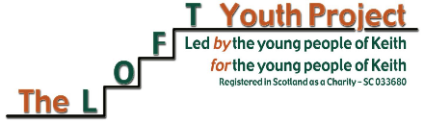 | Keith | Young People | The Loft Youth Project is a one stop shop for young people in Keith and rural areas. We offer activities, volunteering opportunities, accreditation awards and health hub. | N/A | Phone – 01542 886630  Facebook - https://www.facebook.com/KeithLoftYP/
MOD Army Welfare   | Moray Wide | Service Personnel and their families | The Army Welfare Service (AWS) is the Army's professional welfare provider and delivers its services via Personal Support and Community Support. | Self Referral | For Personal Support enquiries and referrals please contact:  E’mail - RC-AWS-IAT-0Mailbox@mod.gov.uk  Phone - 01904 882053.  Any other queries relating the AWS in the North of Scotland please contact your local office on:  Phone - 01309 691123.(this number is still in use, however not manned during lockdown as staff are still working from home)
Agency | Area | Target Group | What the Service Offers | Referral Requirements | Contact Details
Moray Active Schools  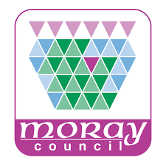 | Moray wide | Usually for P1-S6 pupils however during this time the activities offered online are suitable for all age ranges, encouraging families to get involved. | Currently offering opportunities for children to remain physically active during this time of lockdown through online activities on our social media platforms. These include weekly challenges. Tuesday and Thursday a ‘Work out with Kenny’ and over the weekend skill based activities for various sports. | N/A | Phone - 07966 120518  Facebook - https://www.facebook.com/sportinmoray/
Moray Wellbeing Hub  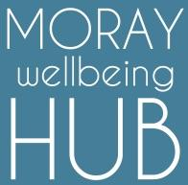 | Moray Wide | Whole community | Lived experience peer led community hub promoting positive mental health. Wellbeing courses for families and parents  Online support – Wellbeing weekday lunchtime informal support over zoom  Online wellbeing courses  Support from peers | Self Referral | Phone – 01343 576219  Email - hello@moraywellbeinghub.org.uk  Facebook - www.facebook.com/moraywellbeinghub/  Web - http://moraywellbeinghub.org.uk/discoverpathways/  http://moraywellbeinghub.org.uk/mhpathways/
Agency | Area | Target Group | What the Service Offers | Referral Requirements | Contact Details
Moray Women’s Aid   | Moray Wide | Offers support to women and children experiencing domestic abuse/ violence. | Providing support, guidance and accommodation to women, children and young people experiencing domestic abuse. | Self-referral if 13+ years old or referral through services working with families | Phone - 01343 548549  E’mail - admin@mwaelgin.co.uk  Web - www.mwaelgin.co.uk
Moray Youth Engagement Team | Moray Wide | Young People | Moray Youth Engagement Team is Moray Council’s Youth Work service. As Youth Workers we work in schools and the community, promoting health and wellbeing, opportunities to get involved in your community, have a voice and take part in awards. | N/A | Engagement team Blog  https://blogs.glowscotland.org.uk/my/engagementteam/  Facebook Page - https://www.facebook.com/Morayyouthwork  Twitter - https://twitter.com/morayyouthwork  Instagram - https://www.instagram.com/morayyouthwork/  Tiktok - https://vm.tiktok.com/JdxrTwL/  Young Scot Moray Page - https://young.scot/moray
Need Help With Money? | Moray Wide | Whole Community | If you need some advice or support with money the services signposted in the link will be able to help. | N/A | http://www.moray.gov.uk/moray_standard/page_129056.html
Agency | Area | Target Group | What the Service Offers | Referral Requirements | Contact Details
Penumbra – Moray Mental Health & Wellness Centre   | Moray Wide | 18 + | The service provides a range of support, including:  • 1:1 support  • Wellness Recovery Action Planning  • Penumbra Workshops on Wellbeing  • 1st Response can provide you with short term support when you feel at crisis point |  | Phone – 0800 234 3490 (1st Response)  01343 556 191  E’mail - moraywellnesscentre@penumbra.org.uk
Quarriers – Arrows  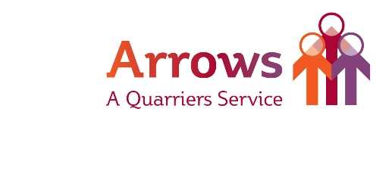 | Moray Wide | Family members of any age.  16+ years for 1:1 support | Support for family members and loved ones with family or friend who has drug or alcohol addiction.  Support for individuals aged 16+ years with drug and alcohol addiction | Self-referral or referral through services working with children and young people | Open 10am - 5pm Monday to Friday, 12noon - 3pm Saturday  Phone - 01343 610500/ 07812 228547  Email - arrows@quarriers.org.uk  Web - http://www.quarriers.org.uk/arrows
Quarriers – Young Carers Service   | Moray Wide | 8-17years | Support for young carers with a focus on supporting the mental health and wellbeing on the young carers. |  | Mon-Fri 9-5.  Phone - 01343 556031  E’mail - carersmoray@quarriers.org.uk  Web - www.quarriers.org.uk  Facebook -https://www.facebook.com/quarriersyoungcarersmoray/
Agency | Area | Target Group | What the Service Offers | Referral Requirements | Contact Details
Relax Kids   | Moray Wide | Children and young people | Mindful and relaxation exercises to improve resilience, emotional regulation and mental health and wellbeing.  Support for Parents | N/A | Phone – 07500 897653  Email - relaxkidswithlaura@gmail.com  Facebook - www.facebook.com/RelaxKidsLauraMawson/
SSAFA   | Moray Wide | ALL military personnel on the Station | SSAFA offer a confidential welfare service We are here to support spouses, partners, children and extended families | Self Referral | Contact our confidential, independent service on:  Phone - 03000 111 723  Available 24 hours a day, 365 days a year  Email - psswsraf@ssafa.org.uk
Social Work  Children and Families Access Team | Moray Wide | All children and young people | Assessment, family support and child protection. Children Service Workers and Family Support Workers can support vulnerable families and children within their homes. | Referral through ‘team around the child’. | Phone - 01343 554370
Agency | Area | Target Group | What the Service Offers | Referral Requirements | Contact Details
Step by Step  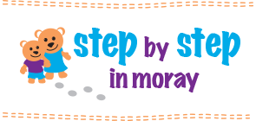 | Moray Wide | 3 years and under and their parents | A parent, baby and toddler group designed for isolated or vulnerable families with young children. | Self Referral | Phone - 01343 544628  Web - www.stepsmoray.org
TSi Moray   | Moray Wide | Whole Community | A database providing Moray's citizens, charities, community groups, social enterprises, and voluntary organisations with support, information and resources during the COVID-19 outbreak | N/A | Phone - 01343 541713  Email – info@tsimoray.org.uk  Web - https://www.tsimoray.org.uk/covid-19-portal

National Links and Services

Agency | Area | Target Group | What the Service Offers | Referral Requirements | Contact Details
One Parent Families Scotland   | National | Single Parents | We can help single parent families on a range of topics regarding their children, including child maintenance, children getting older, one to one support and more. | N/A | Free Helpline:  0808 801 0323  Email: helpline@opfs.org  Online – Web Chat
Sleep Scotland   | National | Parents | Free telephone support line for parents and carers struggling with their children’s and teenager’s sleep problems. | N/A | Free Helpline:  0800 138 6565  Email: sleepscotland@sleepscotland.org
Parent Club   | National | Parents | Helpful information and resources from birth to pre-teen | N/A | https://www.parentclub.scot/
Parentline Scotland | National | Parents | For everything from how to keep your kids entertained at home; to sleep and bedtime routines; and managing phone use and screen time | N/A | https://www.children1st.org.uk/help-for-families/parentline-scotland/  Free Helpline:  08000 28 22 33  Available 7 days a week  Mon-Fri, 9am to 9pm  Sat-Sun, 9am to noon
Agency | Area | Target Group | What the Service Offers | Referral Requirements | Contact Details
Child and Adolescent Mental Health Services  CAMHS Resources | National | Young People, Parents, Carers | This site was created for young people, carers and professionals to pool together lots of helpful resources from across the internet that are available to help support your mental health and well-being | N/A | https://www.camhs-resources.co.uk/
Enable Scotland  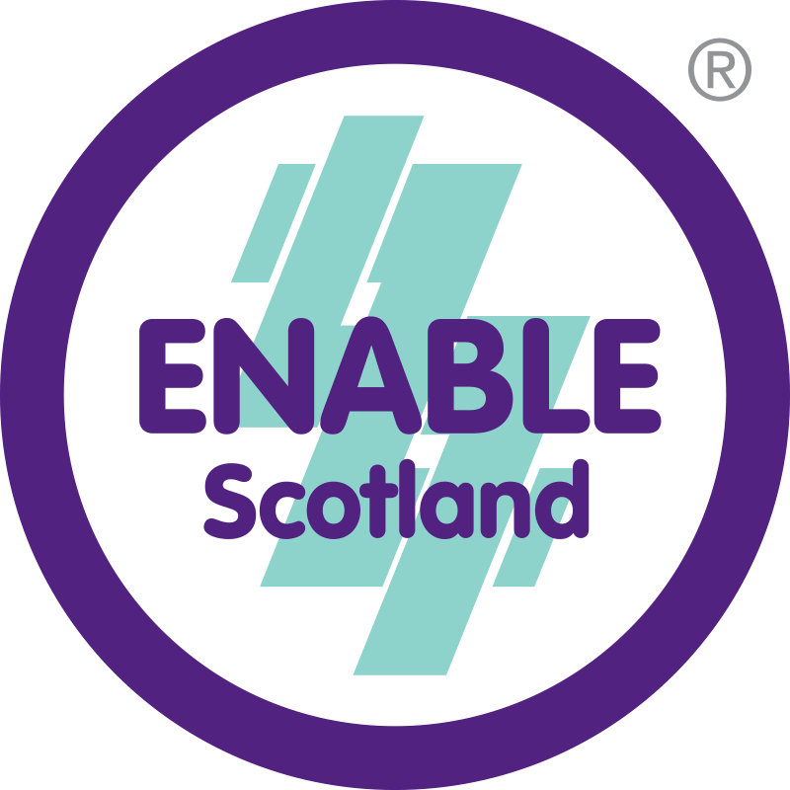 | National | Parents supporting children with a learning disability | - ACE Connect provides: *Reliable and accessible information about COVID 19 and the impact it has on day to day life  - *Activities to keep minds and bodies active  - *The availability of someone to talk to  - *More immediate support for people who are really struggling to cope | N/A | Helpline:  0300 303 1928  Available Monday to Friday 9am-7pm  https://www.enable.org.uk/ace/ace-connect/  https://www.facebook.com/aceconnectenablescotland

