Tomintoul & Strathavon Highland Games

Marching Pipe Bands: ROAD CLOSURES
Moray Council Form RC/1914
Ballater and Huntly Pipe Bands will be attending

Saturday 18th July 2026
(Times listed below)

The following Traffic Management measures for the above event will be put in place for the purposes of road safety: Temporary Road Closure/s

ROADS AFFECTED BY THE PROPOSED CLOSURE
The main road affected during the day is MAIN STREET.
From the junction with Stuart Place at the bottom of the Village to the junction with Delnabo Road at the top of the village. (See Map on Page 02 of this document).

The Highland Marching Band will march four times on our Games day. The following are the approximate expected times. There may be a small variance to the times stated below, but it will not be significant.

1030 - 1100 hours
From the Northwest end of Main Street (A939 from Grantown-on-Spey end) at Stuart Place (start of the village at its lowest point), march Southeast up the gradual incline to the Village Square in the centre of the Village. They will then move onto the grass area around the Village shop and Glenlivet Discovery Centre.

1215 – 1235 hours
Start from the Square, marching up hill in a Southeast direction up Main Street to near to the junction with Delnabo Road/Smiddy Lane. They will carry on past the Delnabo Road turning, moving onto the Old Military Road for a break.

1250 – 1255 hours
Reconvene at the top of Main Street. From Main Street, along Delnabo Road to enter the Games Field (AB37 9EX) at around 1255 hours for the official opening of the Games at 1300.

1700 – 1720 hours
End of the Games. From the Games Field, back along Delnabo Road. Turn left onto Main Street and march down through the village in a Northwest direction, back to the Village Square where they will disperse at some point during the evening.

ALTERNATIVE ROUTES FOR TRAFFIC DURING THE TIMES ABOVE

Through traffic. Entering the village along the Old Military Road from the Northwest (Grantown-on-Spey side). Turn left into the first road into the village (Stuart Place) and follow the back dyke past Findouran Garage and then along the parallel Conglass Lane to the junction with the A939. Turn left for Dufftown, Braemar etc.

Village traffic can access the other main village road, Cults Drive, by going along Conglass Lane and then crossing Main Street at a suitable spot to get to Cults Drive.
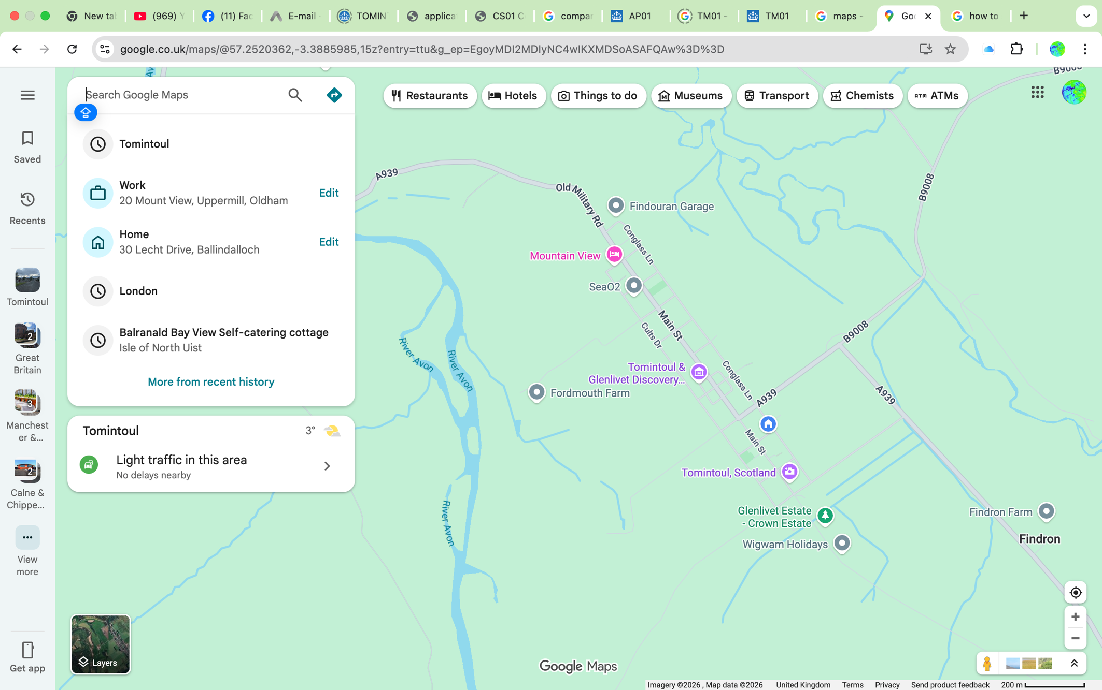
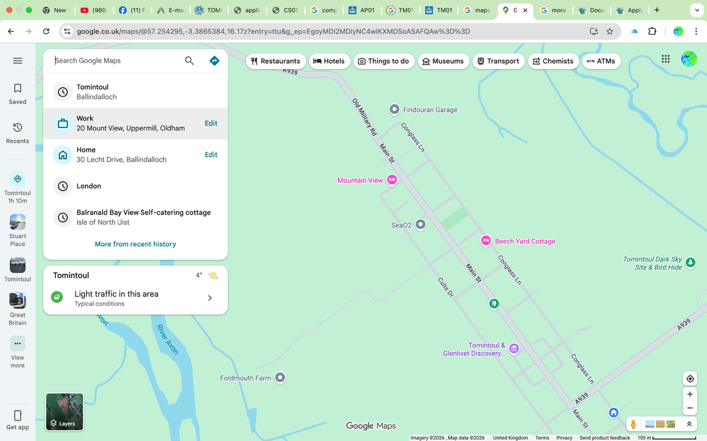
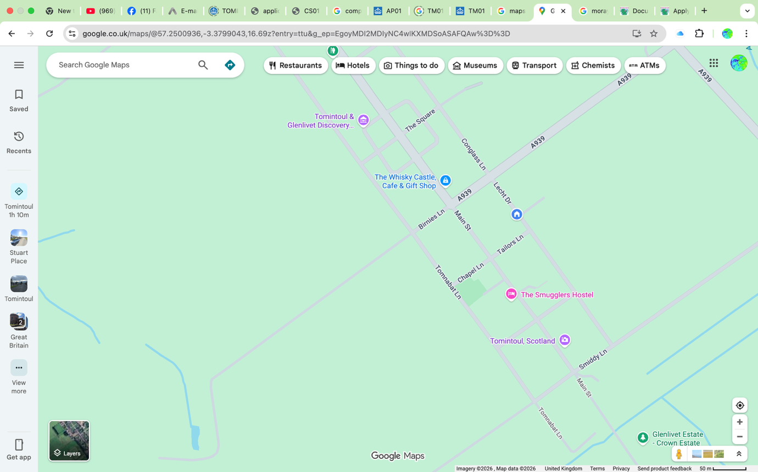
Games Field
Start of March Stuart Place
Village Square
Games Field

