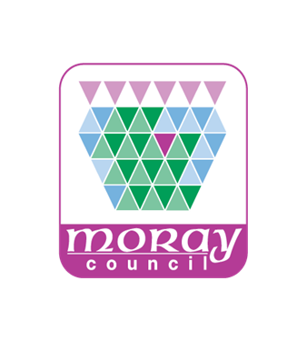

COMMUNITY ASSET TRANSFER

ANNUAL REPORT

1 APRIL 2025 to 31 MARCH 2026

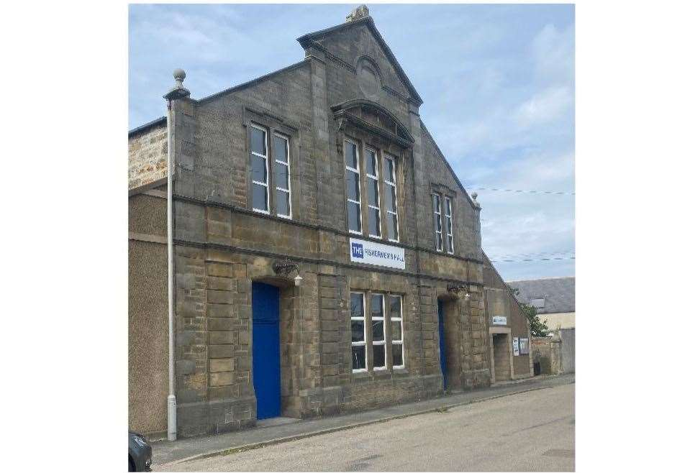

Contents | Page
Introduction | 3
Promotion and support | 3
Asset Transfer Requests | 5
Simplified Arrangements | 6
Contact Us | 6
Appendix 1 | 7
Appendix 2 | 9

INTRODUCTION
From 23 January 2017, the Community Empowerment (Scotland) Act 2015 (the Act) introduced a formal right for eligible community bodies to submit asset transfer requests to public authorities. These requests may relate to any land or buildings owned or leased by the authority. Under the Act, public authorities must agree to the request unless there are reasonable grounds to refuse it.
Section 95 of the Act also requires each authority to publish an annual report detailing the number of asset transfer requests received and processed during the year, along with information on the steps taken to promote asset transfer opportunities and support community bodies through the process. While not all asset transfer requests must be made under the Act, this report includes information on requests handled both within and out with the statutory framework, to ensure transparency and completeness.
PROMOTION AND SUPPORT
Between 1 April 2025 and 31 March 2026, the following actions have continued to further promote and strengthen the Community Asset Transfer (CAT) process.
Empowering Communities
Community empowerment is the process of helping communities gain greater influence and control over the decisions and circumstances that affect their lives. A community can be any group of people connected by shared interests, concerns, or identities. Empowerment focuses on enabling these groups to take charge of the factors that shape their wellbeing and future.
Moray Council has long recognised that transferring property assets can significantly enhance community empowerment and resilience. The Council’s Community Asset Transfer Scheme supports it’s Corporate Plan priority of building thriving, resilient and empowered communities, as well as the Local Outcomes Improvement Plan priority of empowering and connecting communities. Where appropriate, the Council uses asset transfers to give communities more direct control, encouraging them to develop local solutions to community needs and to become more sustainable in the long term.

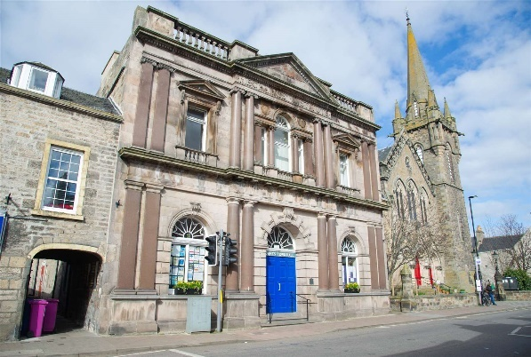

Supporting Communities
The Council’s Community Support Unit (CSU) provides capacity building support to all community groups engaged in the Community Asset Transfer (CAT) process. Officers from the CSU carry out initial assessments of groups submitting an expression of interest, to establish whether the group has the skills, experience and organisational resilience needed to take on an asset. This assessment also reviews the group’s community engagement activity. Based on the outcomes, CSU officers work with groups to address any issues identified, such as governance, consultation, or business planning. The same level of support is available to groups using the simplified arrangements covered by the CAT scheme.

Officers from the CSU encourage groups to consider the requirements of those most in need in their community. To support this, the CSU works with the Council’s Research and Information Officers to provide relevant data and statistical information that helps groups understand local demographics and community needs. The CSU also works with external partners who can offer further assistance to groups, including the Development Trusts Association Scotland’s Community Ownership Support Service (COSS) and Highlands and Islands Enterprise (HIE). HIE has provided funding to enable community groups to commission options appraisals and a Social Return on Investment report to support potential CATs.
Continuous Action
The Council’s dedicated Community Asset Transfer Team continues to manage and respond to all enquiries related to Asset Transfers.
The Council’s website includes a comprehensive Community Asset Transfer section, providing guidance on the CAT process, application forms, examples of successful CAT transfers in Moray, and useful links to Scottish Government guidance, legislation, and other relevant resources. A dedicated mailbox is also available for CAT related enquiries.
Communities can also access information about the Council’s land and property assets through it’s map-based Asset Register. The full register can be viewed, searched, or downloaded via the Council’s Open Mapping Data Portal.


Open Mapping Data Portal
https://data-moray.opendata.arcgis.com/

ASSET TRANSFER REQUESTS

This report covers the period from 1 April 2025 to 31 March 2026. Throughout this time, no asset transfer requests were received. There were also no validated requests awaiting a decision, and no decisions were subject to review or appeal during the reporting period.

Asset transfers successfully completed since the Act came into effect in January 2017 are listed in Appendix 1.

Keith’s Longmore Hall, held by the Council as part of the Longmore Trust, has been operated by Longmore Community Hall SCIO under a short-term lease since July 2018, following the Council’s decision to seek a community organisation to manage the facility. The SCIO’s application for a longer-term lease was approved in November 2023, with the new lease completed on 13 March 2025 and formally registered on 3 June 2025. This transfer was finalised through negotiation out with the Act.

The Council is currently progressing three additional approved transfers comprising one within and two out with the Act, as outlined below. A decision on a further request has been deferred pending investigation of an alternative site, as detailed in Appendix 2.

Approved Transfers

Lossiemouth’s Coulardbank Playing Fields are held by the Council on an inalienable Common Good title. In January 2020, the Lossiemouth Community Development Trust submitted an asset transfer request under the Act seeking a 25-year lease of part of the playing fields to develop a skate park. In October of the same year, the Council approved the request, subject to obtaining court consent and the Trust securing the required planning permission for the development. Court decree was granted on 12 January 2021, and planning consent followed on 21 March 2024, enabling the lease to proceed. The lease is now in the process of being completed.

Land next to Clovenside Cemetery in Forres, held by the Council on a Common Good title, was leased to a head tenant in 2002, who subsequently sub-let the site to Forres Baptist Church. When the head tenant indicated a wish to end the tenancy, Forres Baptist Church submitted an application seeking ownership of the land and the associated building, Clovenside Funeral Home. The Council approved the application on 4 November 2025, subject to agreement on the assignation of the tenant’s interest. The transfer is now progressing towards completion through negotiation out with the Act.

Forres in Bloom have been occupying the Council owned Grant Park Depot in Forres as their main operational hub and horticultural nursery under an informal arrangement for several years. The SCIO’s application for a formal long-term lease was approved on 4 November 2025, and the transfer is also being finalised through negotiation out with the Act.

Expressions of Interest

The Council’s CAT Scheme operates as a two-stage process. Community bodies are encouraged to begin with the pre-application stage by submitting an Expression of Interest (EOI) for any land or buildings they wish to acquire. Once an EOI is received, the Council’s CAT Team will:

- confirm the community body’s eligibility under the scheme,
- check that the Council is able to transfer the relevant property rights,
- identify the Council’s current and future operational requirements for the property,
- identify, as far as possible, any other material considerations relevant to a potential asset transfer, and
- exchange information about the community body, the asset, and the potential transfer.

The EOI stage is intended to help community bodies avoid abortive work and develop a strong business case in support of a formal asset transfer request. Not all community bodies that submit an EOI will progress to a formal request, and some may choose to proceed directly without completing an EOI. During the reporting period, the Council considered five EOIs, all of which remain current.

SIMPLIFIED ARRANGEMENTS

The Council’s former Community Rental Grant Scheme has been incorporated into the CAT Scheme. Under the expanded scheme, voluntary and community organisations leasing Council property may apply for a Community Rent Rebate when their rent is due for review. On 4 November 2025, the Council amended its policy to allow VCOs to submit rent rebate applications out with the usual review timescale in unforeseen circumstances. Each request will be assessed individually. As this element is not governed by Community Empowerment legislation, all applications are assessed entirely at the Council’s discretion and must be supported by a strong business case demonstrating ongoing benefits that justify the rebate.

In response to the pandemic, there was a rise in requests from voluntary and community organisations seeking short-term use of temporarily unoccupied Council assets. These requests often require rapid decisions, which are not always compatible with committee timescales. To ensure an appropriately proportionate approach, a simplified process is now available for organisations seeking short-term or low-value concessionary leases.

CONTACT US

Further information on the scheme is available from the Council’s CAT team or the Community Support Unit (CSU).

📮 Post: Moray Council, High Street, Elgin IV30 1BX
📞 Phone: 01343 543451
📧 Email: CAT@moray.gov.uk | CSU@moray.gov.uk
🌐 Web: http://www.moray.gov.uk/CAT

Appendices

Appendix 1
The assets listed below were transferred prior to the current reporting year, but all after Part 5 of the Community Empowerment (Scotland) Act 2015 took effect on 23 January 2017. No asset transfers were completed between 23 January 2017 and 31 March 2017.

Table 1. Asset transfers completed from 1 April 2024 to 31 March 2025

Property | Community Body | Type | 2015 Act | Transferred
Longmore Hall, Keith | Lossiemouth Community Development Trust | Lease | No | 13/03/2025

Table 2. Asset transfers completed from 1 April 2023 to 31 March 2024

Property | Community Body | Type | 2015 Act | Transferred
Fishermen’s Hall, Buckie | Fishermen’s Hall Trust | Ownership | Yes | 19/05/2023

Table 3. Asset transfers completed from 1 April 2022 to 31 March 2023

Property | Community Body | Type | 2015 Act | Transferred
Findochty Town Hall | Findochty Town Hall (SCIO) | Ownership | Yes | 21/07/2022
West Dunes Toilets, Findhorn | Findhorn Village Conservation Company | Ownership | Yes | 12/10/2022
Garmouth Water Tower | Garmouth and Kingston Community Association | Ownership | No | 19/12/2022
Table 4. Asset transfers completed from 1 April 2021 to 31 March 2022

Property | Community Body | Type | 2015 Act | Transferred
Cullen Community and Residential Centre | Three Kings Cullen Association | Ownership | Yes | 05/11/2021

Table 5. Asset transfers completed from 1 April 2020 to 31 March 2021

Property | Community Body | Type | 2015 Act | Transferred
Dufftown Sports and Community Centre | Dufftown Community Centre (SCIO) | Ownership | No | 05/03/2021
Forres Town Hall | Forres Area Community Trust | Ownership | Yes | 26/02/2021
Land, Lesser Borough Briggs, Elgin | Elgin Sports Community Trust | Lease | Yes | 23/11/2020

Table 6. Asset transfers completed from 1 April 2019 to 31 March 2020
Property | Community Body | Type | 2015 Act | Transferred
Portknockie Bowling Green | Portknockie Bowling and Tennis Club | Ownership | No | 08/11/2019
Marine Park, Lossiemouth | Action Marine Park | Ownership | No | 05/06/2019

Table 7. Asset transfers completed from 1 April 2018 to 31 March 2019

Property | Community Body | Type | 2015 Act | Transferred
Cabrach School and Community Hall | Cabrach Trust | Ownership | No | 24/10/2018
Abbeylands School, Kinloss | Morayvia | Ownership | No | 05/10/2018

Table 8. Asset transfers completed from 1 April 2017 to 31 March 2018

Property | Community Body | Type | 2015 Act | Transferred
Tomintoul Bowling Green | Tomintoul and Glenlivet Bowling Club | Ownership | No | 25/05/2017
Tomintoul Youth Hostel | Tomintoul and Glenlivet Development Trust | Ownership | No | 19/04/2017
Tomintoul Museum | Tomintoul and Glenlivet Development Trust | Ownership | No | 19/04/2017

Appendix 2
The following assets are awaiting completion or are currently deferred pending a Council decision.

Table 1. Approved Asset Transfer Requests Awaiting Completion

Property | Community Body | Request | 2015 Act | Approved
Land, Coulardbank Park, Lossiemouth | Lossiemouth Community Development Trust | Lease | Yes | 06/10/2020
Land adjacent to Clovenside Cemetery, Forres | Forres Baptist Church | Ownership | No | 04/11/2025
Former Depot and land at Grant Park, Forres | Forres In Bloom | Lease | No | 04/11/2025

Table 2. Deferred Asset Transfer Requests

Property | Community Body | Request | 2015 Act | Deferred
Land, Grant Park, Forres | Forres Skate Park Initiative | Lease | No | 27/09/2023

